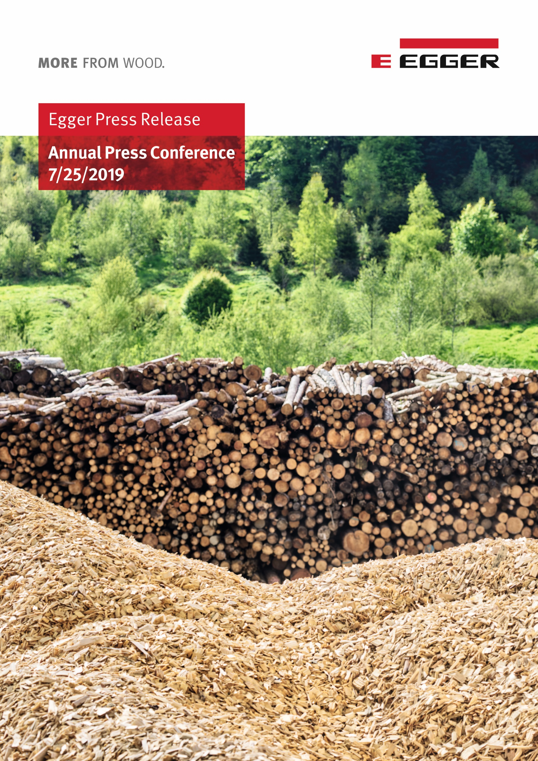

Your contact persons

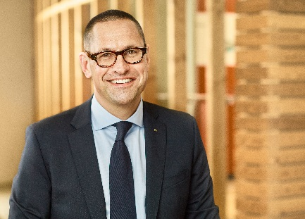 | 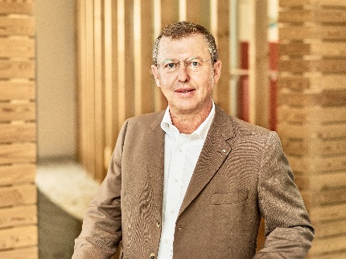 | 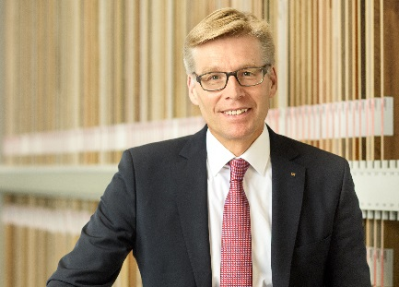
Dr. Thomas Leissing  Head of Finance/  Administration/Logistics  EGGER Group;  Spokesperson of the Group Management | Walter Schiegl  Head of Production/Technology  EGGER Group | Ulrich Bühler  Head of Sales/Marketing  EGGER Group

For inquiries:

FRITZ EGGER GmbH & Co.
Holzwerkstoffe
Manuela Leitner
Weiberndorf 20
6380 St. Johann in Tirol
Austria
T +43 5 0600-10638
F +43 5 0600-90638
manuela.leitner@egger.com
EGGER Group brings the 2018/2019 financial year to a close with stable results and very high investments
The wood-based materials manufacturer recorded sales of EUR 2.84 billion and adjusted EBITDA of EUR 425.0 million.
The EGGER Group reports on a successful, albeit challenging, 2018/2019 financial year (4/30/2019) during its annual press conference on 25 July 2019 at its headquarters in St. Johann in Tirol. The key performance indicators showed a stable development: Group turnover increased by +5.6%, while adjusted EBITDA declined slightly by -4.7%. The record total investment of EUR 489.1 million had a strong impact on this result. One of the flagship projects was recently completed: The 19th EGGER plant in Biskupiec, Poland, started operations at the end of June.
EGGER Group Management is satisfied with the sales of EUR 2,841.5 million achieved in the 2018/2019 financial year (+5.6% compared to the previous year) and the adjusted operating result (EBITDA) of EUR 425.0 million (-4.7% compared to the previous year). "We have not achieved all of our ambitious goals, but we are on schedule with the implementation of our strategic growth plan. Against the background of our investments and the associated start-up costs, some of which cannot be capitalized, we were able to achieve develop together with our 9,600 employees," summarizes Thomas Leissing, Spokesperson of Group Management and responsible for Finance, Administration and Logistics. The adjusted EBITDA margin amounts to 15.0% and is thus in line with the long-term average. The equity ratio remains at the high level of 36.8% (previous year: 40.8%).
Stable development in the markets
In the second half of 2018, global economic growth slowed, particularly in the eurozone. The construction industry is growing slower than forecast. For EGGER, environments in the key markets in Europe and Russia were satisfactory in the past financial year and enabled stable development. The most important geographical market for the company is Western Europe, and above all Germany with the furniture industry strongly represented there. The Western European market with a turnover of EUR 1,672 million (+4.7%) also grew in the 2018/2019 financial year and thus generated 58.9% of the sales revenues.
The Central & Eastern European and Russian markets also achieved a stable sales share of 29.5%, with declining sales of flooring products in Turkey and falling demand for OSB having a negative impact. However, this was offset by an increase in sales of flooring and interior design products in Russia and sales growth in other sales territories of the region.
Non-European countries are playing an important role for EGGER. In 2018/2019 they accounted for EUR 330 million (+10% compared to the previous year) or 11.6% of total sales. Sales at the new plant in Argentina fell short of expectations: "The Argentine market, which is new to us, was very challenging, as it was characterized by very high inflation and the currency decline of the Argentine peso and the associated economic recession," explains Ulrich Bühler, EGGER Group Management Sales/Marketing.
Sales growth in all divisions
In the 2018/2019 financial year, EGGER reported for the first time in the divisions: EGGER Decorative Products Centre (plants in Germany, Western Austria and Turkey), EGGER Decorative Products West (plants in Great Britain and France) and EGGER Decorative Products East (plants in Eastern Austria, Romania, Russia and Poland), EGGER Flooring Products (plants in Wismar (DE) and Gagarin (RU)) as well as the "Other" segment. The "Other" segment comprises group functions, the sawmill in Brilon (DE) and other independent divisions or plants that are currently being set up. The two OSB plants in Radauti (RO) and Wismar (DE) have been assigned to the divisions EGGER Decorative East and EGGER Flooring Products since May 1, 2018.
In 2018/2019, all divisions recorded sales growth: Decorative products for furniture and interior design accounted for the largest share with 76.0% of sales. The Decorative Products Centre division generated sales of EUR 862.4 million (+2.1% compared to the previous year). The Decorative Products West division increased sales by +8.5% to EUR 714.0 million. Sales in the Decorative Products East division rose by +2.1% to EUR 837.7 million. The Flooring Products division accounted for 14.1% of total sales and, at EUR 447.0 million, was also up +5.0% on the previous year. At EUR 313.7 million, the Other segment accounted for 9.9% of total sales. The increase of +24.8% from the previous year is due to the inclusion of the Concordia (AR) plant for the first time for a full twelve months and a very positive development at the Brilon (DE) sawmill.
A slight decline in earnings performance in the decorative divisions is attributable to a change in the product and market mix, start-up costs from investments and regionally increased raw material prices. The threat of Brexit has so far shown no noticeable effects.
Record amount invested
In the 2018/2019 financial year, EGGER invested EUR 489.1 million in property, plant equipment and intangible assets (previous year: EUR 483.8 million). Of this amount, EUR 78.1 million was attributable to maintenance investments and EUR 411.0 million to growth investments. The two greenfield projects in Biskupiec (PL) and in Lexington, NC (USA), accounted for the largest investments. Walter Schiegl, EGGER Group Management Technology/Production reports: "We completed our 19th plant in Poland in the course of the financial year and commissioned it on June 28, 2019. The plant has been started up by almost 400 Polish employees. In Lexington, NC, our first production site in the USA, we started construction work in November 2018 and its is progressing according to plan. We expect it to be commissioned by the end of 2020."
In addition to these major investments, EGGER also invested extensively in its existing sites, in particular in finishing and logistics at the Brilon (DE) and St. Johann (AT) plants and in the expansion of the Wismar (DE) plant, where a new flooring system was installed.
Fully utilized plants and 9,600 EGGER colleagues
In the 2018/2019 financial year, the volume of raw boards including timber produced was increased to 8.8 million m³ (+3.5%), which means full utilization of all primary production capacities. The increase is mainly attributable to the plant in Concordia, Argentina, which was only included for 7 months after its acquisition in October 2017. In addition, production of MDF/flooring in Gagarin (RU) and the volume of timber at the Brilon sawmill (DE) increased.
The number of EGGER employees amounted to 9,481 (previous year: 8,765) on average throughout the year and 9,643 as of 30 April 2019. The increase in the number of employees is again attributable to growth investments.
All detailed information on the 2018/2019 financial year can be found in the annual financial report at www.egger.com/credit-relations.
Continued focus on sustainability
EGGER is once again publishing its annual sustainability report (non-financial statement) at the same time as the annual financial report. This is available at www.egger.com/nachhaltigkeit and contains all approaches, objectives and performance with regard to economic, ecological and social sustainability. The EGGER Sustainability Report 2018/2019 contains many best practice examples of the company's sustainable actions.
Positive outlook for 2019/2020
In the current financial year, EGGER aims to exploit the earnings potential of the investments made. Thomas Leissing is confident about this: "Although weaker economic development has been noticeable in some of our markets in recent months, our outlook for the 2019/2020 financial year is positive. With our competitive industrial base, we will be able to build on our current results. In addition, we will launch our new EGGER Decorative Collection 2020–22 in the market at the turn of the year, continuing the great success of the first edition of this collection". EGGER also anticipates a positive development in demand for the OSB and timber product areas. Laminate flooring will continue to be under market pressure in Western Europe. Due to the stable development in the core area of furniture and interior design, growth in Russia and the shift of volumes from weaker regions to alternative markets, EGGER anticipates sustained sales growth and stable earnings for the Group as a whole in the 2019/2020 financial year.
Greater uncertainties may arise from the further development of political tensions in the Middle East, the effects of Brexit, the economic situation in Turkey, currency, inflation and economic developments in Argentina and the trade dispute between the USA and China and its effects on the world economy. The development of the raw material markets, and above all a regional shortage of wood, also represents a long-term risk. The company is countering this with the commissioning of additional refining capacities and investments to improve the raw material and energy situation as well as with continuous optimization of material usage and cost structures.
In the coming years, EGGER will focus on the completion of ongoing strategic expansion investments and their integration into Group-wide processes and systems. "We will continue to pursue our sustainable sales and marketing strategy, respond to structural change in an agile manner, and provide customers with the best possible products and services. In addition, we will make targeted use of the opportunities offered by digitization in our processes and offerings," says Ulrich Bühler, outlining the approach.
Designing digital trends for customers
EGGER is currently entering into new partnership to provide its customers, carpenters and dealers with the best possible access to the major growth areas of online planning and the online purchase of furniture. The wood-based materials manufacturer is building up a company together with Roomle, an internationally leading digital company from Linz (AT) in the field of digital furniture planning. This marketing company will offer international carpenters and timber merchants suitable solutions for digital market access.
EGGER inside, a service which combines the digital requirements of a carpenter with the online configuration of furniture and which is already used by over 200 carpenters in Germany and Austria, is to be further developed in future and made accessible to customers outside the German-speaking region. EGGER holds 75% and Roomle 25% of the shares of the newly founded company Furniture eServices GmbH. To secure the underlying technological competence, EGGER is also acquiring a 9% stake in Roomle GmbH.

EGGER Group brings the 2018/2019 financial year to a close with sales and investment highs
- Turnover: EUR 2.84 billion (+5.6%)  - Sales growth in all divisions  - EBITDA: EUR 425.0 million (-4.7%)  - Investments: EUR 489.1 million  - Biggest projects: Biskupiec (PL) was put into operation on 6/28/2019; construction work started in Lexington, NC (US) in November 2018 | - 9,481 employees on average throughout the year  - Production: 8.8 million m³ raw boards including timber (+3.5%)  - Outlook 2019/2020: sustained sales growth and stable earnings  - Future focus on sustainability and digitization solutions

Captions
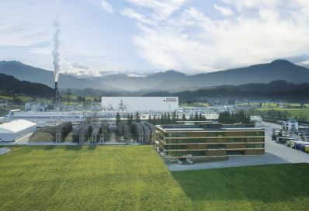 | The EGGER Group, headquartered in St. Johann in Tyrol, increased its sales by 5.6% to EUR 2.84 billion in the 2018/2019 financial year.
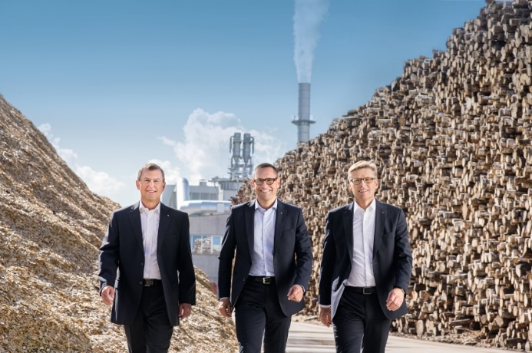 | The EGGER Group Management with Walter Schiegl, Thomas Leissing, and Ulrich Bühler (left to right) reported a stable financial year and major plans for the future.
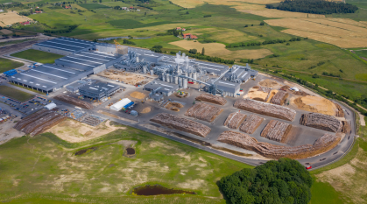 | On 28 June 2019 the time had come: production started at the new EGGER plant in Biskupiec, Poland. The plant is equipped with state-of-the-art equipment, a raw chip capacity of 650,000 m³ and coating facilities.

PHOTOS: EGGER Holzwerkstoffe, reprints quoting the name of the copyright owner are free
IMAGE DOWNLOAD: https://celum.egger.com/webgate/pin.html?lang=en&pin=81HH1RKXOJIX

