EGGER welcomed trade fair visitors into the era of “synchrony”
Highlights from the wood-based materials specialist thrilled at the Interzum Cologne.
Under the motto “MORE+less”, EGGER presented its new introductions at the Interzum from the 21st to the 24th of May 2019. The world’s leading trade fair broke a new record in its 60th anniversary year thanks to the 74,000 international visitors.
Under the motto “MORE+less”, EGGER showed with this year’s trade fair presentation that several trends can work next to each other but also with each other. How we live and how we design our space is less and less influenced by trends, but more and more by the individual interpretation of trends, influences and materials. “Our visitors appreciated this year’s concept, with six room settings that included highlight decors, surfaces and products adapted to the relevant trend,” says Hubert Höglauer, Head of Marketing and Product Management Furniture and Interior Design, about the exceptional feedback.
EGGER was also recognised at the interzum award: intelligent material & design 2019. During the award ceremony on 20 May in Cologne, PerfectSense Matt with Duo edging received the award “Best of the Best” for the successful interplay of the two products. The new worktop texture ST75 Mineral Satin and PerfectSense Topmatt worktops with edging received the "High Product Quality” award.
Look and feel in harmony
The wood-based material manufacturer presented the new ST20 Metal Brushed texture for the popular Metallic trend. Its look and feel points to finely brushed metal. For worktops, EGGER presented the newly developed ST75 Mineral Satin texture. It gives decors a matt and velvety feel. Its irregular look makes the decor image appear very realistic, particularly marble reproductions. The Feelwood family has also grown: ST32 Feelwood Vintage is synchronised with the decor image of the Sherman Oak and replicates burnt wood or waste wood. ST19 Deepskin Excellent creates liveliness and a natural finish with its interplay of matt and gloss grains. It looks like lacquered wood on a uni colours.
New and further developments among products
EGGER also has a few novelties and further developments among products. Two new entries were presented among worktops. The homogeneous, moisture-resistant and extremely robust compact worktop of 12 mm thickness is predestined for use as a worktop. Two-sided bevel milling on the longitudinal and transverse edges emphasise the thin, modern look of the compact worktop.
In order to bring the trend of the matt look into the kitchen, EGGER has presented the new PerfectSense Topmatt worktop with edging on the basis of a 16 mm MDF board. PerfectSense Topmatt laminate used for the surface is ideal for applications on worktops. It seduces with its impact and scratch resistance and it is also resistant to abrasion. The supermatt and velvety warm surface also stands out thanks to its anti-fingerprint feature.
PerfectSense Gloss and Matt lacquered boards have been developed further: In matt or high-gloss variants, they are now also available two-sided. This means high-end solutions in furniture and interior design can be realised without needing to make compromises.
EGGER’s Interzum presentation in Cologne also focussed on the product area furniture components. Important investments were made in this area in our St. Johann in Tirol (AT) plant. This means EGGER is able to continuously produce furniture components with Clic technology. Customers benefit from the fast and uncomplicated assembly thanks to furniture components that can be easily clicked into each other, as well as from transport directly to the construction site and efficient logistics.

EGGER welcomed trade fair visitors into the era of “synchrony”

- Successful EGGER presentation at the Interzum 2019 under the motto “MORE+less”.  - Three recognitions at the interzum award: intelligent material & design 2019: "Best of the Best" for PerfectSense Matt with Duo Edge, "High Product Quality" for the new worktop texture ST75 Mineral Satin and the PerfectSense Topmatt worktop with edging. | - Surface highlights: ST20 Metal Brushed, ST75 Mineral Satin, ST32 Feelwood Vintage, ST19 Deepskin Excellent.  - Product novelties: PerfectSense Gloss and Matt Lacquered Boards now also finished on both sides; homogeneous, moisture-resistant and extremely robust compact worktop of 12 mm thickness; PerfectSense Topmatt worktop with edging based on a 16 mm MDF board.

Captions
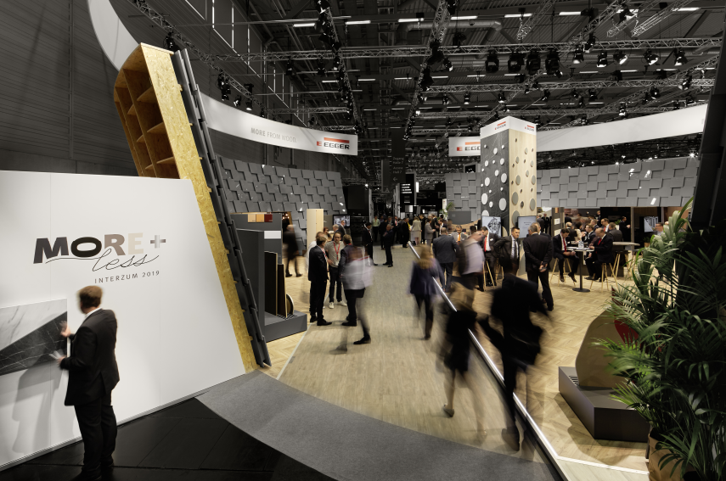 | EGGER at the Interzum 2019 in Cologne with the motto “MORE+less”.  © Becker Lacour
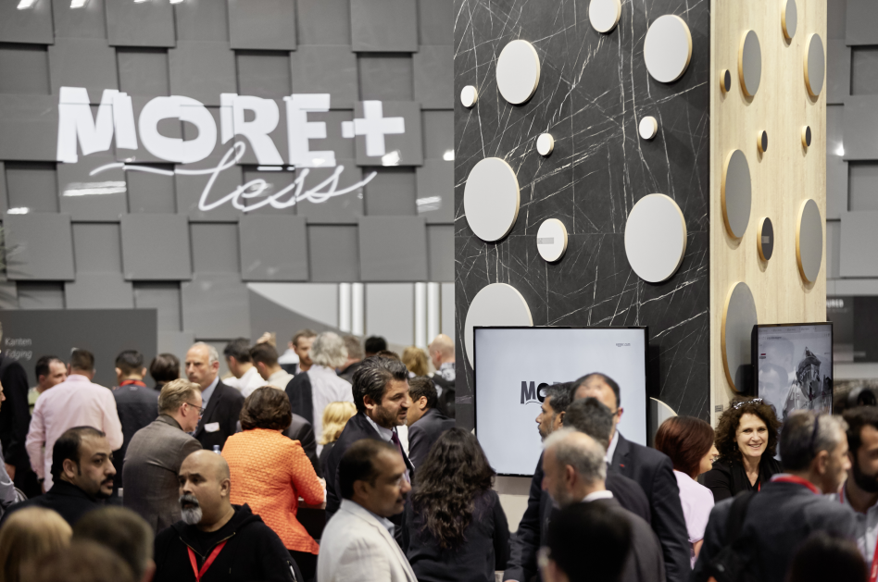 | International trade fair visitors very interested in EGGER’s product, decor, and surface highlights.  © Becker Lacour
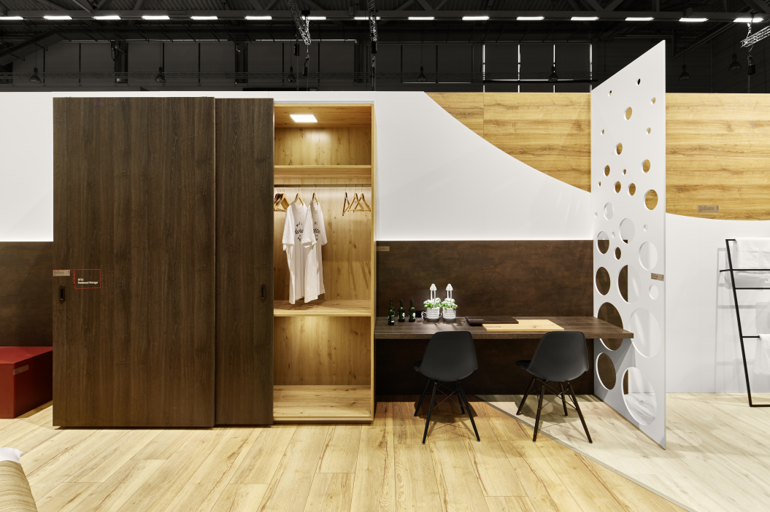 | EGGER showed its highlights in a total of six room berths. This is the newly developed synchronised pore texture ST32 Feelwood Vintage on a large cabinet front surface.  © Becker Lacour
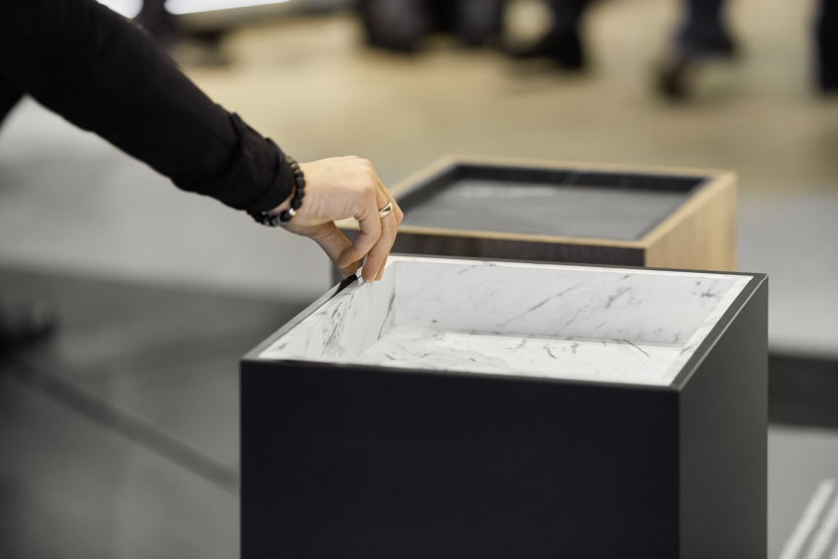 | Eye-catcher: The combination of PerfectSense Matt with Duo edging received the “Best of the Best” award at the Interzum Award 2019.  © Becker Lacour
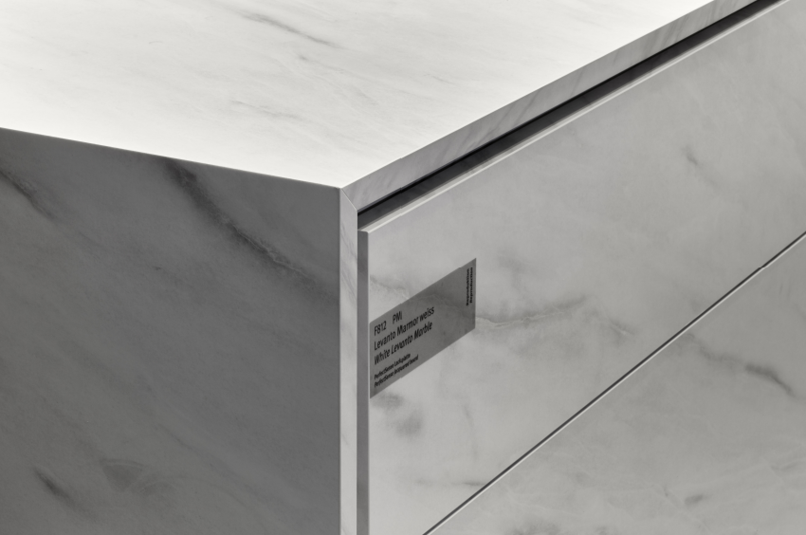 | New worktops in EGGER’s range: The PerfectSense Topmatt worktop with edging awarded with “High product quality” at the Interzum Award 2019.  © Becker Lacour
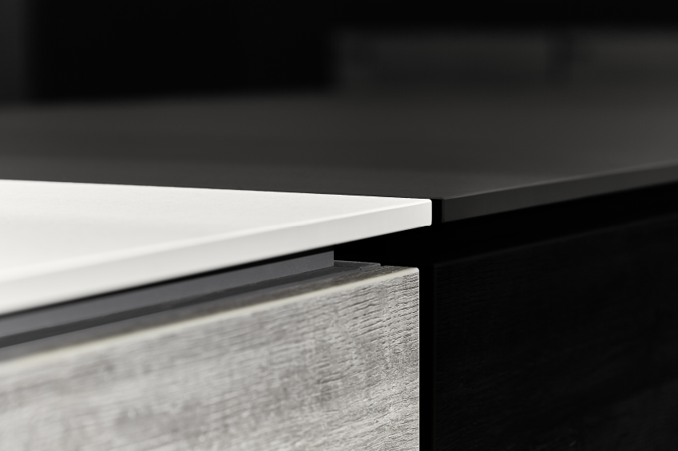 | Absolute robustness with a thin look: The 12 mm compact worktop is another worktop novelty from EGGER.  © Becker Lacour

PHOTOS: All image rights belong indefinitely to EGGER - please name the photographers Image download: https://celum.egger.com/webgate/pin.html?lang=en&pin=YUV5IGED8PFX

For queries:

FRITZ EGGER GmbH & Co. OG
Holzwerkstoffe
Karin Mumelter
Weiberndorf 20
6380 St. Johann in Tirol
Austria
T +43 5 0600-10691
F +43 5 0600-90691
karin.mumelter@egger.com

