Start of production at the 20th EGGER plant in Lexington, North Carolina, USA
After a two-year construction period a big milestone has been reached: the EGGER Group has started production at the new wood-based materials plant in Lexington, North Carolina, USA. This is the 20th plant of the globally active family company and the first EGGER plant in North America. The investment amounts to around 440 million euros. The new location creates 400 new jobs. With an annual capacity of up to 650,000 m³ of particleboard in the Lexington, NC plant, EGGER is responding to the growing demand for wood-based materials in the North American market.
"It is another historical milestone in the history of the EGGER family business. We are very proud that we are able to start up our 20th plant in Lexington, NC, North America", announced Walter Schiegl, EGGER Group Management Production & Technology. "With our new plant in Lexington, NC, we will now also become a local producer and reliable partner in North America. This enables us to ensure continuous product availability and increase delivery speed. “
The new plant: More than a production site
The plant in Lexington, NC, was planned and built using the best available production technology, with a focus on the environmental. From now on raw and laminated particleboard will be produced for the North American market. When fully operational, the production capacity will be 650,000 m³ of raw particleboard per year, a large proportion of which will be finished with decorative surfaces. The first short-cycle press for lamination was also put into operation in September.
In December 2019, the company was able to move into a modern office building on the site, which contains a technical training center and a design center in addition to around 80 workstations. Here architects, designers, trade and furniture industry customers can get to know EGGER products and services on site.
North Carolina: Long tradition of furniture making
The location decision for the first North American EGGER plant was a well-considered step: the supply of resources, especially the most important resource wood, is sourced locally, and good infrastructural connections create optimal logistical conditions. The state of North Carolina is known for its long tradition of furniture production, which also guarantees the availability of qualified employees. 290 people are already employed at EGGER in Lexington, with 400 to be added in the coming months. In addition, the company has also been offering a specially developed apprenticeship programme for junior staff since 2018, establishing the dual training model in the USA, which has been successful in Europe.
EGGER Decorative Collection: From 1 October also in North America
The start of production at the new plant also marks the launch of the first EGGER Decorative Collection for the North American market. With the new collection, EGGER offers North American architects, designers, processors and dealers a coordinated range of decor and material combinations as well as a comprehensive service package.
About EGGER
The family company, founded in 1961, employs approximately 10,100 people. At 20 plants worldwide, they produce an extensive product range of wood-based materials (chipboards, OSB and MDF boards) as well as timber. The company generated a turnover of EUR 2.83 billion in the 2019/2020 business year and has worldwide customers in the furniture industry, wood and flooring retailers, as well as DIY markets. EGGER products are found in countless areas of private and public life, including kitchens, bathrooms, bedrooms, offices, hotels and shops. EGGER is a full-range supplier for the furniture industry, interior design, wood construction and wood-based flooring industries.

EGGER plant in Lexington, NC, North America starts production
- The plant as a campus: production, office building, customer and training centre  - EGGER now also local producer in North America.  - Technically and ecologically state-of-the-art facilities | - Chipboard plant with an annual capacity of 650,000 m3  - Investment amount: 440 million euros  - 400 new jobs  - Training programme for dual training

Picture caption
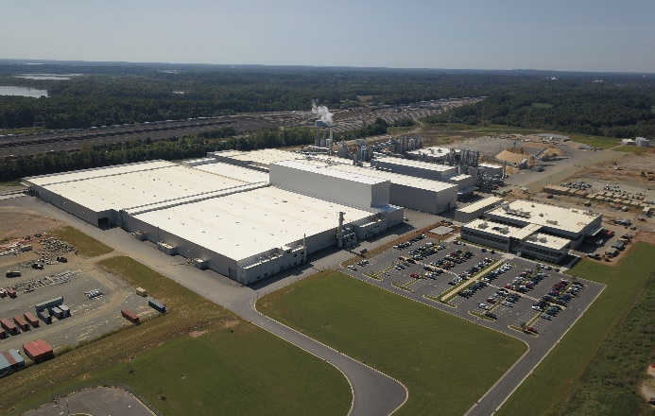 | A milestone for EGGER: On 19.09.2020, the 20th plant in Lexington, North Carolina, USA, will start production.
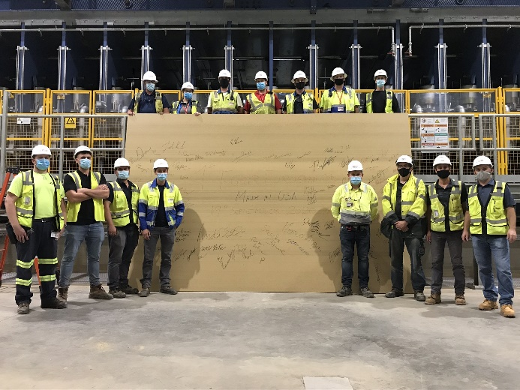 | In good tradition, the project team gathered at the ContiRoll press to produce the first raw particleboard and proudly signed the result.
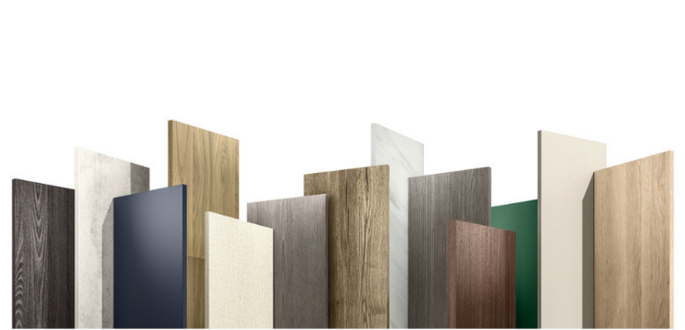 |  | Launch of the EGGER Decorative Collection in North America on 1.10.2020: More choice of colours and haptics, more products in a decor composite and supporting services offer architects, processors and retailers more possibilities.

PHOTOS: EGGER Wood Based Materials, reproduction with naming of copyright holder free of changes
Picture download: https://celum.egger.com/pinaccess/showpin.do?pinCode=DSnvILOuoj9o

For queries:

FRITZ EGGER GmbH & Co. OG
Wood-based materials
Manuela Leitner
Weiberndorf 20
6380 St. Johann in Tirol
Österreich
T +43 5 0600-10638
F +43 5 0600-90638
manuela.leitner@egger.com
www.egger.com

