Ground-breaking ceremony for the EGGER plant in Poland
Official kickoff for the 19th production plant of the EGGER Group
On the 25th of October 2017, together with approximately 160 Polish customers, partners, political and industrial representatives, authorities, and members of the media, Michael Egger and Ulrich Bühler, EGGER Group Management Sales & Marketing, launched the ground-breaking ceremony. In Biskupiec, located in the Warmia-Masuria region of north-east Poland, an ultramodern production plant for 650,000 m³ of chipboard will be built by the end of 2018. The international corporate group with headquarters in St. Johann in Tirol (AT) is investing approximately EUR 250 million in this location.
“I am very proud of the fact that we will build our 19th plant in Poland, in the heart of the European furniture industry. We’ve been active in Poland already since the early 1990s, and are successfully working with more than 150 local customers. With our growing chipboard plant, we will be able to serve the growing market in Poland and in the neighbouring regions even better”, announced Michael Egger during the ground-breaking ceremony. “We believe in sustainable growth through our own efforts and the plant in Biskupiec is also a long-term investment for future generations.”
The Biskupiec plant will have ultramodern facilities that are based on the latest available production technology and environmental knowledge. The entire site covers 85 hectares. The current construction phase focuses on production lines for raw and laminated chipboard. The systems are designed for the production of 650,000 m³ raw chipboard. A large part of it is coated with melamine resin film. The first board is expected to be produced by the end of 2018.
A 1,000 jobs for the region
In addition to the Polish furniture producers and retailers, the region will experience a valuable push forward thanks to the investment. There will be approximately 400 jobs in the EGGER plant, and an addition 600 indirect jobs with suppliers or service providers. EGGER wants to be a good neighbour and active member of the local community in all its locations.
Biskupiec was chosen due to the number of well-trained employees available in the region and the great tradition of wood processing. The location is also advantageous from the point of view of transport and enjoys a good supply of EGGER's key raw material - wood.

About EGGER
The family company, founded in 1961, employs approximately 9,000 people. In 18 plants across the world, they produce an extensive product range of wood-based materials (chipboard, OSB and MDF board) as well as timber. The company generated a turnover of EUR 2.38 billion in the 2016/2017 financial year. EGGER has global customers in the furniture industry, wood and flooring retailers, as well as DIY markets. EGGER products are found in countless areas of private and public life, including kitchens, bathrooms, offices, living rooms and bedrooms. EGGER is a full-range supplier for the furniture and interior design industry, for wood construction, as well as wood-based flooring (laminate, cork and design flooring) industries.
The EGGER Group is currently experiencing significant growth. On the 1st of October 2017, it took over a plant in Concordia, Argentina, as its 18th production plant. In addition to Biskupiec (PL), an additional greenfield investment is planned for Lexington, North Carolina (US).

Ground-breaking ceremony for the EGGER plant in Poland
- The Biskupiec plant is located in the Warmia-Masuria region of north-east Poland  - Chipboard plant with a 650,000 m³ capacity and state-of-the-art lamination facilities | - Investment level: EUR 250 million  - 400 direct jobs, with an additional 600 indirect jobs in the region  - 1st board planned for the end of 2018

For queries:

FRITZ EGGER GmbH & Co.
Holzwerkstoffe
Manuela Leitner
Weiberndorf 20
6380 St. Johann in Tirol
Austria
T +43 5 0600-10638
F +43 5 0600-90638
manuela.leitner@egger.com
Captions
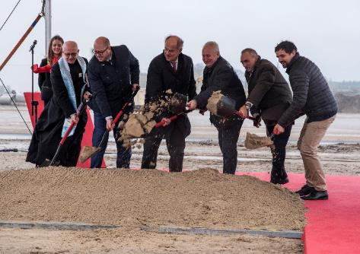 | At the symbolic ground-breaking ceremony: Project Lead Leopold Atschreiter, Jan Szynaka (President of the Polish furniture manufacturers), Marshal Marek Gustaw Brzezin, Michael Egger, Mayor Kamil Kozłowski und Priest Wiesław Badura.
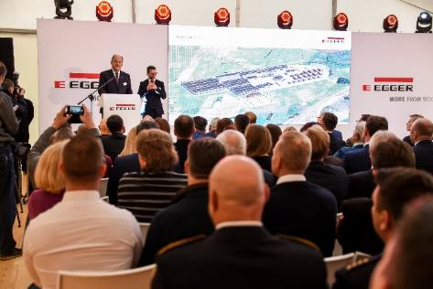 | Around 160 guests responded to the invitation to the ground-breaking ceremony in Biskupiec
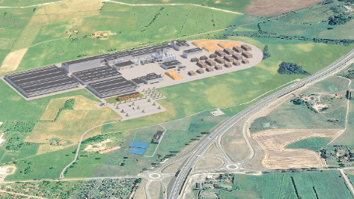 | An ultramodern chipboard plant with 650,000 m³ capacity will be built in Biskupiec, Poland, by the end of 2018.
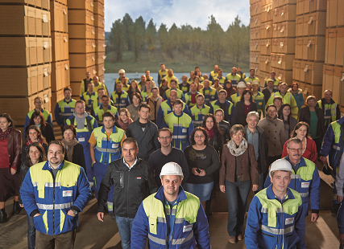 | The new location creates 400 direct and 600 indirect jobs in the region.
PHOTOS: EGGER Holzwerkstoffe, reprints that quote the name of the copyright owner are free
IMAGE DOWNLOAD: https://celum.egger.com/webgate/pin.html?lang=en&pin=L54LN0ZYLZIQ

