USA EGGER Distribution Center Opens
Lexington, NC - The new EGGER distribution center near Detroit opened its doors in mid-December 2017, allowing authorized distributors in North America to quickly and easily access trendy EGGER products.
The EGGER Group is a leading international wood-processing company. The family-owned company, headquartered in Austria, has been a reliable partner in the USA and Canada for several years. The new distribution center in Michigan (34450 Industrial Road, Livonia, MI 48150) began operation in mid-December 2017, offering EGGER’s authorized North American distributor and industry customers better product availability.

“Based on our sales activities so far, we know that our product range is very attractive for architects, designers, and distributors in the USA,” said Mario Bobsin, EGGER Wood Products LLC Director of Sales. “With easier accessibility and shorter delivery times, we will be well-positioned to meet growing demands, and support our distribution partners to service EGGER specifications in North America.”
The distribution center in Michigan is another important step of a comprehensive, long-term investment strategy; the construction of a new wood-based materials plant is to start in Lexington, NC, in late 2018. With the opening of both the distribution center and the new production site in the USA, the EGGER Group will be positioned to broadly enter the growing North American wood-based products market.
Maximum diversity in one collection
EGGER bundles an expansive product and service offering with innovative decors and textures, for distributors, craftsmen, and architects, in the new EGGER Decorative Collection 2017–2019. Authorized EGGER distributors can now purchase a large selection of the collection’s vast product range, featuring coordinated decors, surfaces, and edgebanding, from the new distribution center. For more information about the EGGER Decorative Collection, visit www.egger.com/decorative.
The EGGER decor and material match is a unique selling point particularly in the USA and Canada. Many decors are available on a broad range of materials: Eurodekor (EGGER’s thermally-fused laminates available on particleboard or MDF substrate), Eurolight lightweight panels, or compact laminate. ABS edgebanding in the same decor or structure is available to complement the product portfolio.
“Customers no longer need to worry about where they can get each product from and whether the decors will even match,” said Bobsin. “They can get everything from us: matching decors, surfaces, and edgebanding out of one hand!”
About EGGER
The family company founded in 1961 employs around 9,000 people. At 18 plants throughout the world, they produce an extensive product range of wood-based materials (chipboard, OSB and MDF boards) and provide timber. The company generated a turnover of approximately EUR 2.38 billion in the 2016/2017 business year. EGGER has customers worldwide in the furniture industry, wood and flooring distribution, and DIY markets. EGGER products are found in countless areas of private and public life: in kitchens, bathrooms, offices, living rooms, bedrooms and warehouses. EGGER is a full-range supplier for the furniture industry and interior design, wood construction, and laminate flooring sectors (laminate, cork, and design flooring). Find out more on www.egger.com
Captions
 | The EGGER family company was founded in 1961 in St. Johann in Tirol (AT). The wood-based materials manufacturer employs around 9,000 people worldwide.
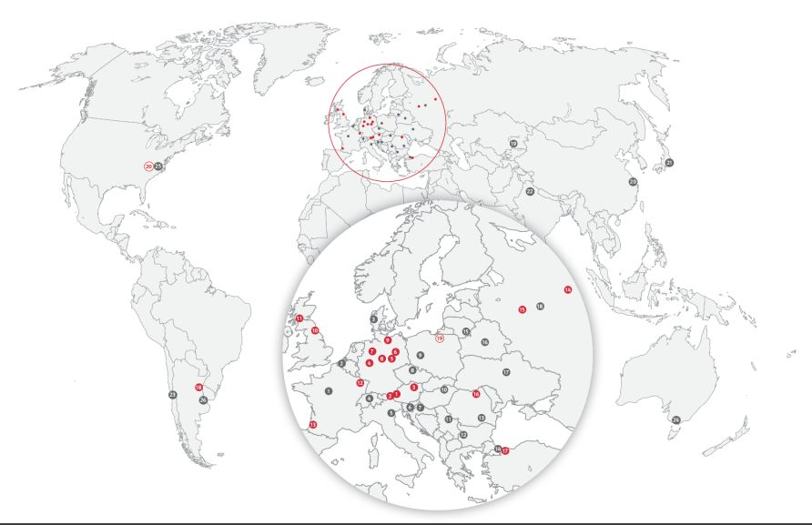 | EGGER has 18 plants and 26 sales offices worldwide.
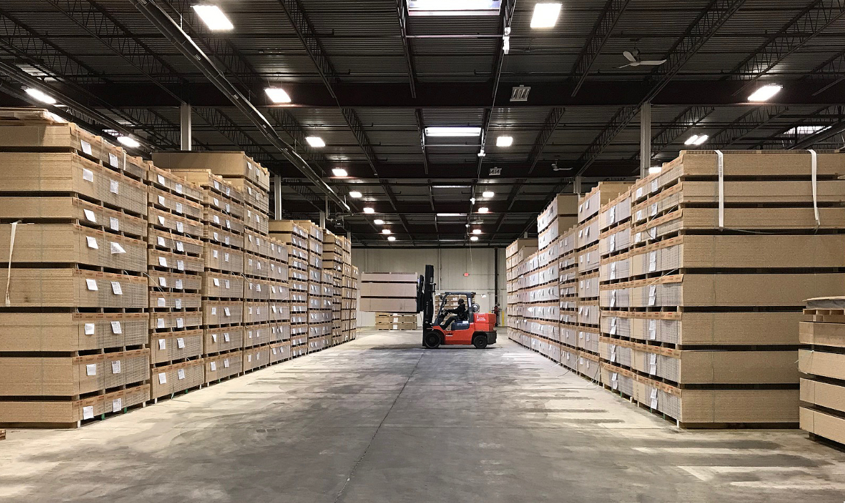 | Authorized distributors in North America can purchase EGGER products from the warehouse in Livonia, MI, beginning in mid-December 2017.
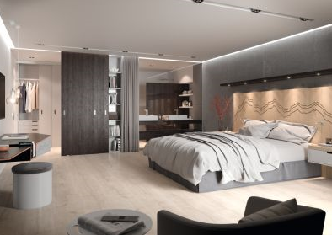 | Diverse and creative applications can be realized with EGGER products, like Eurodekor chipboards, Eurolight lightweight boards, Eurodekor MDF, laminate, and edgebanding.
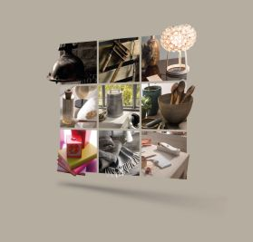 | EGGER distributors can purchase products and decors from the Livonia distribution center. Products from the globally successful EGGER Decorative Collection 2017-2019 are available.
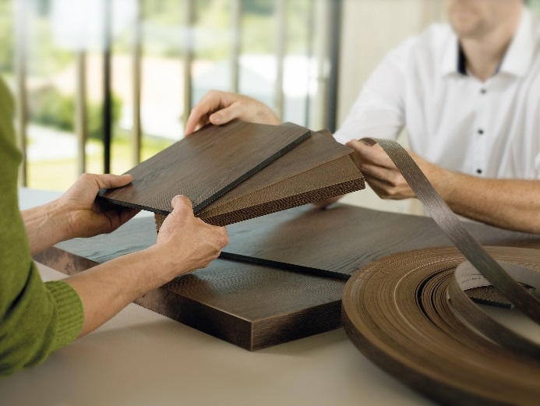 | With EGGER, customers can get everything from one source: coordinated decors, surfaces, and edgebanding.
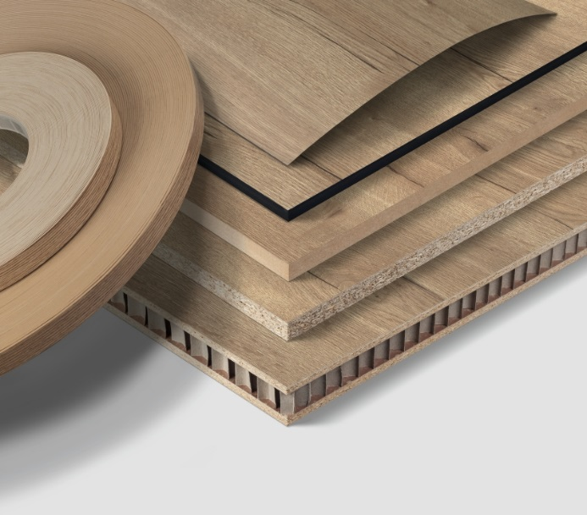 | The EGGER decor and material match: The wood-based materials company manufactures all support materials, including laminate and edgebanding in the exact same decor and texture.
PHOTOS: EGGER Wood Products LLC, reprints quoting the name of the copyright owner are free
Image download: https://celum.egger.com/webgate/pin.html?lang=en&pin=J0S0FUKPB9UK

For inquiries:

EGGER Wood Products LLC
Jamie Newman
P.O. Box 907
Lexington
NC 27293
T +1 800 940 9633
jamie.newman@egger.com

