Sustainably successful: EGGER Group once again receives awards for its sustainability performance
Sustainable management is a significant component of the EGGER Group's corporate behaviour. The company has aspired to act sustainably since its founding. A key requirement is the continuous improvement of its own sustainability management. EGGER therefore has itself assessed regularly by external institutions. Most recently, EGGER was able to achieve two awards in sustainability ratings: Prime status in the ISS ESG Corporate Rating and the EcoVadis silver medal.
Sustainability in the DNA
At its core, the founding of EGGER is based on a sustainable idea. More than 60 years ago, Fritz Egger Sr. decided to close his sawmill and devote himself to the production of wood-based materials instead. His essential guiding principle was that wood scraps are far too valuable to throw away. Since then, the company has been using these scraps as materials and refining them into high-quality products.
This history continues to this day: EGGER takes responsibility for its products, its own production as well as for employees and society and acts with future generations in mind. In doing so, EGGER strives for continuous improvement, has set itself ambitious goals and has its own performance evaluated annually by leading global ESG rating agencies. ESG refers to the consideration of criteria from the areas of environment, social affairs and responsible corporate management (governance). "We have high standards for our sustainability management and our transparent reporting. Through the objective analyses of external ESG rating agencies, we gain additional valuable insight into how we can further translate our objectives into our processes," says Thomas Leissing, Chief Financial Officer EGGER Group.
ESG ratings give good report card
ISS ESG is one of the leading rating agencies in the sustainable investment segment. For the third time already, it awarded the EGGER Group Prime status, which is reserved for the best companies in their respective industries. ISS ESG follows a scientifically based rating concept. Non-financial information from the areas of environment, social affairs and governance is taken into account. Companies achieve Prime status if they meet or exceed the sustainability performance requirements defined by ISS ESG for a specific industry. Companies with Prime status are considered sustainability leaders in their industry. EGGER found itself in the top 3 of 49 companies in its own industry that were assessed by ISS.
EcoVadis, one of the world's largest providers of sustainability ratings, awarded EGGER the silver medal for the fourth time already. This puts the wood-based materials manufacturer among the top 25 percent of all companies evaluated. The evaluation focuses on 21 criteria, which are subdivided into four subject areas: environment, labour and human rights, ethics and sustainable procurement.

Contribution to the circular economy
A core element of sustainability at EGGER is working in closed cycles. This significantly helps to conserve fresh resources. The wood-based material manufacturer is a secondary processor of sawmill residues and post-consumer recycling wood. The waste wood comes from disposed goods such as old furniture, pallets or packaging material. It is processed accordingly and cleaned of impurities. Only to a small extent does EGGER use fresh wood in the form of industrial wood that is not suitable for cutting in its wood-based materials. Meanwhile, 64% of the wood used comes from recycling or by-products of industrial wood processing steps such as hackchips and wood shavings. Wood residues that can no longer be recycled provide energy from renewable sources in the company's own biomass power plants. At the end of their long service life, EGGER products are in turn largely recyclable and can be reintroduced into the cycle.
All key sustainability topics can be found in the EGGER Group's sustainability report (non-financial statement) at www.egger.com/sustainability. It contains the Group's strategy, objectives and performance with regard to economic, ecological and social sustainability.

Awards for sustainability performance

- ISS ESG awards EGGER Prime status for the third time.  - EcoVadis awards EGGER the silver medal for the fourth time. | - All details on EGGER's sustainability strategy can be found in the annual sustainability report. www.egger.com/sustainabilityreport

About EGGER

The family company, founded in 1961, employs approximately 11,100 people. In 21 plants across the world, they produce an extensive product range of wood-based materials (chipboard, OSB and MDF board) as well as timber. The company generated sales of EUR 4.23 billion in the 2021/2022 financial year. EGGER has global customers in the furniture industry, wood construction and flooring retail, as well as DIY markets. EGGER products are found in countless areas of private and public life, including kitchens, bathrooms, offices, living rooms and bedrooms. EGGER is a full-range supplier for the furniture and interior design industry, for wood construction and wood-based flooring industries.

Captions
 | The EGGER Group's sustainability performance is once again recognised with ISS ESG Prime status and the EcoVadis Silver Medal.
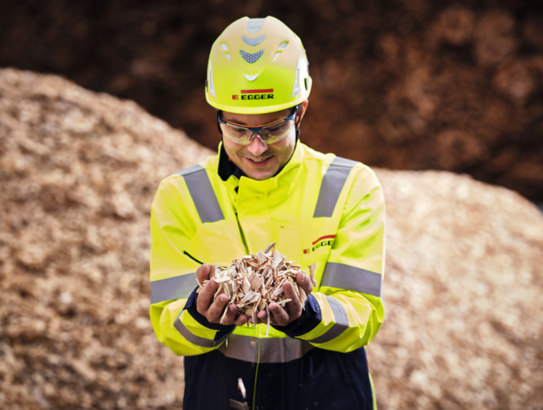 | Circular economy at the core of the business model. The careful use of precious resources is essential for EGGER, which is why 64% of the wood used comes from by-products or recycling.
PHOTOS: EGGER Holzwerkstoffe, reprints naming the copyright owner are free of charge
REPRODUCTION: All our mentioned decors are reproductions.
Picture download: https://celum.egger.com/pinaccess/pinaccess.do?pinCode=W9Ao0VOXPLPR

For queries:

FRITZ EGGER GmbH & Co OG
Holzwerkstoffe
Katharina Wieser
Weiberndorf 20
6380 St. Johann in Tirol
Austria
T +43 5 0600-10128
F +43 5 0600-90128
katharina.wieser@egger.com

