Lamination has started at the EGGER plant in Markt Bibart
The EGGER Group is investing in its strategic focus areas of sustainability, upgrading and automation in Markt Bibart. The next milestone has been set.
The EGGER Group, headquartered in St. Johann in Tirol (AT), is investing more than EUR 200 million in its 22nd plant in Markt Bibart (DE), thereby realising one of the largest investment projects in the industry. The wood-based material manufacturer is implementing extensive, multi-stage investment steps, which are due to be completed in autumn 2026. Another milestone has been reached at the Markt Bibart plant: the first short-cycle press has started production. Following the roofing ceremony for its production hall in August and the smooth installation of the facility, the lamination of decorative boards now starts – a first for the location, which previously only produced raw particleboard. The owners Michael and Fritz Egger also travelled to Markt Bibart for the historic first laminated board.

”The start of the first short-cycle press marks the beginning of a new era for our plant in Markt Bibart. It brings us a big step closer to our goal of becoming a modern wood-based material plant. The speed at which we are developing our plant is unbelievable, and we are doing it during ongoing operation. A great achievement by the project team, all our colleagues on site and our partners”, underlines Markus Scheran, Plant Director Technical/Production.
The creation of upgrading capacities is a major innovation at the plant. The site previously produced raw particleboard with an annual capacity of up to 650,000 m³. Existing customers will continue to be reliably supplied with raw particleboard of the highest quality. Part of the production quantity will be laminated from now on. This investment will ensure sustainable utilisation of production capacity and give customers access to EGGER's comprehensive product portfolio of laminated particleboard with trendy decors and diverse textures. The new short-cycle press produces up to 8 million m² of laminated particleboard per year.
Next steps in this major project
The Markt Bibart plant was taken over by EGGER in autumn 2023 and has since been successfully integrated into the Group. Immediately after the takeover, the family company began extensive investments. The projects are being implemented at an impressive pace. The new recycled wood processing facility, which enables the use of recycled wood in the production of high-quality particleboard on site, has been gradually ramped up since September. The first short-cycle press has now also been put into operation. Additional pioneering project steps are planned until autumn 2026: the creation of other lamination options with a second short-cycle press, the construction of a highly automated high-bay warehouse and a loading hall as well as optimisation of existing facilities.
As is usual for EGGER, the family company is also using state-of-the-art system technology at the Markt Bibart site. The investment will create around 70 new jobs in Markt Bibart.

Lamination has started at the EGGER plant in Markt Bibart
- EGGER is taking extensive, multi-stage investment steps in Markt Bibart, which should be completed by autumn 2026.  - With an investment sum above EUR 200 million, this is one of the largest projects in the industry. | - Markt Bibart is now a strategic location for raw particleboard and laminated particleboard. The first short-cycle press is in operation.  - EGGER is thus generating positive impulses for local value creation as well as creating around 70 new workplaces at the plant itself.

About the EGGER Group
The family company, founded in 1961, is a leading international manufacturer of wood-based materials with approximately 12,000 employees and 22 production plants worldwide. EGGER is a full-range supplier for furniture and interior design, for wood construction and for wood-based flooring, making it a reliable partner for the furniture industry, wood and flooring retailers and DIY stores. In the 2024/2025 financial year, the EGGER Group generated a turnover of EUR 4.13 billion.
Sustainable business practices are a core focus for EGGER: The family business takes its responsibility for climate protection seriously and is committed to the ambitious Net Zero target by 2050. 66% of the wood used in EGGER wood-based materials already comes from recycling or sawmill by-products. At the end of their long service life, EGGER products are in turn largely recyclable and can be reintroduced into the cycle. EGGER is constantly working towards its goal of "creating more from the valuable resource wood" and thus enabling sustainable living and working.

Captions
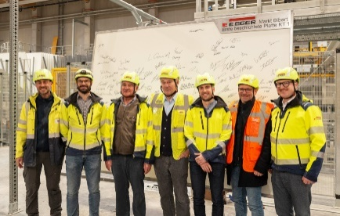 | Happy faces at the production of the first laminated board. From the left: Manuel Aigner (Project Team Representative), Markus Scheran (Plant Director Technical/Production), Fritz Egger, Michael Egger, Björn Brem (Plant Director Logistics), Klaus Nölp (Mayor of Markt Bibart), Gerhard Riedmann (Plant Director Finance/Administration)
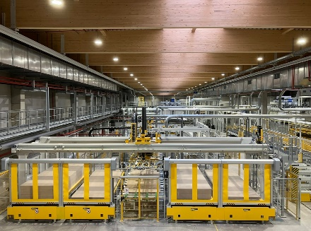 | The assembly of the first short-cycle press in Markt Bibart took place at record speed.
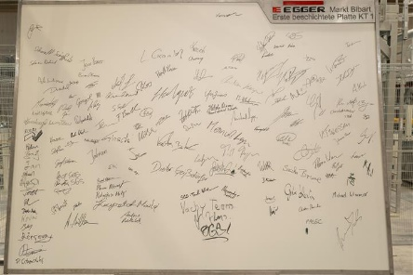 | In good EGGER tradition, the first laminated board was ceremoniously signed by employees and project partners.
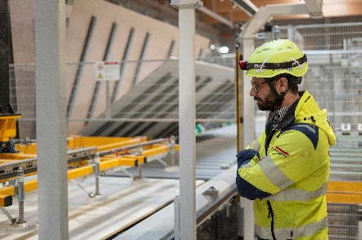 | The short-cycle press meets the latest standards. In the picture: Markus Scheran, Plant Director Technical/Production

PHOTOS: EGGER Holzwerkstoffe, reprints that quote the name of the copyright owner are free
REPRODUCTION: All our mentioned decors are reproductions.
Image download: https://celum.egger.com/pinaccess/showpin.do?pincode=jpdob8vuuaz4

For queries:
EGGER Holzwerkstoffe GmbH
Katharina Wieser
Weiberndorf 20
6380 St. Johann in Tirol
Austria
T +43 5 0600-10128
katharina.wieser@egger.com

