Wood-based materials in focus: EGGER at the DACH+HOLZ International 2026 in Cologne
When individual parts turn into something big.

DACH+HOLZ International will take place in Cologne from 24 to 27 February 2026. Visitors can look forward to exciting insights into modern wood construction. Highlights at the EGGER exhibition stand include the EGGER EcoBox, the flame-retardant EGGER OSB Flammex and a finger-jointed roof batten.

Thanks to research, normative adjustments and automated production methods, wood-based materials are now a key component of contemporary architecture. As a renewable raw material, wood offers outstanding physical constructive characteristics, such as high mechanical strength with low weight, good insulation and soundproofing values, and promotes a healthy indoor climate. At the same time, requirements for efficiency, resource conservation and industrial prefabrication are increasing. A growing challenge: the quality of wood has been deteriorating noticeably for some years now. "We accept the challenges of modern construction – climate protection, scarcity of resources and the need for efficient prefabrication – and develop customised solutions with foresight," says Moritz Steinruck, Head of Product Management EGGER Building Products, "By continuously developing new product ideas for building with wood and thinking about wood as a resource, we are driving modern wood construction forward."
From 24 to 27 February 2026, the company will be presenting at the DACH+HOLZ International in Cologne, under the motto "When individual parts turn into something big", a combination of tried-and-tested wood construction products and pioneering innovations.
A particular highlight is the EGGER EcoBox, which will be used as a key component of the EGGER exhibition stand in Hall 7. The EcoBox impresses in timber frame construction as a rafter, structural pillar and ceiling element thanks to its extremely resource-efficient use of materials. At DACH+HOLZ 2026, the entire supporting structure of the EGGER exhibition stand is made entirely of EcoBox.

The EGGER EcoBox - technically sophisticated and resource-efficient

The EGGER EcoBox is a hybrid product made of EGGER OSB, EGGER timber and soft woodfibre insulation. As an innovative solution in wood construction, it is characterised by efficient and resource-conserving use of materials.
The EcoBox is used as a modern alternative to solid wood supports in timber-frame walls and can also be used as a rafter, beam and parapet solution in roof construction. It also serves in house and façade renovations. The resource-conserving building product combines numerous advantages: it offers high dimensional stability thanks to intelligent material combinations while using less material. Industrial, standardised production guarantees consistent and reproducible quality. This makes the EcoBox ideal as a starting product for manual production and highly automated production processes for elements and room modules. The EcoBox is available in lengths of up to 6,500 mm. The widths vary between 160-400 mm depending on market requirements and energy requirements. The EcoBox is available in a thickness of 80 mm and from March 2026 also in a 60 mm version.
In addition to the EGGER EcoBox, EGGER will present in Cologne additional product innovations in the segment of building products, such as the OSB Flammex and the finger-jointed roof batten.

The EGGER OSB Flammex

The new EGGER OSB Flammex addresses the essential issue of fire protection. The pioneering softwood board meets the increased requirements of fire protection and at the same time impresses with its efficient use of resources. Thanks to a fire protection coating, the OSB Flammex board is flame-retardant and fulfils the strict EU classification B-s1, d0 in accordance with DIN EN 13501-1. The board is specially designed for the interior design of buildings with increased fire protection requirements, such as office buildings, public facilities, trade fairs, hotels, multi-storey buildings or other demanding construction projects and proves that fire protection and cost-effectiveness can go hand in hand. Thanks to a thin fire protection layer, the resistant OSB is flame-retardant. The development of smoke and flames is slowed down and dripping is prevented in the event of a fire. The high dimensional accuracy and dimensional stability makes it easy to work with. The board is quick and easy to process, can be cut to size cleanly and does not require time-consuming machining.

The finger-jointed roof batten - wood strengthens wood

Thanks to their stability, sustainability and efficiency, finger-jointed roof battens have established themselves as an important solution in the modern wood construction industry. In order to guarantee standardised lengths and qualities, only roof battens made from a single piece of wood were previously used in wood construction. EGGER now offers finger-jointed roof battens in European spruce and pine. "The main advantages of finger-jointing lie in upgrading the quality of the timber by selectively cutting out the defects, which significantly reduces the proportion of waste, and in the resource-efficient production of high-quality timber products," explains Arndt Silberg, Plant Director for Technical and Production at the sawmill. The finger-jointed roof batten has no disadvantages compared to standard roof battens. On the contrary, it is at least as stable and resilient, as well as temperature and moisture resistant. The dependence on high-quality, long wood is therefore a thing of the past. Expanding the product range to include other kinds of wood, such as pine, also ensures even greater independence. Pine is a tree species whose availability has increased significantly in recent years compared to spruce. Its characteristics have no disadvantages compared to spruce and even offer advantages, such as high raw density and high elasticity.

The digital EGGER Planning support: when wood construction must run according to plan

EGGER supports planners, architects and craftspeople with a central online tool: the digital planning support. It offers tested and certified designs for roofs, walls and ceilings as well as the associated standard details and connection information. In addition, digital data formats such as IFC, Revit and DWG are available for direct integration into BIM and CAD systems. EGGER thus ensures maximum planning reliability and efficiency. In addition to design details, the planning support provides comprehensive information on topics such as fire and sound insulation, heat and moisture protection and wood preservation. It is therefore not only a planning tool, but also a valuable knowledge platform for modern wood construction.
The EcoBox roof, wall and ceiling constructions, which form the basic framework of this year's EGGER exhibition stand, can also be found as construction details in the EGGER Planning support. EGGER is thus demonstrating how digital planning and real-life execution go hand in hand.

DACH+HOLZ International 2026 is the showcase for innovations in wood construction. With its products, EGGER demonstrates how wood construction can be driven forward by technological advances and sustainable solutions.

All information on EGGER building products is available at to.egger.link/bauprodukte

About EGGER
The family company, founded in 1961, is a leading international manufacturer of wood-based materials, with around 12,000 employees and 22 production sites worldwide. EGGER is a full-range supplier for furniture and interior design, wood construction, and wood-based flooring, making it a reliable partner for the furniture industry, wood and flooring distributors, DIY stores and DIY markets. In the 2024/2025 financial year, the EGGER Group generated a turnover of EUR 4.13 billion.

Sustainable business management is the focus for EGGER. The family company takes its responsibility for climate protection seriously and is committed to the ambitious Net Zero target by 2050. 66% of the wood used in EGGER wood-based materials already comes from recycling or sawmill by-products. At the end of their long service life, EGGER products are in turn largely recyclable and can be reintroduced into the cycle. EGGER is also constantly working towards its objective to create “more from the valuable resource wood” and thus enable sustainable living and working.

Fact box

- From 24 to 27 February 2026, EGGER will be presenting tried-and-tested wood construction products and pioneering innovations at the DACH+HOLZ 2026 in Cologne.  - The EGGER EcoBox is a resource-conserving solution in modern wood construction for walls, ceilings and roofs. Precise and dimensionally accurate wooden components are produced in a modern, precise production process. | - Finger-jointed roof battens are just as stable, resilient, temperature and moisture resistant as classic roof battens.  - The OSB Flammex is flame-retardant and fulfils the strict EU classification B-s1, d0 of the European standard EN 13501-1.  - The central online tool for planners, architects and craftspeople is the digital EGGER Planning support.

Captions
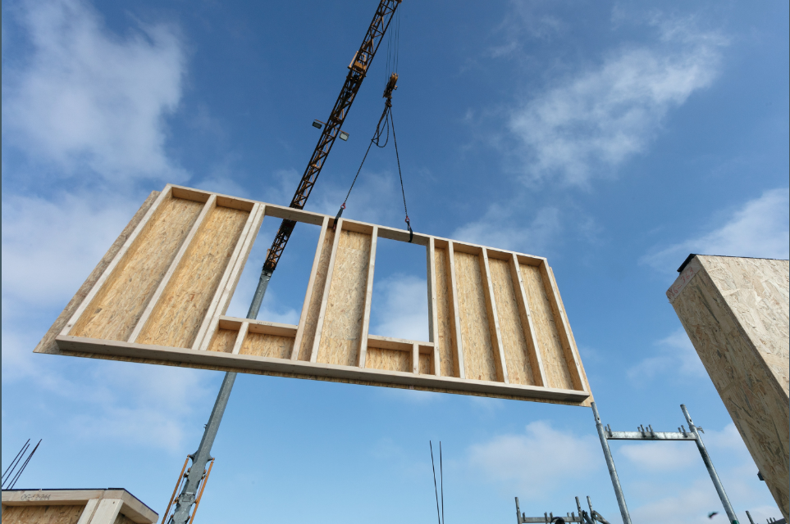 | The EGGER EcoBox in use as an innovative alternative in timber frame construction walls.
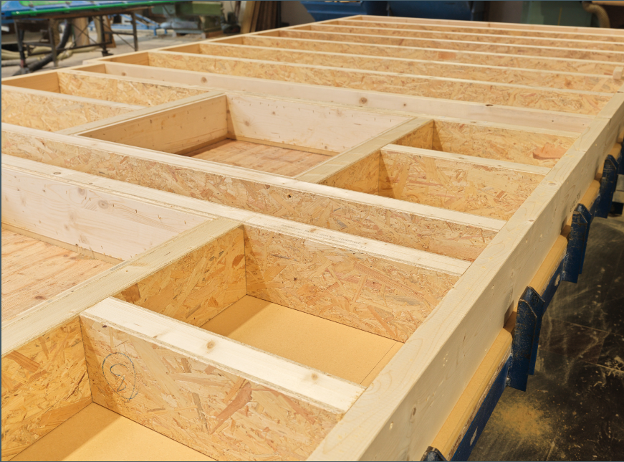 | With the EGGER EcoBox, exact and dimensionally stable wood components are created in a modern, precise production process.
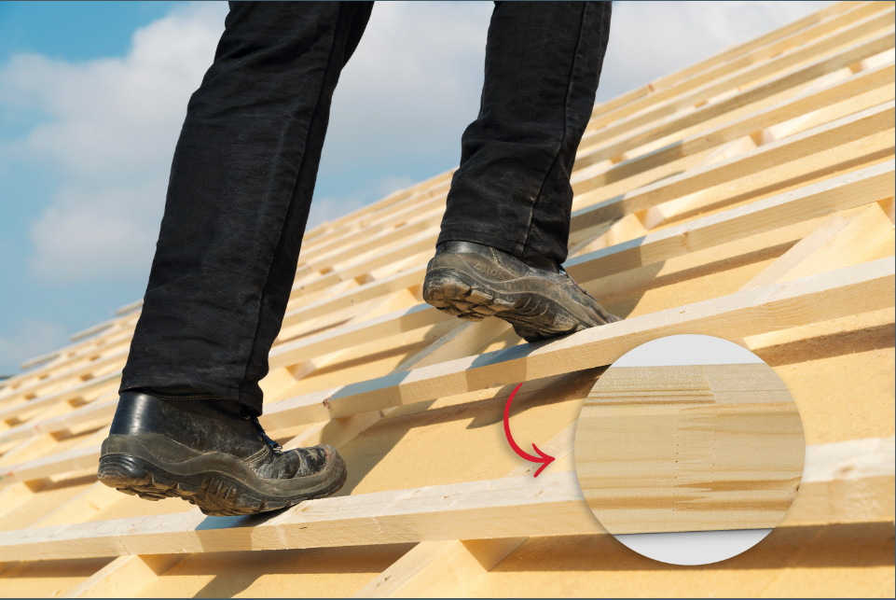 | Finger-jointed EGGER roof battens offer even more safety.
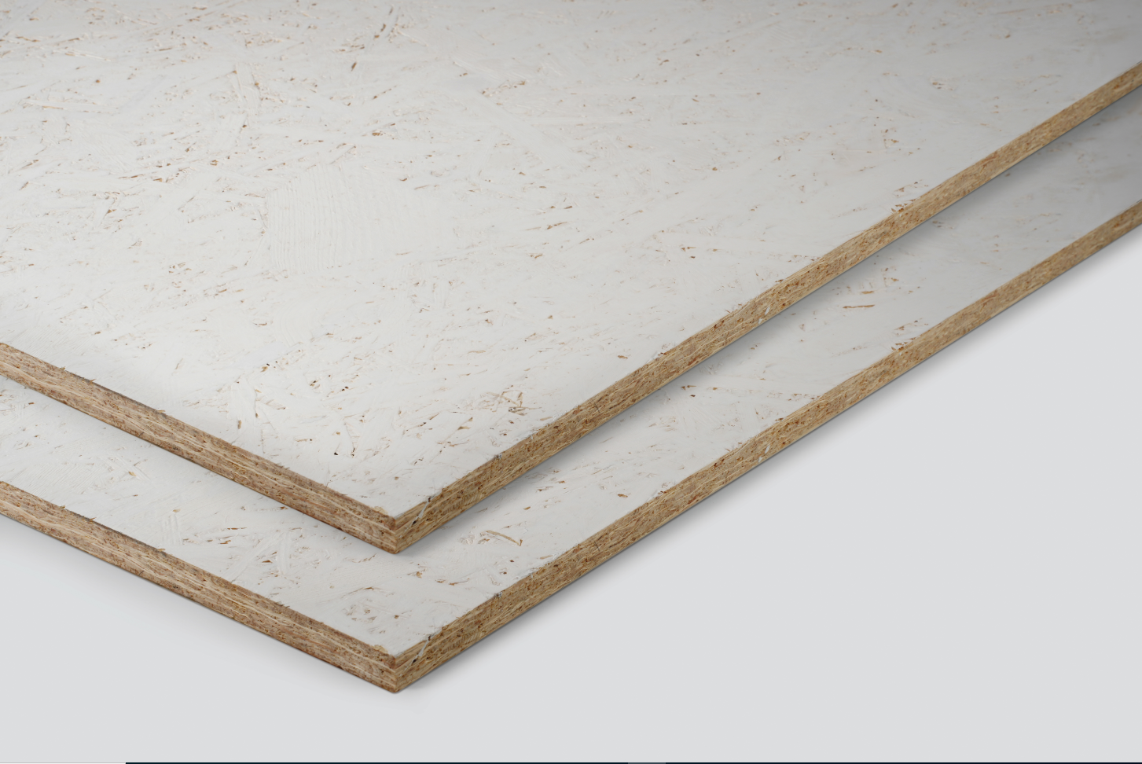 | The fire protection coating of the OSB Flammex ensures fulfilment of the strict EU classification B-s1, d0 of building and furnishing materials in accordance with the European standard EN 13501-1.
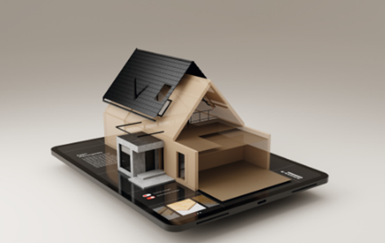 | EGGER not only offers a wide selection of building products for a wide range of applications, but also helpful digital services such as the planning support.

PHOTOS: EGGER Holzwerkstoffe, reprints that quote the name of the copyright owner are free
REPRODUCTION: All our mentioned decors are reproductions.
Image download: https://celum.egger.com/pinaccess/showpin.do?pinCode=DWwhenwPeHUN

For queries:

EGGER Holzwerkstoffe Wismar GmbH & CO.KG
Ulrike Brosius
Am Haffeld 1
D-23970 Wismar
Tel: +49 3841 301 21284
Fax: +49 3841 301 61284
ulrike.brosius@egger.com

