EGGER starts construction of an office building in Lexington, North Carolina
In July of last year, the EGGER Group announced that it would build a wood-based material factory in Lexington, North Carolina. A first step has been taken with the ground-breaking ceremony for the office building on site. In early 2019, around 80 administrative employees will be able to move into their new workplaces. The wood-based material manufacturer is planning to start the construction of the production plant at the end of 2018.
The modern office building, which is expected to be completed in early 2019, will house EGGER’s North American future office staff. In addition, EGGER plans to set up a training centre there to train and promote local professionals. At the same time, the company's own building offers the opportunity to present EGGER products and services to architects, designers, retail and furniture industry customers.
The administrative building also forms the basis for the future production plant. During the first phase of the project, EGGER will build a chipboard plant with coating capacities in Lexington, NC. This first phase involves an investment volume of approximately EUR 260 million and will create 400 direct jobs over the next six years. The start of construction of the production plant is planned for the end of 2018. Production in the future plant is scheduled to start in 2020.
The North Carolina plant will have ultramodern facilities for making laminated chipboard and will allow EGGER to better serve its customers in North America. EGGER’s previous distribution activities in the USA and Canada have already clearly shown that the range of products, the quality, and the price structure of the product portfolio are very attractive for architects, designers, wholesalers, and industry customers. The planned production plant in Lexington, North Carolina, will enable EGGER to increase its presence in the North American wood-based materials market, ensuring product availability for its customers and increasing delivery speed.
About EGGER
The family company, founded in 1961, employs approximately 9,000 people. In 18 plants across the world, they produce an extensive product range of wood-based materials (chipboard, OSB, and MDF board) as well as timber. The company generated a turnover of EUR 2.38 billion in the 2016/2017 financial year and has worldwide customers in the furniture industry, wood and flooring retailers, as well as DIY markets. EGGER is a full-range supplier for the furniture and interior design industry, for wood construction, as well as wood-based flooring (laminate, cork and design flooring) industries.

Groundbreaking ceremony for EGGER office building in Lexington, NC, USA

- Office building with 80 workplaces should be completed by early 2019  - Office workstations, customer and training centre, and basis for future production operation | - Planned start of construction for the production plant: end of 2018, commissioning 2020  - approx. EUR 260 million investment volume  in the first phase

Captions
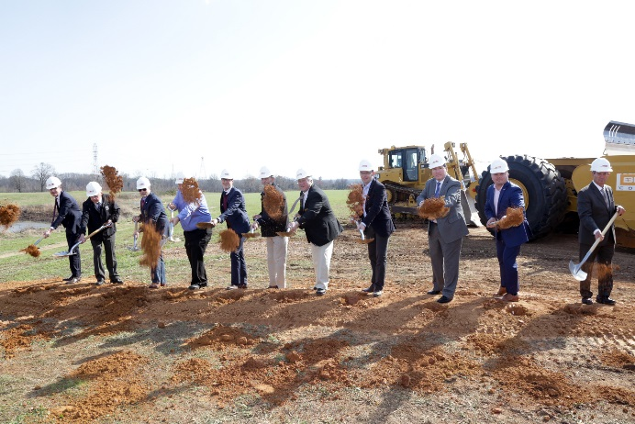 | The EGGER project team and members of the Davidson County community gather to celebrate the groundbreaking of EGGER’s U.S. Corporate Office Building.  (L-R) Mario Bobsin (EGGER), Davidson County Board of Commissioners (DCBC) Chairman Don Truell, DCBC Commissioner Lance Barrett, DCBC Vice Chairman Todd Yates, Karl Grasser (EGGER), NC Representative Larry Potts, DCBC Vice Chairman Steve Shell, Bernhard Vorreiter (EGGER), DCBC Commissioner Zak Crotts, DCBC Commissioner Steve Jarvis
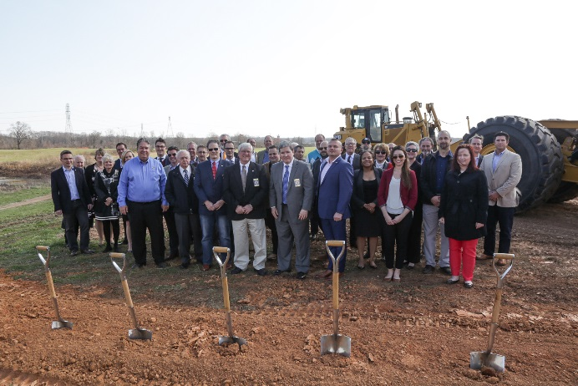 | The EGGER U.S. project team with representatives from Davidson County and the Economic Development Commission at the groundbreaking ceremony
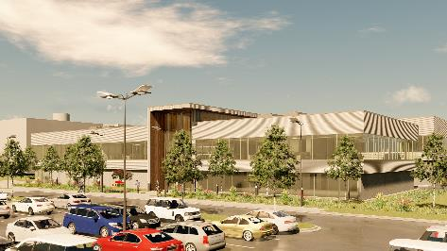 | Visualization of the EGGER administrative building in Lexington, North Carolina
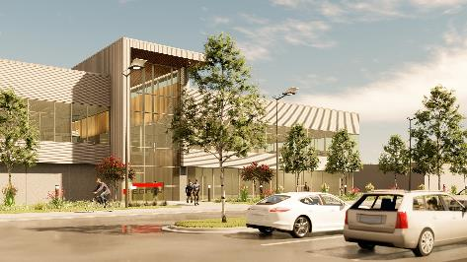 | Visualization of the EGGER administrative building in Lexington, North Carolina
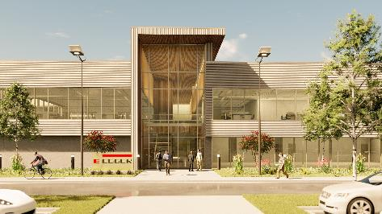 | Visualization of the EGGER administrative building in Lexington, North Carolina

PHOTOS: EGGER Holzwerkstoffe, photocopy when naming the copyright owner free of charge
Picture download: https://celum.egger.com/webgate/pin.html?lang=en&pin=9CMBC9W1T5DM

For queries:

FRITZ EGGER GmbH & Co. OG
Holzwerkstoffe
Manuela Leitner
Weiberndorf 20
6380 St. Johann in Tirol
Austria
T +43 5 0600-10638
F +43 5 0600-90638
manuela.leitner@egger.com
www.egger.com

