Making building with wood simple and efficient
EGGER Group establishes new Building Products Division
Wood is becoming increasingly important as a sustainable building material. Renovation pressure and densification in urban areas, a shortage of skilled workers in the trades and resource issues mean both potential and challenge for the industry. EGGER is responding to this with its own organisational unit, the EGGER Building Products Division. It is led by CEO Ulrich Weihs.
In order to be best positioned for further growth in the core market of Europe and beyond, and to develop sustainable solutions for the pressing residential and commercial construction issues of our time together with wood construction customers, the EGGER Group is bundling the production and marketing of building products in the new division. It comprises all activities of the OSB plants in Wismar (DE) and Radauti (RO) as well as the sawmill in Brilon (DE) and the worldwide marketing of the OSB, DHF product groups.
The EGGER Building Products Division is headed by Ulrich Weihs (CEO). He will be succeeded by Georg Lingemann, CEO of the sawmill in Brilon (DE). Also on the management team of the new EGGER Building Products Division are Andrea Kempen (Finance/Administration), Jost Börger (Sales DACH), Jürgen Schaffer (Sales Eastern Europe & Scandinavia), Moritz Steinruck (Product Management) and Christian Moßhammer (Marketing). Together with the management of the OSB plants in Wismar and Radauti and more than 460 employees working in the division, they will develop system solutions for building with wood, create further finishing options for building products and strengthen synergies between the sites.
Focus on serial construction and system solutions
"Building products made of wood and wood-based materials have a great future," CEO Ulrich Weihs is convinced. "They are sustainable building materials that grow back in a climate-neutral way. Our aim is to develop innovative system solutions for wood construction that can be manufactured industrially and that spare the precious resource wood. The EGGER Building Products Division will contribute to making building with wood simple and efficient."
With the organisation operational as of 1.5.2021, the EGGER Group now consists of six divisions, structured according to product categories and regions: EGGER Decorative Products West, Central, East and Americas, EGGER Flooring Products and EGGER Building Products.

About EGGER
The family company founded in 1961 employs around 10,100 people. In 20 plants across the world, they produce an extensive product range of wood-based materials based on chipboard, OSB, and MDF board, as well as timber. EGGER has global customers in the furniture industry, wood construction and building materials specialist trade, as well as DIY markets. EGGER products are found in countless areas of private and public life including: kitchens, bathrooms, offices, living rooms and bedrooms. EGGER is a full-range supplier for the furniture industry and interior design, wood construction and laminate flooring sectors.

New EGGER Building Products Division

- 3 plants: OSB plants in Wismar (DE) and Radauti (RO), sawmill in Brilon (DE)  - EGGER has been producing OSB since 2000, timber since 2008. | - Capacities:  880,000 m³ OSB  >20,000 m³ DHF  550,000 m³ timber  - Approx. 460 employees

For queries:

FRITZ EGGER GmbH & Co. OG
Holzwerkstoffe
Manuela Leitner
Weiberndorf 20
6380 St. Johann in Tirol
Austria
T +43 5 0600-10638
F +43 5 0600-90638
manuela.leitner@egger.com

Captions
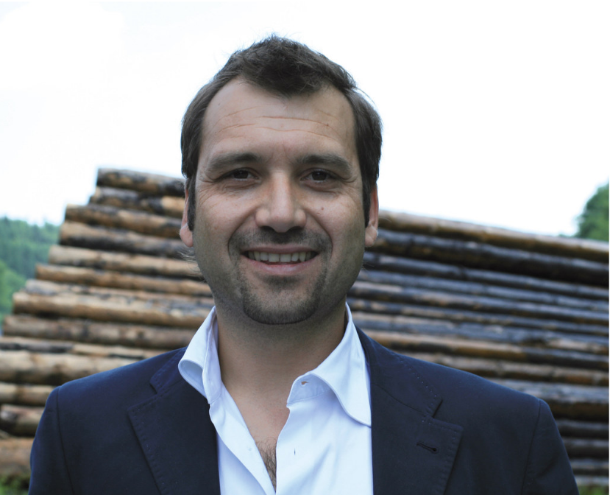 | Ulrich Weihs is CEO of the new EGGER Building Products Division.
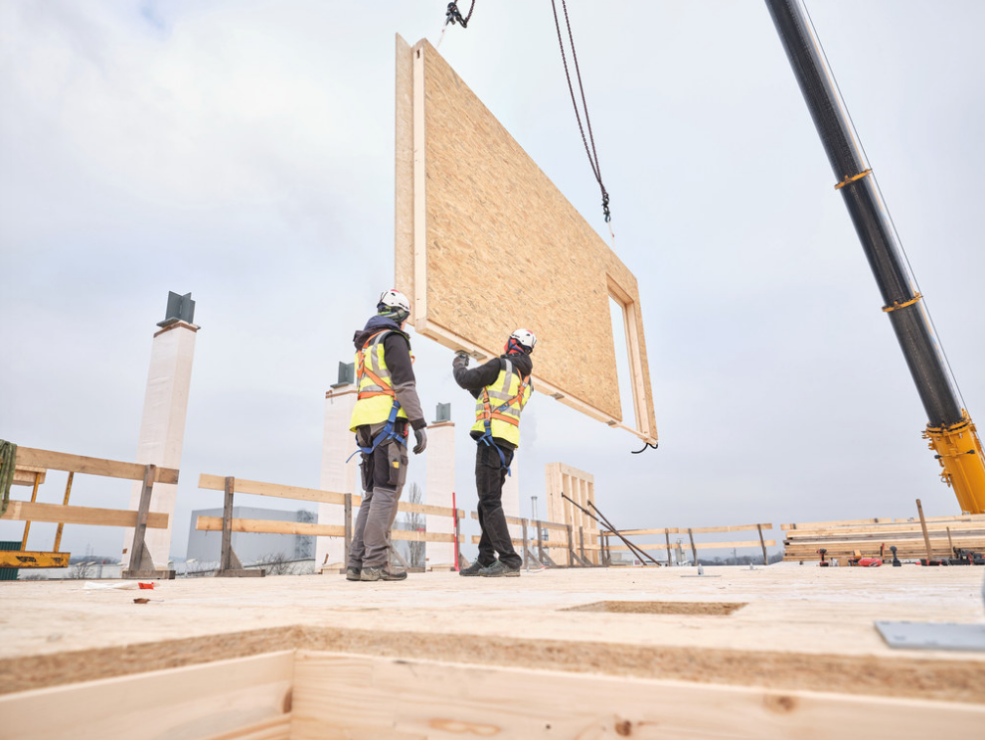 | EGGER Building Products offer system solutions for private and commercial wood construction.
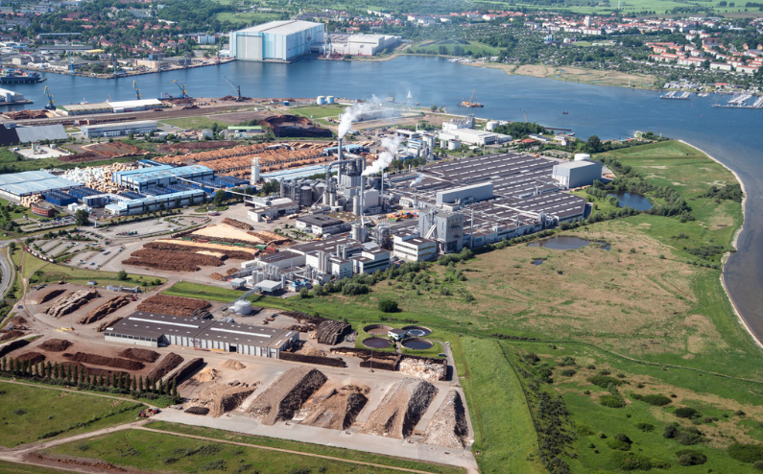 | OSB plant Wismar (DE)
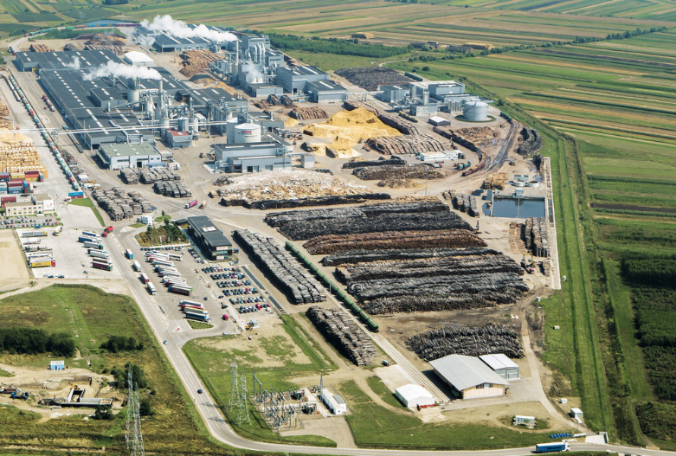 | OSB plant Radauti (RO)
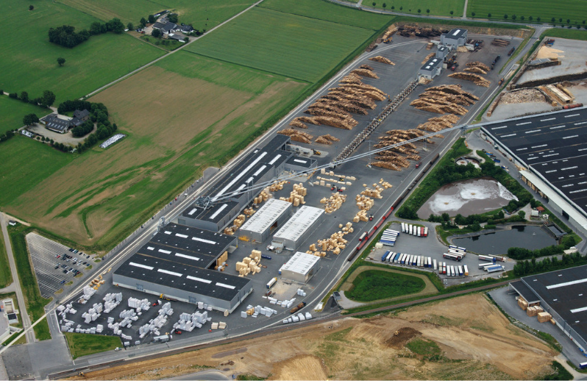 | Brilon sawmill (DE)

PHOTOS: EGGER Holzwerkstoffe, reprints naming the copyright owner are free of charge
For download: https://fritzegger.sharefile.eu/d-sb01fc97b8fc54297af06146ce58e3b79

