More variety with PerfectSense® Lacquered Boards
EGGER continues to develop its matt and high-gloss surfaces.
PerfectSense is a range that has been impressing the industry for more than five years with its visual and haptic properties as well as quality. But the wood-based materials manufacturer EGGER is not resting on its previous success: It is continuing to develop the popular matt and high-gloss PerfectSense Lacquered Boards so that customers can use them to set new standards in the design of furniture and interior fittings.
Since the market launch in 2015, PerfectSense Matt and Gloss MDF Lacquered Boards have been delighting the furniture industry, architects, fabricators and end customers with their elegant look, pleasant feel and durability. The wood-based materials specialist EGGER has enhanced the quality of its PerfectSense Lacquered Boards for high-quality furniture and room concepts: PerfectSense Matt has become Premium Matt and PerfectSense Gloss Premium Gloss. Both variants can now be used in an even greater variety of ways. "Due to the worldwide success and the continuing trend of matt surfaces, we have further developed our well-known matt and high-gloss Lacquered Boards. They now also show off their advantages on horizontal surfaces," says Hubert Höglauer, Head of Marketing and Product Management Furniture and Interior Design in the EGGER Group.
Premium Matt: Now also for horizontal applications
With the PerfectSense Lacquered Boards in Premium Matt (PM), EGGER is making a statement in the trend for matt surfaces. For customers, there are new advantages in planning and processing, as Hubert Höglauer knows: "The innovative lacquer system has noticeably optimised the micro-scratch and scratch resistance of our matt Lacquered Board. As a result, we are extending the range of applications for this product to horizontal surfaces, such as tables, counters and shelves." The anti-fingerprint property of Premium Matt reduces cleaning effort, as virtually no fingerprints remain on the surface. This is particularly advantageous for trendy dark decors.
Premium Gloss: Brilliance at a new level
PerfectSense Premium Gloss Lacquered Boards (PG) are distinguished by their timeless elegance. The further development Premium Gloss emphasises the mirror finish as well as the brilliant reflective nature to contributes to the visual enlargement of any room. The surface properties now also extend the areas of application of Premium Gloss: Less stressed horizontal surfaces, such as sideboards, can now also be implemented in a high gloss.

Perfectly matched
EGGER's portfolio includes matching ABS edges and PMMA accent edges for visually exciting designs for all PerfectSense Lacquered Boards in Premium Matt and Premium Gloss. To complete the matt or high-gloss look, PerfectSense Topmatt or HighGloss laminates are available. The new PerfectSense Topmatt worktop with edging can be used for consistent matt kitchen designs. "In this way, we offer the right product solution for all design ideas in a sophisticated matt or gloss finish," says Hubert Höglauer.

More variety with PerfectSense® Lacquered Boards

- Micro-scratch and scratch resistant (PM): Resistant to micro-scratches, such as those that can occur during cleaning; the matt surface also withstands coarser scratches.  - Use of Premium Matt now also on horizontal surfaces such as tables, counters and shelves; Premium Gloss can be used for less stressed horizontal surfaces such as sideboards.  - Anti-fingerprint property of Premium Matt: Virtually no fingerprint residue on matt surfaces; reduced cleaning effort; especially beneficial for dark decors. | - Matt and velvety warm look and feel with Premium Matt, mirror finish and reflective nature with Premium Gloss.  - Antibacterial surface property according to ISO 22196 (=JIS Z 2801)  - Insensitive to conventional stains.  - Resistant to many cleaning agents.  - Resistant to heat and moisture.  - Sustainable MDF coreboard with 87 % material from renewable resources.

Captions
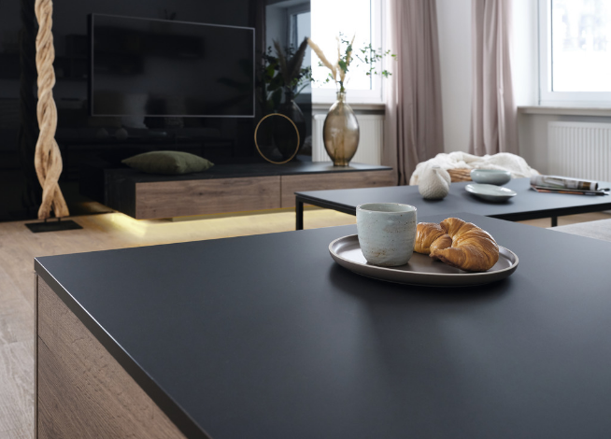 | Thanks to the improved surface properties, PerfectSense Lacquered Boards in Premium Matt can now be used for horizontal surfaces.
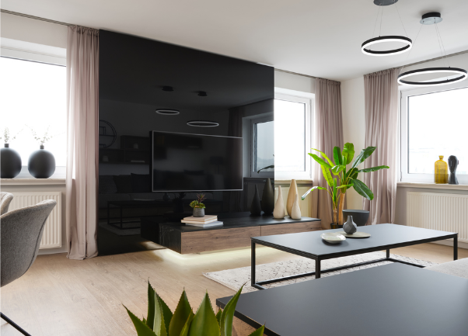 | PerfectSense Lacquered Boards in Premium Gloss impress with their elegant mirror finish and reflective nature. In the new quality, they can also be used on less stressed horizontal surfaces, such as sideboards.
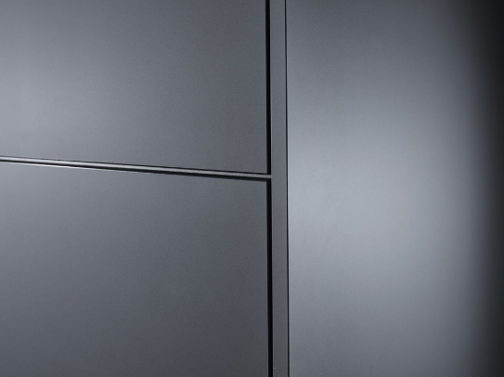 | Thanks to the anti-fingerprint property of Premium Matt, fewer fingerprints remain and cleaning is reduced.
PHOTOS: EGGER Holzwerkstoffe, reprints naming the copyright owner are free of charge
REPRODUCTION: All our mentioned decors are reproductions.
Picture download: https://celum.egger.com/pinaccess/showpin.do?pinCode=Vn6qymp0DCIx

For queries:

FRITZ EGGER GmbH & Co. OG
Holzwerkstoffe
Karin Mumelter
Weiberndorf 20
6380 St. Johann in Tyrol
Austria
T +43 5 0600-10961
F +43 5 0600-90691
karin.mumelter@egger.com

