EGGER plant Unterradlberg will in future supply district heating for the city of St. Pölten
With the signing of the heat supply contract with EVN, a pioneering energy project is getting under way: from the end of 2027, renewable heat from the EGGER particleboard plant will be fed into the district heating network of St. Pölten.
Together with the energy supplier EVN and the city of St. Pölten, the wood-based material manufacturer EGGER is implementing a project to modernise the energy supply at its plant in Unterradlberg (AT). EGGER is investing specifically in its local energy infrastructure for this purpose. The positive effects extend beyond the plant boundaries: in future, the plant will be integrated into the city's district heating supply. On 18 June 2026, the project partners signed the heat supply contract, thereby officially setting the starting point for this pioneering project. The first heat delivery is planned for the end of 2027.
"Over the past few years, we have invested massively in renewable energy supply at our plant in several stages. In two biomass power plants, we generate renewable electricity and heat from biogenic fuels for our own processes. We produce at our plant in normal operation without natural gas and are already supplying heat to the neighbouring companies Egger Getränke and Sunpor Kunststoff GmbH. We are pleased that we can now take the next step as part of a comprehensively conceived regional energy concept and will soon be able to supply district heating to the city of St. Pölten,” says Martin Wurzl, EGGER Plant Director Technical/Production.
“Since 2009, we have been supplying the state capital St. Pölten via our 30 km transport pipeline from Dürnrohr with sustainable waste heat from the waste treatment plant. This year, our biomass heating power plant in St. Pölten also went into operation. With the heat partnership now finalised for feeding in industrial heat, we are setting another important building block for an efficient, secure and environmentally friendly district heating supply for the state capital,” explains EVN Executive Board spokesman Stefan Szyszkowitz.
Technical innovations
At the heart of the investment plan is a new steam turbine that will be installed at the EGGER plant in Unterradlberg. It will generate around 4.77 megawatts (MW) of electricity for the EGGER plant from the steam from biomass boiler 1. This will raise the proportion of electricity generated on site to around 87%. The resulting exhaust steam will then be used for district heating. In addition, a new heat pump will feed heat into the district heating network using the turbine exhaust steam from the existing turbine 2 from biomass boiler 2.
The fuels used will be for example wood dust from our own production, wood waste and biogenic production residues that can no longer be used as materials. In total, around 10 MW of hot water are to be delivered into the district heating pipeline during the winter months, which corresponds to around 10% of the heat demand of district heating customers in St. Pölten. It is particularly noteworthy that this additional benefit is achieved without a higher fuel input, meaning the overall efficiency of the energy facilities can be significantly increased. A key advantage: in this way, the use of natural gas in district heating network operations can be further reduced and replaced by heat from renewable energy.
Strong partnership for the region
A project of this size can only succeed with good and strategic partners. A viable energy concept was developed in close cooperation with EVN and the city of St. Pölten. The district heating pipeline runs close to the EGGER plant, and a transfer point has already been planned. EVN is taking over the connection to the existing network and is building the necessary infrastructure from the transfer point at the power plant to the existing district heating pipeline. This integrates the heat generated efficiently into the city’s supply system. The project schedule provides for EGGER’s first heat delivery in the 4th quarter of 2027.
Positioning within EGGER’s climate strategy
EGGER pursues a clearly defined climate strategy with the goal of reducing its climate-impacting greenhouse gas emissions in line with the Paris Climate Agreement. The company is committed to the Net Zero target by 2050. To achieve this, comprehensive measures are being implemented, with a focus on decarbonising the energy supply of its own plants. The development of site-specific energy projects fits into this long-term approach.
The project in Unterradlberg combines numerous positive aspects: more self-generated electricity from renewable sources at the EGGER plant, no additional fuel requirements, more efficient use of existing energy, and connection to the district heating network of the city of St. Pölten. In this way, it makes an important contribution to the future-proof energy supply of the region.

EGGER plant Unterradlberg will in future supply district heating for the city of St. Pölten

- EGGER invests in a forward-looking energy project  - Technical innovations at the EGGER plant: new turbine and heat pump | - This means more self-generated electricity and capacities for district heating supply  - Integration into the St. Pölten district heating network  - First heat delivery planned for the end of 2027

About the EGGER Group
The family company, founded in 1961, is a leading international manufacturer of wood-based materials with approximately 12,000 employees and 22 production plants worldwide. EGGER is a full-range supplier for furniture and interior design, for wood construction and for wood-based flooring, making it a reliable partner for the furniture industry, wood and flooring distributors and DIY stores. In the 2024/2025 financial year, the EGGER Group generated a turnover of EUR 4.13 billion.
As a family company, EGGER is committed to long-term corporate development and growth based on its own performance. Sustainability aspects are firmly embedded in the company’s strategy. EGGER aims to gradually reduce its climate-impacting greenhouse gas emissions and achieve Net Zero by 2050. Already today, 71% of the energy used within the Group comes from renewable sources. 66% of the wood used in wood-based material production across the Group comes from recycled wood and sawmill by-products. In this way, EGGER is constantly working towards its objective of creating “More from the valuable resource wood”.

EVN’s natural heat supply
The use of renewable energies has been of great importance to EVN for many years, particularly in the heat sector. Together with partners from agriculture and the sawmill industry, EVN already operates around 80 biomass plants across Lower Austria and parts of Upper Austria. Around two thirds of the municipal district heating supplied is generated from biomass.
Through EVN’s close cooperation with regional agriculture and forestry, value creation remains in the region. EVN relies on regional biomass and works only with Austrian partners. With the use of around 3.0 million loose cubic metres of hackchips, EVN is the largest natural heat supplier from biomass in Austria. In addition, EVN is working on further technologies such as power-to-heat plants, solar thermal energy and deep geothermal energy in order to put heat supply in Lower Austria on an even broader footing.

Captions
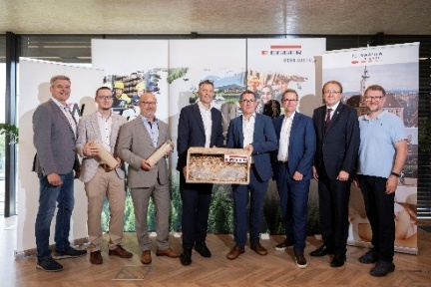 | The project partners are presenting a forward-looking energy project. From left in the picture: Anton Waxenegger (Managing Director Fernwärme St. Pölten), Stefan Steigenberger (Project Manager EGGER), Karl Flor (Head of Project Development EVN Wärme), Hannes Mitterweissacher (Chief Technology Officer EGGER), Martin Wurzl (Plant Director Technical/Production EGGER), Stefan Szyszkowitz (Spokesman of the EVN Executive Board), Matthias Stadler (Mayor of St. Pölten), Franz Gruber (Managing Director Fernwärme St. Pölten)  © EVN - Matejschek
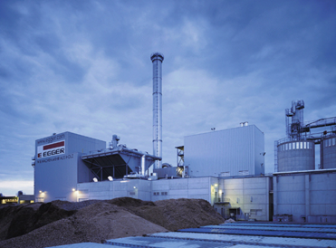 | The EGGER Unterradlberg plant already has two biomass power plants and, in normal operation, produces without natural gas.
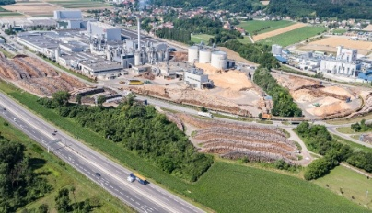 | The next energy project will bring benefits not only for the Unterradlberg plant, but for the region through its integration into district heating.
PHOTOS: EGGER Holzwerkstoffe, reprints that quote the name of the copyright owner are free
REPRODUCTION: All our mentioned decors are reproductions.
Image download: https://celum.egger.com/pinaccess/showpin.do?pincode=a3j5mi3ipero

For queries:
EGGER Holzwerkstoffe GmbH
Katharina Wieser
Weiberndorf 20
6380 St. Johann in Tirol
Austria
T +43 5 0600- 10128
katharina.wieser@egger.com

