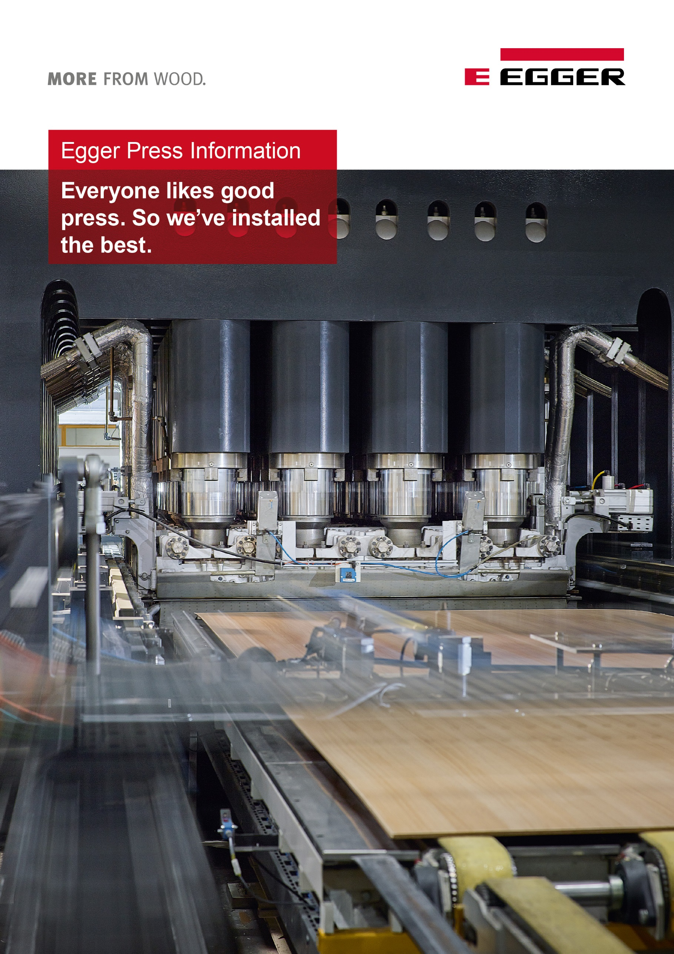

Your contacts

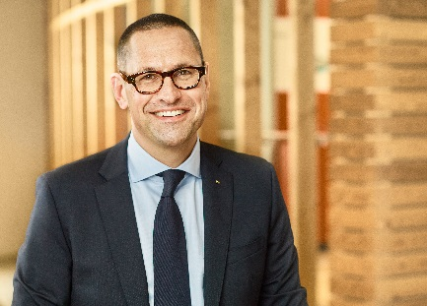 | 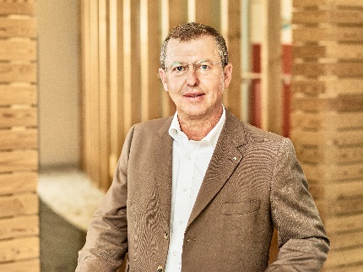 | 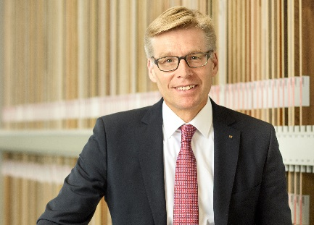
Dr. Thomas Leissing  Head of Finance/  Administration/Logistics  EGGER Group;  Spokesman of the Group Management | Walter Schiegl  Head of Production/Technology  EGGER Group | Ulrich Bühler  Head of Sales/Marketing  EGGER Group

For queries:

FRITZ EGGER GmbH & Co.
Holzwerkstoffe
Manuela Leitner
Weiberndorf 20
6380 St. Johann in Tirol
Austria
T +43 5 0600-10638
F +43 5 0600-90638
manuela.leitner@egger.com
The EGGER Group is growing: Stable results for the business year 2016/2017, big plans for the future
The wood-based material manufacturer recorded EUR 2.38 billion sales and EUR 363.7 million EBITDA for the business year 2016/2017.
During the annual press conference, which took place on 27th July 2017 at the headquarters in St. Johann in Tirol, the EGGER Group presented a positive development of key indicators. The Group sales (+1.7%), as well as the EBITDA (result before interest, taxes and depreciation) (+4.0%) once again reached record levels for the company’s 56-year history. At the same time, the Group Management forecast even stronger growth for the coming years and announced significant investments in Poland, Argentina, and the USA.
The EGGER Group set new records in its annual results for 2016/2017. The sales increased during the business year 2016/2017 by +1.7% to reach EUR 2,384.8 million. The EBITDA increased by +4.0 % to reach EUR 363.7 million. The EBITDA margin exceeded previous years’ levels by 15.3 %. The family business continues to enjoy a good credit rating thanks to a high equity ratio of 37.5 %. The quantity of rawboards, incl. timber, increased to 7.9 million m³ (+3 %), which means the full utilisation of all primary production capacities. On average last year, EGGER employed 8,145 employees group-wide.
Positive development in almost all regions
“Europe’s economy has recovered and the European construction industry is once again on a solid growth course,” summarises Thomas Leissing, spokesperson of the Group Management and in charge of Finances, Administration, and Logistics. Demand was high particularly in Austria, Germany, Central and Eastern Europe. Positive sales developments were achieved and the market share was developed in almost all regions across the world. Despite uncertainties following the Brexit vote, the overall development over the past twelve months was positive in Great Britain. Diminished sales and earnings are due exclusively to a weaker British Pound. The tense political and economic situation in Turkey led to lower local sales of edging, which, however, was largely compensated through exports.

Biggest gains in decorative products
EGGER is extremely happy with the developments in the area of Furniture and Interior Design (EGGER Decorative Products), which represented the largest sales share with 75.6%. The market launch of the EGGER Decorative Collection 2017-2019 and its début at the BAU trade fair in January 2017 in Munich were very successful. The sales of EGGER’s Decorative Products reached EUR 1,906.9 million, an increase of +2.0%. Increasing sales in markets in Austria, Germany, Romania, and Russia, primarily via the new MDF production facility in Gagarin (RU), are countered only by decreased sales in Great Britain and Turkey. A large part of these setbacks are due to weak local currencies.
The Flooring sales (EGGER Retail Products) are stable at the previous year’s level with EUR 330.5 million (-0.2%). On the one hand, the activity of the low-profit flooring markets was reduced and the focus moved to higher value goods. On the other hand, the new flooring production in Gagarin (RU) is becoming established on the market. The sales of laminate flooring in Russia and the CIS countries will be pushed further in the coming years. For Building Products (EGGER Building Products), the sales of EUR 284.4 million remained largely stable at the previous year’s level (-1.2%), despite a weak market and high price pressure for OSB and timber.
Investments: EUR 260 million last year
Under the EGGER motto “Sustainable international growth”, investments in property and intangible assets as well as acquisitions of EUR 259.2 million were posted during the business year 2016/2017 (previous year: EUR 302.7 million). Out of this amount, EUR 64.3 million was spent on maintenance investments and EUR 194.9 million on growth investments. A large part went into completing the MDF/HDF production facility including additional coating lines as well as flooring production in our Gagarin plant (RU). Other significant parts went into the two plants in France, where energy supply was renewed, and investments were made in maintenance and logistics. Central growth investments were made in several plants in Germany, Austria, and Great Britain.
First non-European plant in Argentina
EGGER will be busy taking big steps towards further growth during the current business year 2017/2018 and well beyond. On 17th July 2017, the EGGER Group announced it is taking over the plant Concordia, Argentina, from the Chilean Masisa S.A. This will be the first time EGGER is represented with a production site outside Europe. “Our own production plant in the South-American growth markets is a precondition for capturing the market potential of the region”, explains Thomas Leissing the strategy. “We want to become a key market player in South America. Through our distribution office in Chile, we’ve already gathered first experiences of the South-American market. But without our own manufacturing capacities we would be relegated to a niche existence.
The plant in Concordia has facilities for the production and lamination of chipboard and MDF boards. In 2016, it recorded production capacities of 165,000 m³ chipboards,
280,000 m³ MDF boards and 274,000 m³ lamination. Alongside the plant and its distribution, EGGER will also take over the established Masisa Placacentro Argentinian dealer network, which is independently run by 42 partners. EGGER will take over the approximately 500 employees of Masisa in Argentina and offer them a transparent future.
Start of construction for chipboard plant in Poland
The already announced new construction of a chipboard plant in Biskupiec, Warmia-Masuria, in the north of Poland, will start soon. The levelling works on the 85 ha site have already been completed. The construction will start in the coming weeks, as soon as we have obtained all necessary permits. The new wood-based materials plant will use the latest technology and will be equipped with a raw chip capacity of 650,000 m³, lamination and impregnation units.
“We hope construction and installation will go smoothly, and expect to commission the new facility towards the end of 2018”, says Walter Schiegl, EGGER Group Management Technology/Production. The total investment is approximately EUR 250 million. The recruiting process has also already started. 400 direct and approximately 600 downstream jobs will be created in Biskupiec thanks to the new EGGER plant.
USA: Greenfield project being planned, distribution centre starting in October
Another greenfield project is currently in the early planning stages. Together with the Governor and representatives of local authorities, EGGER has recently announced its intention to build a wood-based materials plant in Lexington, North Carolina. The project implementation is scheduled to take place in several stages, the first being the construction of a chipboard plant with coating capacities. Assuming all agreed framework conditions are fulfilled and the relevant permits are obtained, construction should start by the end of 2018. The first project phase involves an investment volume of approximately EUR 260 million and will create 400 direct jobs.
A proprietary production location in the USA opens the way for the EGGER Group to enter the growing US market. “Our long-term objective is to become the leading brand for wood-based solutions in America”, explains Ulrich Bühler. EGGER is already taking the first step by setting up a distribution centre near Detroit, Michigan. In October 2017, the warehouse will start operation and provide our US customers with better availability of EGGER products, as well as higher levels of competitiveness. “Via our distribution activities, we already know that our range of products are very interesting for architects, designers, retailers and industrial customers. We are able to respond to this demand with simplified access and shorter delivery times”, concludes Bühler.
Very positive outlook for 2017/2018
Given all these large projects, the EGGER Group has very positive expectations for the future. EGGER expects the revenue and results to continue growing in the current business year, which started in May. The reason is the positive development in Europe and Russia. Expectations for the EGGER Decorative Products division in particular are positive across the Group. In Western and Eastern Europe, a stable and slightly increasing development is expected for EGGER Retail Products. The newly built flooring capacity in Gagarin (RU) will reinforce sales possibilities in Russia and the neighbouring CIS space. The expected increase in the demand for EGGER Building Products, despite continued OSB overcapacities, will slowly lead to a relaxation of the price pressure, which means that growth is also forecast here.
More significant uncertainties may result from further developments regarding the political tensions in the Ukraine/Crimea conflict, in Turkey and the Middle East, the impact of the Brexit vote, as well as the terrorism threat and migration in Europe, which are both difficult to estimate. In this context, current internationalisation efforts outside Europe also mean market diversification and thus a secure future for the entire EGGER Group and its employees. “The integration of the Argentinian plant Concordia and the implementation of the greenfield projects in Poland and North Carolina will definitely represent great challenges for the company, but we are ready for them. Anyone who knows us will recognise that our growth strategy is conservative. We are committed to moderation and ensured that every step the organisation makes is viable. At the same time, it is important for us to create a secure future for all employees”, concludes Leissing.

The EGGER Group is growing: Stable results for the business year 2016/2017, big plans for the future
- Sales: EUR 2.38 billion (+1.7 %)  - EBITDA: EUR 363.7 million (+4.0 %)  - Investments: EUR 259.2 million  - 8,145 employees in 2016/2017 (year’s average)  - EGGER’s first proprietary production site outside Europe: Takeover of the plant Concordia, Argentina, from the Chilean Masisa S.A. | - EGGER’s new wood-based materials plant in Biskupiec, Poland, with a raw chip capacity of 650,000 m³, total investment volume of approximately EUR 250 million, is due to start in the next few weeks.  - EGGER plant greenfield project in the USA: approximately EUR 260 million investment in building a new plant in Lexington, North Carolina.

Captions
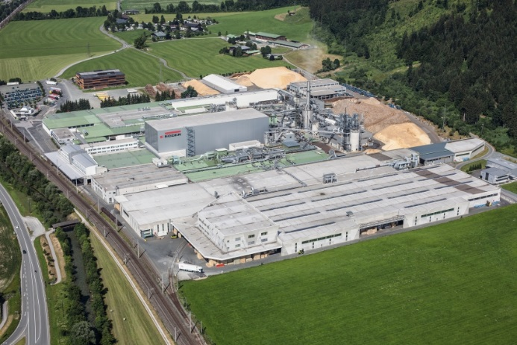 | The EGGER Group with headquarters in St. Johann in Tirol increased its sales during the financial year 2016/2017 by 1.7 % to reach 2.38 billion Euro.
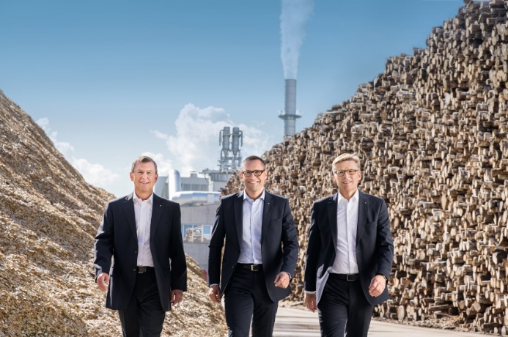 | The EGGER Group Management with Walter Schiegl, Thomas Leissing and Ulrich Bühler (from left) reported a positive business year and big plans for the future.
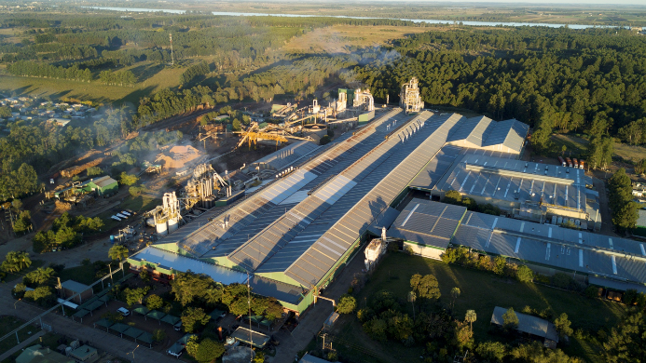 | On 17th July 2017, EGGER announced it is taking over the plant Concordia, Argentina, from the Chilean Masisa S.A. This will be the first time the wood-based material manufacturer is represented with a production site outside Europe.
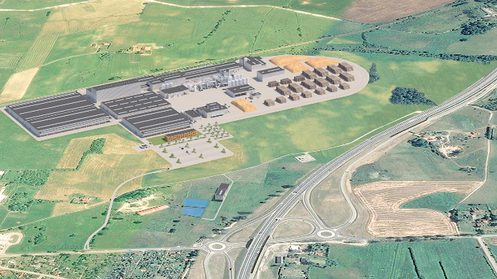 | The new EGGER plant in Biskupiec, Poland, will use the latest technology and it will be equipped with a raw chip capacity of 650,000 m³, lamination and impregnation units. Furthermore, EGGER creates 400 direct and approximately 600 downstream jobs.
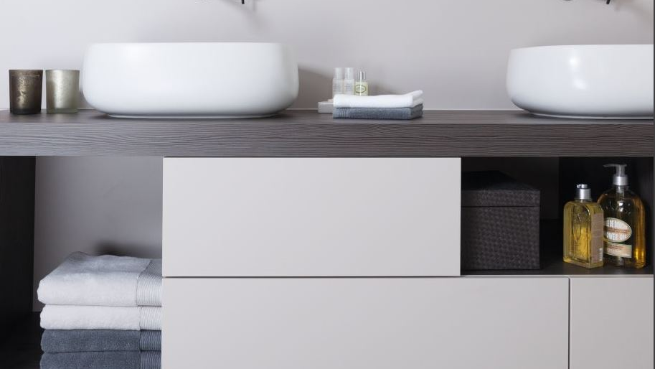 | EUR 1,906.9 million (+2%) were obtained in the division of Furniture and Interior Design (EGGER Decorative Products) during the business year 2016/2017.
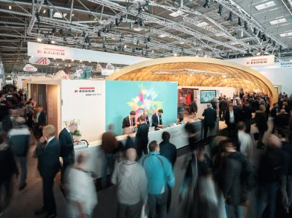 | The introduction of the EGGER Decorative Collection 2017-2019 as well as the trade fair presentations at the BAU 2017 in Munich and the Interzum 2017 in Cologne represented great successes for EGGER Decorative Products.
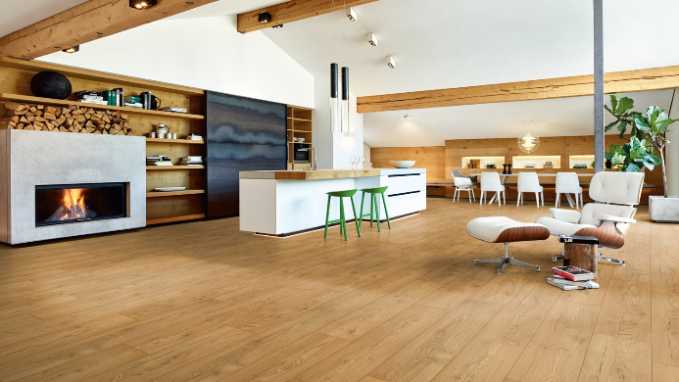 | The Flooring sales (EGGER Retail Products) are stable at the previous year’s level with EUR 330.5 million.
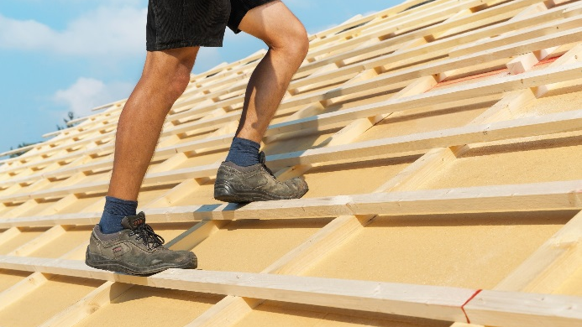 | Despite a weak market and price pressure for OSB and timber, the sales of Building Products (EGGER Building Products) remained largely stable at the previous year’s level with EUR 284.4 million.

PHOTOS: EGGER Holzwerkstoffe, reprints that quote the name of the copyright owner are free
IMAGE DOWNLOAD: https://celum.egger.com/webgate/pin.html?lang=en&pin=SGQEY9ONWGZ3

