Egger Press Information
July 2019

Designing Tomorrow’s Spaces Today

Material Lab, located on Titchfield Street in Central London, was the ideal venue, on Tuesday 25th June, for a stimulating panel discussion about the impact of biotechnology on the future development of materials, new ways of constructing buildings, the negative impact of continuing as we are now on society and the environment, and the growing concern of how all this affects our lives.

Hosted by EGGER, a world leading wood based panel manufacturer with one of its 18 state of the art facilities located in the North East of England, the event boasted an eminent panel of experts, chaired by Peter Murray, Chairman of New London Architecture, founder of Blueprint magazine and Wordsearch and much more.

Panel topics ranged from advocating an innovative approach to materials, the shift from industrial to ecological, using robots and machines to make new things, creating spaces for young people to develop ideas and new materials, to looking at biological systems to revolutionise business and manufacturing practices.

Self-styled maverick Raphael Gielgen, Trendscout Future of Work for furniture giant Vitra, started with two questions to set the tone. These were 1) What do you have to do to stay relevant to your company in 10 years? and 2) What does your company have to do to stay relevant in 10 years? From the discussions that ensued, expertly facilitated by Peter Murray, it was clear that the answer was simple. Change. Innovate. Listen.

Panellist Rachel Armstrong, Professor of Experimental Architecture at Newcastle University, leads a hub for biotechnology in the built environment, part of an EU innovation project. She spoke passionately about taking responsibility for the environment around us and working with living organisms to create new products and materials or to perform industrial tasks. Examples of this included using urine to charge mobile phones at Glastonbury, bio-electricity created in a composting environment with microns turning waste into electrons and the rise of bio-composites such as self-healing bio-concrete, where organisms are mixed into traditional material.

Ehab Sayed, Founder and Director of Innovation, Biohm and PhD Researcher at Northumbria University, added further revelations to this glimpse of a new world ahead, by showing the audience some of the new material his company is making from living organisms and waste products. Ehab and his colleagues are driven by a vision of mutual integration between the built and natural environment via a circular economy based on a clear ethos of mutual benefit and doing what is right for the planet. He wowed the audience with his new form of carbon-neutral insulation developed using the fungus mycelium which feeds on organic and synthetic waste to grow into desired shapes.

Both Rachel and Ehab are at the forefront of innovation in their fields and advocate that changing how we build our cities and lead our lives has to and will happen. Raphael Gielgun picked up the point that however desirable, change is restricted in the current construction industry because it is driven by giants, the big house builders and investment companies. It is hard to challenge the status quo but it has to be done. There are so many standards in the construction industry that have to be adhered to that it is hard for new products to break through the barriers. Raphael also criticised universities and design and architecture courses for not leading the way in terms of embracing change and shaping the architecture of the future.

Pannelist Leonne Cuppen, curator and founder of Yksi Connect, feels very strongly about giving our architects of the future the space and opportunity to develop new ideas and more sustainable products. Her work connects designers with industry, bringing all the parties together, focussing on social issues, sustainability, and circularity in relation to design. In her eyes, young people are highly connected with technology and motivated to make the world a better place in which to live. She called for big companies to work with young designers to create something new. She recognised how hard it is for big corporate organisations to change but feels optimistic it can happen. Raphael mentioned EGGER’s headquarters in San Johann, Austria, as a fine example of a large company that has sustainability at its heart, suggesting to the audience that they should visit to see for themselves.

The event finished off with some pertinent questions from the audience about the ethics of bio-technology and also the difficulty for architects to specify new products and materials that don’t meet construction standards. The final question touched on the lifespan of things in a throw-away society. It led to further discussion about making products that last a long time, and whether we should instead be looking to create products that are temporary but also don’t need recycling.

The evening’s discussion was succinctly summarised by Peter Murray. We need to think more and find out more about biological systems. He mentioned Rachel’s comment about a chair that is not a chair but a living chair that harvests friction and energy from a body. He underlined that although people see how these new products can deliver benefits, we have a long way to go to shift current industry practices and the constraints of building regulations. Getting new material onto the market is clearly challenging but there is a lot of optimism that this can happen, with the right education, investment and creative spaces for new ideas to flourish.

Andrew Laidler, director of sales and marketing at EGGER, finished off the event by thanking Peter Murray and all the speakers for a fascinating insight in to the future of design and architecture and the role that biotechnology companies can play in promoting a new approach to construction.

To answer Raphael Gielgen’s two questions, we all have to change and develop to stay relevant to our companies, and companies themselves have to change, innovate and listen to what the younger generations are asking for: a sustainable economy and a world free of materials that are harmful to humans and the environment.

ENDS

For more information, please contact kate.wallace@egger.com/01434 613395

Images
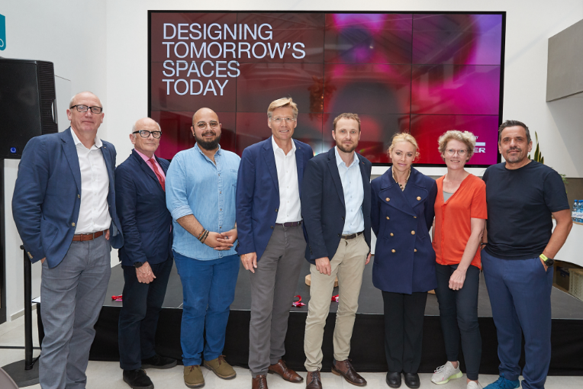 | Designing Tomorrow’s Spaces Today.  L-R Andrew Laidler (EGGER), Peter Murray, Ehab Sayed, Ulrich Bühler (EGGER), Andreas Walde (EGGER), Rachel Armstrong, Leonne Cuppen and Raphael Gielgen.
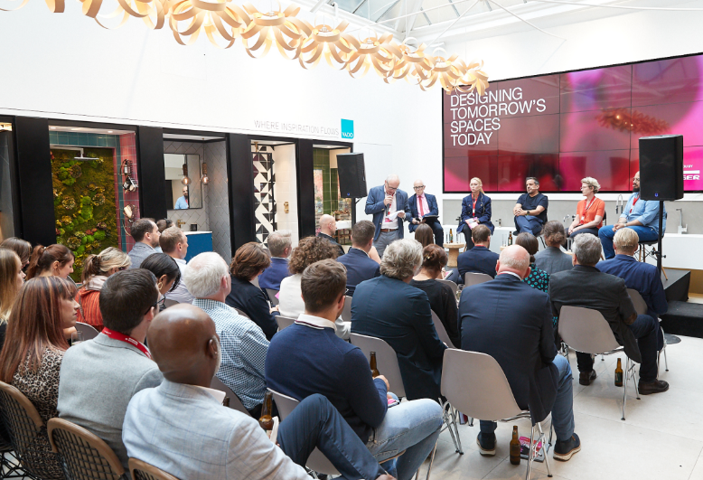 | Designing Tomorrow’s Spaces Today was held at Material Lab, London and chaired by Peter Murray, Chairman of New London Architecture.
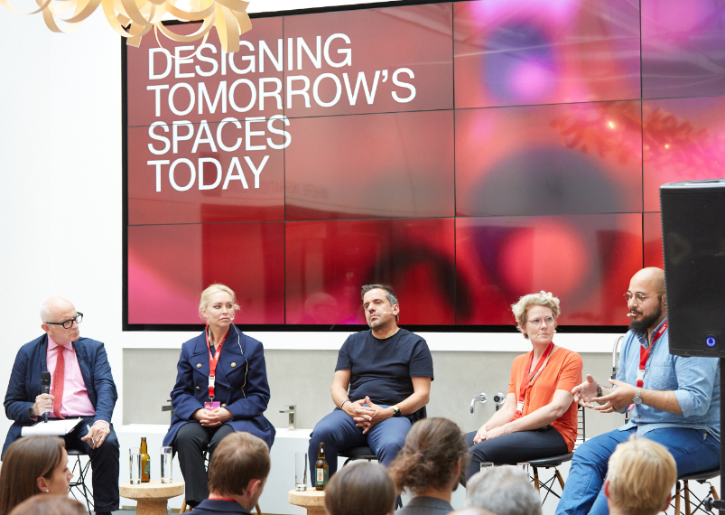 | Panel discussion from the thought leaders who are pushing design boundaries.

