EGGER plant in Biskupiec starts production
On June 28, 2019, EGGER Biskupiec began to operate its state-of-the-art chipboard production plant for furniture manufacturing. It is the EGGER Group’s 19th plant in the world, with capacity of 650,000 cubic meters of chipboard and an investment of €440 million. With 400 direct and 600 indirect jobs, EGGER Biskupiec will supersede the current chipboard import for Poland – one of the largest furniture producing countries in the world.
“I am delighted that we have started production at our EGGER Biskupiec plant, and together with our management team and employees we are honored to become an important supplier to the Polish furniture industry. We’ve been active in Poland since the early 1990s, and are successfully working with more than 150 local customers”, announced Michael Egger – the co-owner of the company. “We are also proud to contribute to local development in Warmia-Masuria region by offering almost 1,000 jobs during the construction and now, when operating.”
Built according to EU BAT
The EGGER Biskupiec plant was planned and built according to European Union regulation of BAT (Best Available Techniques), which means use of the best available technology to prevent or minimize emissions that impact the environment. The modern facilities use the latest available production technology and environmental knowledge to produce EGGER products. The plant has production lines for raw and laminated chipboard which are now, step by step, being started up. In full operation, the production capacity will be 650,000 m³ raw chipboard per year, of which a large part will be finished with decorative surfaces.
A 1,000 jobs for the region
In addition to the Polish furniture producers and retailers, the region is experiencing a valuable push forward thanks to the investment from EGGER. There are already more than 370 people employed at EGGER Biskupiec, and this will soon increase to 400. Employees have been trained at other plants of the EGGER Group and will now take over responsibility for daily operation of the 19th plant. Furthermore, an addition 600 indirect jobs with suppliers or service providers have been created.

EGGER plant starts operating in Poland
- The Biskupiec plant is located in the Warmia-Masuria region of north-east Poland  - Chipboard plant with a 650,000 m³ capacity and state-of-the-art facilities | - Investment level: EUR 440 million  - 400 direct jobs, with an additional 600 indirect jobs in the region

For queries:
FRITZ EGGER GmbH & Co.
Holzwerkstoffe
Manuela Leitner
Weiberndorf 20
6380 St. Johann in Tirol
Austria
T +43 5 0600-10638
F +43 5 0600-90638
manuela.leitner@egger.com
Picture Download:
https://celum.egger.com/webgate/pin.html?lang=en&pin=ZLM9LDCIUWV2

Captions
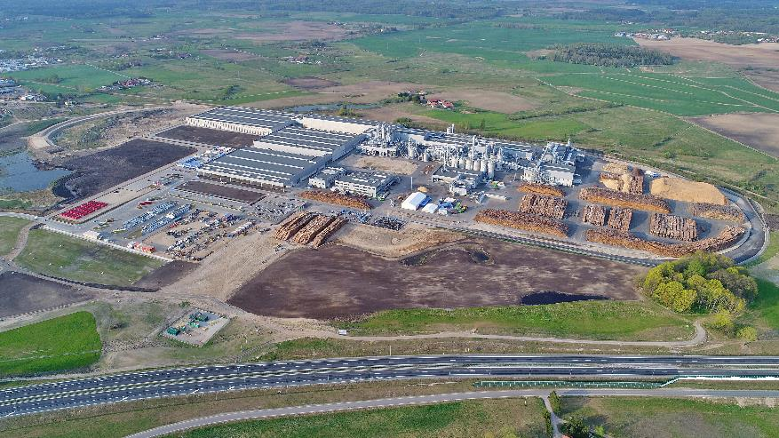
The 19th plant of the EGGER Group in Biskupiec, Poland, started to operate

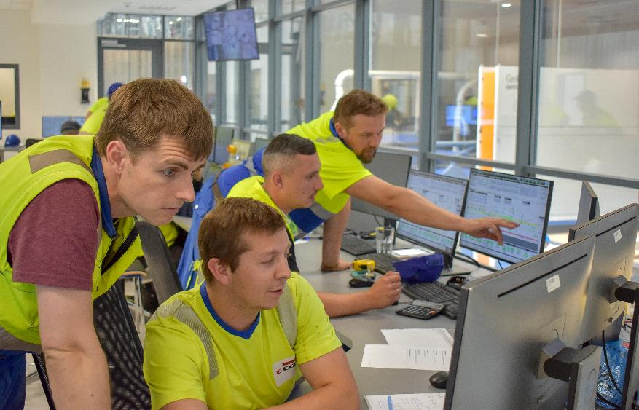
The well-trained Polish EGGER employees were excited to start their plant.
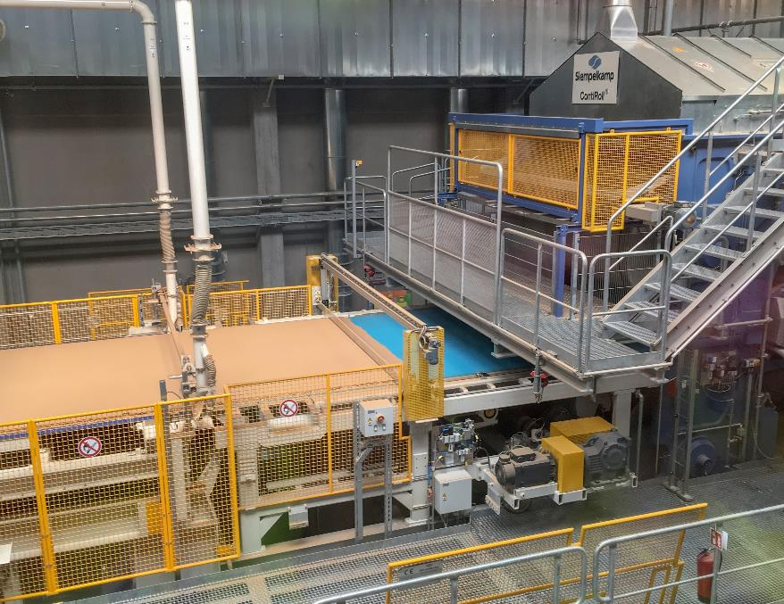
First chipboard on the Siempelkamp ContiRoll

