A BIG deal for forestry and wood processing
EGGER has welcomed a major boost for forestry and wood processing in the north of England and south of Scotland after funding was confirmed for a growth deal worth almost £400 million.
EGGER is delighted that the industry is so prominently featured in the Borderlands Inclusive Growth (BIG) Deal, which is funded by the UK and Scottish Governments and five local authorities, three in England and two in Scotland.

Last summer, EGGER released the paper Forestry and wood processing in the Borderlands Growth Deal to open up a debate about the sector's importance to the industry on both sides of the border. Company representatives John Paterson and Simon Hart have since taken an active role in discussions about the potential to include a Forestry Innovation Centre in the proposals.

Documents released this week confirm that the Deal partners will "develop with the forestry sector a centre of excellence to showcase innovation that would improve productivity across the whole supply chain".

More broadly, the documents also include an initial £10 million of funding (£5 million each from the UK and Scottish Governments) to "underpin the development of the rural economy" either side of the border.

The Borderlands 'Heads of Terms', which will be developed over the next 6-12 months into a detailed business case, says: "Both governments will work collaboratively with partners to establish the best way to deliver a challenge fund for businesses and land managers to trial environmentally friendly pilots of the Borderlands natural capital, advance sector strategies and measures to capture and analyse real time information to maximise product yield, minimise pollution, promote carbon capture and flood management. These interventions could form the development of a Natural Capital Innovation Zone across the Borderlands region."

John Paterson, Head of EGGER Forestry, said: "EGGER opened up the conversation about the importance of our industry to the Borderlands and we have been delighted to continue to play a central role in very constructive discussions with colleagues from the industry, academia and public forestry. It is tremendous to see the culmination of a year of hard work - and both the Forestry Innovation Centre and wider Natural Capital Innovation Zone are fantastic news for the sector. We now look forward to further discussions to move these proposals forward and make them happen."

The funding for the Borderlands Inclusive Growth Deal was confirmed by Minister for the Northern Powerhouse, Jake Berry MP, who said: "This once-in-a-generation deal will deliver unprecedented investment in the Borderlands region while strengthening our cross-border links. We have moved closer to finalising a deal which will deliver over 5,500 jobs, dramatically improve transport and digital connectivity, boost tourism and generate around £1.1 billion of economic benefits for the region."

Mr Berry visited the EGGER plant at the end of May last year and was presented with a copy of Forestry and wood processing in the Borderlands Growth Deal.

Stuart Goodall, Chief Executive of trade body Confor, said: "This is a BIG Deal for forestry on two levels. Firstly, it is great to see the exciting idea of a Forestry Innovation Centre made it into today's documents.

"Secondly, the immediate funding to support rural economic development and to create a Natural Capital Innovation Zone is a great opportunity for the forestry sector to show how it can deliver multiple benefits to the economy, environment and communities in the Borderlands area."

The Heads of Terms document uses similar language to EGGER's original report. It says: "The forestry and wood sector in the Borderlands is an asset to the region which can deliver substantial low carbon growth and contribute towards sustainable economic development. Forestry and wood processing are a significant employers and contributors to the economic growth of the Borderlands region."

* The Borderlands region comprises the five local authority areas of Carlisle City, Cumbria County, Dumfries and Galloway, Northumberland County and Scottish Borders. The Borderlands is home to over 1 million people over a combined geography that comprises 10% of the UK landmass.

A BIG deal for forestry and wood processing

- EGGER has welcomed a major boost for forestry and wood processing in the north of England and south of Scotland after funding was confirmed for a growth deal worth almost £400 million.  - Documents released this week confirm that the deal partners will “develop with the forestry sector a centre of excellence to showcase innovation that would improve productivity across the whole supply chain.” | - The documents also include an initial £10 million of funding to “underpin the development of the rural economy” either side of the border.  - The funding for the Borderlands Inclusive Growth Deal was confirmed by the Minister for the Northern Powerhouse, Jake Berry MP, who visited the EGGER Hexham plant last year.

A BIG deal for forestry and wood processing
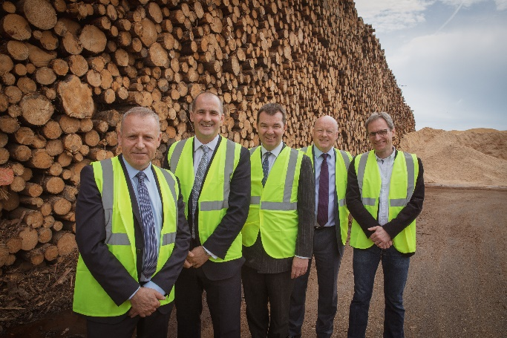 | Last year, Minister for the Northern Powerhouse, Jake Berry MP, visited the EGGER Hexham plant. Pictured L to R: John Paterson, director of EGGER Forestry; Jake Berry MP; Guy Opperman MP: Bob Livesey, commercial director at EGGER Western European Division; Tobias Zimmermann, EGGER Hexham plant director technical/production.
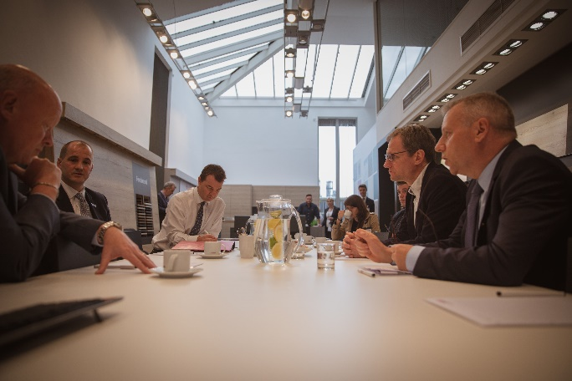 | Jake Berry MP was given a tour of the EGGER Hexham plant last year and spoke to apprentices and staff as part of a visit to the region to promote the Borderlands Growth Deal.
For Queries:

Laura Bracher
EGGER (UK) Ltd
Anick Grange Road
Hexham
Northumberland
T +44 1434 613285
M +44 7966155335
Laura.Bracher@egger.com

