Don't just follow the trends, set your own accents with the EGGER Trend Selection.
The Premium selection for inspiring living and working environments

With the Premium selection Trend Selection of the PRO Flooring Collection 2021+, EGGER once again brings to the fore its design competence and sense of trends and offers its customers specially coordinated decor and product packages. The innovative design concept leaves room for individual accents and opens up fascinating possibilities in the design of interior flooring.
When it comes to trends, there are two options: you can follow them - or set them yourself, especially when designing rooms. The floor lays the foundation for individuality and personality. It lets rooms come to life and have an effect. It shapes perception through deliberately placed accents. It combines high-quality materials and atmospheric looks, shapes and colours. It creates atmosphere and emotions.

With the EGGER Trend Selection, the team led by Klaus-Dieter Monhoff, Head of Design & Decor Management, has set a new milestone. The staging of harmonious overall concepts and individual highlights is child's play. Whether for the retreat at home, for the stylish combination of privacy and home office or for sophisticated commercial use: the EGGER Premium Selection inspires new ideas whose implementation sets its own standards with the highest quality and timelessly beautiful design.

The EGGER Trend Selection consists of three decor and product packages that open up fascinating possibilities: Pure Solids, Creative Functions and Interior Match.

Made for a long life: Pure Solids
Solid wood and parquet looks are in. Pure Solids goes one step further - and combines high quality and natural design with the valuable properties of laminate. EGGER Laminate Flooring is robust and easy to clean, flexible and quick to install and offers excellent value for money. Innovative installation looks find their place here just as much as classic country house floorboards.

Pure Solids contains ten authentic decors, which fulfil all style wishes from reduced-elegant to powerfully striking and also reproduce classic parquet looks. With five different plank formats - Classic, Medium, Large, Kingsize and Long - small and large rooms can be optimally staged. Thanks to the easy-to-understand decor concept, customers can make their choice quickly.

Good combination: Creative Functions
Open spaces and flowing transitions: In times when living and working are moving closer together than ever before, variety and separation are in demand. Especially within a room whose division into defined areas does justice to all functions. Combine, contrast and match decors and floors to create exciting and vibrant interior designs.

With 9 decors and 17 article variants, Creative Functions comprises three overarching style concepts that extend across all EGGER flooring types: the Bedollo Walnut theme includes 4 colour-coordinated decors in the Laminate, Comfort and Design Flooring GreenTec product categories. The Berdal Marble theme combines classic oak with white marble.
The product range is complemented by natural oak decors from the EGGER PRO Flooring Collection 2021+, which is available as Laminate, Comfort and Design Flooring GreenTec. In this way, application-appropriate floors, such as the warm and soft Comfort flooring in the bedroom and the hard-wearing Laminate flooring in the living room, can be combined to form a harmonious whole.

The EGGER Design, Comfort and Laminate Flooring can be perfectly combined visually and installed directly into each other. This creates rooms and areas with their own character. They are colour and decor-coordinated, complete with variance and variability, and each has the desired property: from water-resistant, to warm and quiet, to resistant and of lasting value.

Interior Match brings together what belongs together
The theme of "Mix & Match" has dominated interior designs for some time now. The combination of colours, materials and surfaces gives room for creativity and individuality. This can be realised particularly well in trendy open residential living and working areas. With the blurring of boundaries and the lack of spatial demarcation of functional areas, new demands are being placed on flooring and interior design. "With all the design freedom, coordinated fixed points bring the desired visual harmony," says Klaus Monhoff, Head of Design & Decor Management at the EGGER Group. EGGER responds with its new Interior Match design concept. For the first time, this combines the Decorative Collection with the PRO Flooring Collection 2021+.
With a selection of 30 decors, the wood-based materials manufacturer is implementing this theme for the first time in such a comprehensive offer. Architects, fabricators and also end customers thus have the opportunity to effortlessly realise contemporary and harmonious designs.
In Interior Match, a distinction is made between the same decor solutions and those which are colour-coordinated. In Decor Match, floors as well as furniture and interior design products are available in the same decor with different surface textures. Customers can choose the same decor for floors, doors, the kitchen worktop or complete furniture, thus bringing harmony to their designs. The Colour Match, on the other hand, features decors that are colour-coordinated. "The total of 30 decors includes many new introductions from both collections. They have been selected so that they can be used in a variety of ways. Fronts, worktops or entire pieces of furniture can easily be combined with the floor. Whether striking or understated - there is something for every style in Interior Match," explains Ayla Schwarzmayr, Decor Management Senior Specialist Flooring.

About EGGER
The family company, founded in 1961, employs approximately 10,100 people. In 20 plants across the world, they produce an extensive product range of wood-based materials (chipboard, OSB and MDF board) as well as timber. The company generated a turnover of EUR 2.83 billion in the 2019/2020 financial year. EGGER has global customers in the furniture industry, wood construction and flooring retail, as well as DIY markets. EGGER products are found in countless areas of private and public life, including kitchens, bathrooms, offices, living rooms and bedrooms. EGGER is a full-range supplier for the furniture and interior design industry, for wood construction and wood-based flooring industries.

Trend Selection, the Premium selection

- EGGER Trend Selection - the Premium selection for the design of inspiring living and working environments with floors from the EGGER PRO Flooring Collection 2021+.  - Interior Match: coordinated decors from the Decorative Collection 2020-22 for furniture and interior design and the PRO Flooring Collection 2021+. With 23 Decor Match and 7 Colour Match decors. | - Creative Functions: Room and living concepts with clarity, texture and attractive looks. With 9 decors and 3 style concepts.  - Pure Solids: Solid wood and parquet looks combined with the valuable properties of laminate. With 10 authentic decors and 5 flooring board formats.  - More information at www.egger.com/trend-selection

Captions
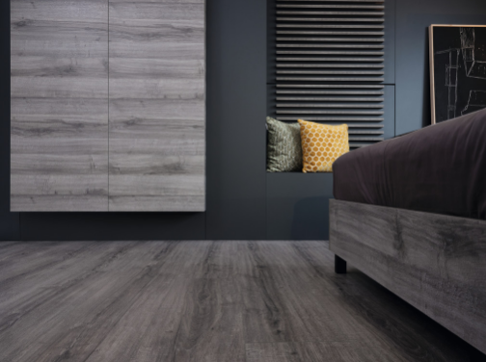 | In the Interior Match, suitable products are available for all areas of application in the same decor or colour-coordinated.  Featured decor:  Furniture: H1345 ST32 Grey Sherman Oak  Flooring: EPL185 Grey Sherman Oak
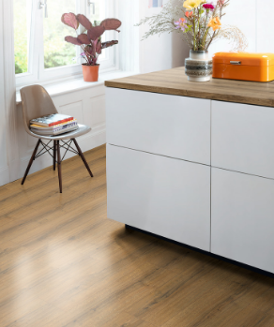 | Worktop and flooring in the same decor? Easily achievable with the Interior Match.  Featured decor:  Worktop: H1344 ST32 Cognac Brown Sherman Oak  Flooring: EPL184 Cognac Brown Sherman Oak
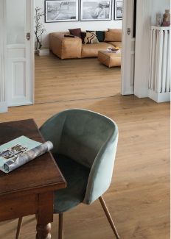 | Different requirements, different floors, one look? No problem with the Creative Functions decors. The warm and quiet Comfort Flooring was installed in the living room. The floor in the dining area has the same decor - but in the robust Laminate version.  Featured decor:  Living room: EPC001 Natural Waltham Oak  Dining room: EPL122 Natural Waltham Oak
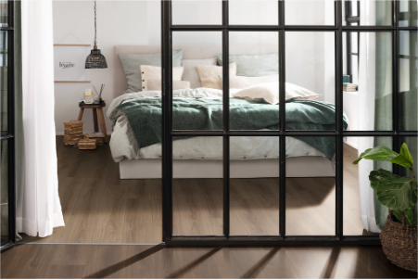 | Creative Functions makes it possible to combine 2 different floors of one decor theme and thus creates a harmonious demarcation of the living areas. The sleeping area is designed with a Comfort floor in a light walnut look, the area in the foreground shows the same decor a shade darker as a Laminate floor.  Featured decor:  Sleeping area: EPC030 Light Bedollo Walnut  Front area: EPL175 Dark Bedollo Walnut
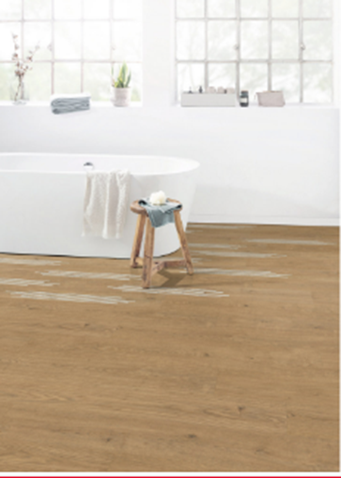 | Design, Comfort and Laminate floors from the Creative Functions concept can be perfectly combined and installed directly into each other. Combine, contrast and match decors and floors to create exciting and vibrant interior designs.  Featured decor:  Foreground: EPD034 Natural Berdal Oak  Bath area: EPD035 Creative Berdal Oak
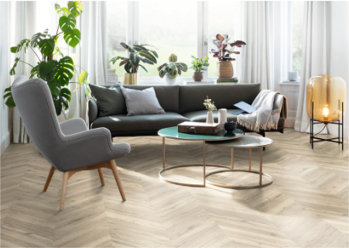 | Pure Solids. Solid wood and parquet looks combined with the valuable properties of laminate.  Featured decor:  Living room: EPL011 Light Rillington Oak

PHOTOS: EGGER Holzwerkstoffe, reprints naming the copyright owner are free of charge
REPRODUCTION: All our mentioned decors are reproductions. Slight deviations between furniture and flooring decors are possible due to different surface finishes.
Picture download: https://celum.egger.com/pinaccess/showpin.do?pinCode=FqbFDFdkE7um

For queries:

EGGER Holzwerkstoffe Wismar GmbH & CO.KG
Ulrike Brosius
Am Haffeld 1
D-23970 Wismar

Phone: +49 3841 301 21284
Fax: +49 3841 301 61284
ulrike.brosius@egger.com

