Joint Press Release

Enhanced cooperation: EGGER to acquire minority stake in CLEAF

CLEAF and EGGER, two manufacturers globally active in the sector of surface materials for furniture and interior design, enhance their cooperation, as already announced: With the signing of the acquisition agreement on 9.9.2020 and expected closing in November, the Austrian EGGER Group will acquire a 27.5% stake in the Italian CLEAF.

Lissone-St. Johann in Tirol, September 28, 2020 - CLEAF and EGGER entered into a partnership about a year ago as an expression of a common vision and mutual respect between the two family businesses. As already announced (Joint Press Release of 23.9.2019), the sales partnership will now be followed by the next step: EGGER will acquire a minority stake of 27.5% in CLEAF. The parties agreed not to disclose the value of the transaction.

"We have always pursued the vision of broader cooperation. Our cooperation in sales has shown that together we can offer our customers the best of two worlds," both companies comment. The majority shareholding in CLEAF will continue to be held by the Caspani family. EGGER emphasizes that it does not intend to acquire a majority stake in CLEAF in the future either.

Successful sales partnership
About a year ago the two companies announced the "CLEAF presented by EGGER" collection for six European markets. Since its launch together with the EGGER Decorative Collection in February 2020, customers in Germany, Austria, Switzerland, Poland, the Czech Republic and Slovakia have shown great interest in this range. The two companies also presented themselves at the Euroshop in February 2020 in Düsseldorf on directly connected exhibition stands.

About CLEAF
CLEAF is an Italian company that produces innovative surfaces and solutions for the furniture and interior design industry. Coated panels, laminates and edgings, produced exclusively at the four production sites in Brianza, are used worldwide by architects and companies creating inspiring spaces to live and work in.

About EGGER
The family-owned company, founded in 1961, employs around 10,100 people. At 20 locations around the world, they provide a comprehensive range of products made of wood-based materials
(chipboard, OSB and MDF boards) and sawn timber. In the 2019/2020 financial year, the company thus generated a turnover of 2.83 billion euros. EGGER has customers worldwide in the furniture industry, the wood and flooring trade and DIY stores.

Picture caption

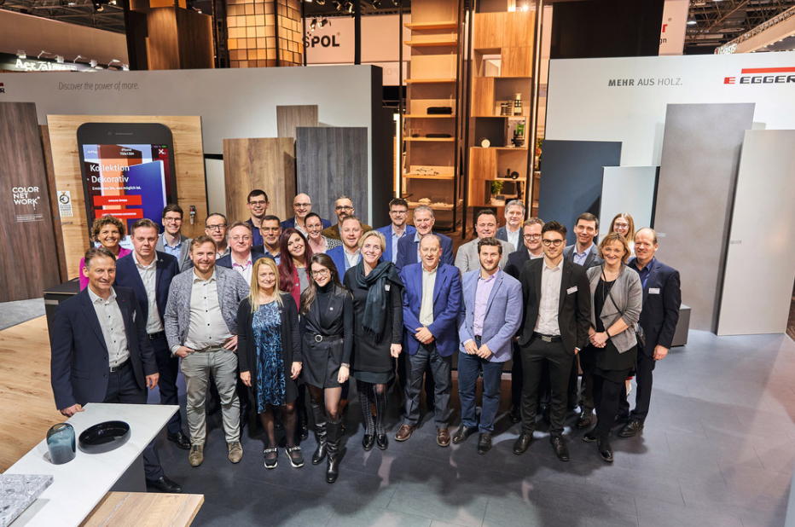 | In February 2020 CLEAF and EGGER presented together at Eurohop in Düsseldorf.

Picture download: https://celum.egger.com/pinaccess/showpin.do?pinCode=xoC8287ccsqR

For queries:

CLEAF SPA FRITZ EGGER GmbH & Co. OG
Luca Pangrazzi Manuela Leitner
Communication Manager Head of Corporate Communications
Via Bottego 15 Weibndorf 20
20851 Lissone 6380 pcs. Johann in Tyrol
Italia Austria
T +39 039 20741 T +43 5 0600-10638
F +39 039 2017820 F +43 5 0600-90638
lucapangrazzi@cleaf.it manuela.leitner@egger.com

