EGGER Group receives awards for its sustainability performance
Sustainable management is a significant component of the EGGER Group's corporate strategy. These efforts are also reflected in the assessment by external institutions. EGGER was able to achieve two awards in sustainability ratings: Prime status in the ISS ESG Corporate Rating and the EcoVadis silver medal.
EGGER takes responsibility for products, its own production, as well as for employees and society and acts with future generations in mind. "We are very pleased about the awards from leading global ESG rating agencies. At the same time, we take their analyses as an opportunity to identify potential and continue to improve our sustainability performance in the future," says Ulrich Bühler, EGGER Group Management Sales & Marketing.
ESG ratings give good report card
ISS ESG is one of the leading rating agencies in the sustainable investment segment. For the first time, it awarded the EGGER Group Prime status, which is reserved for the best companies in their respective industries, on the basis of the 2019/2020 sustainability report. ISS ESG follows a scientifically based rating concept. Non-financial information from the areas of environment, social affairs and governance is taken into account. The assessment of a company's sustainability performance is based on around 100 criteria that are specifically selected for each industry. Companies achieve Prime status if they meet or exceed the sustainability performance requirements defined by ISS ESG for a specific industry. EGGER found itself in the top 3 of 46 companies in its own industry that have been assessed by ISS.
EcoVadis, one of the world's largest providers of sustainability ratings, awarded EGGER the silver medal for the second time. This puts the wood-based materials manufacturer among the top 25 percent of all companies evaluated industry-wide. The evaluation focuses on 21 criteria, which are subdivided into four subject areas: Environment, Labour and Human Rights, Ethics and Sustainable Procurement. EGGER was able to increase its overall rating compared to the last EcoVadis rating and is now among the top 5 percent of companies evaluated in its own industry.
More from wood means more transparency
All key sustainability topics can be found in the EGGER Group's sustainability report (non-financial statement) at www.egger.com/sustainability. It has been published annually since 2018. It contains the Group's strategy, objectives and performance with regard to economic, ecological and social sustainability. EGGER transparently discloses its strategic sustainability goals with the report. The current report contains the EGGER Group's commitment to the United Nations Sustainable Development Goals (SDGs). The wood-based materials manufacturer shows how it works towards the goals and sub-goals of the Agenda 2030 in its business activities in order to make the greatest possible contribution to achieving them. This once again confirms the family company's pioneering role as a responsible player.

Awards for sustainability performance

- ISS ESG awards EGGER Prime status.  - EcoVadis awards EGGER the silver medal. | - All details on EGGER's sustainability strategy can be found in the annual sustainability report. www.egger.com/sustainabilityreport

Captions
 | The EGGER Group's sustainability performance is recognised with ISS ESG Prime status and the EcoVadis Silver Medal.
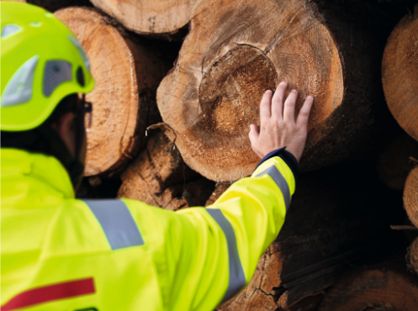 | Sustainable management has always been the goal of the EGGER Group. Careful use of precious resources is essential in this respect.
PHOTOS: EGGER Holzwerkstoffe, reprints naming the copyright owner are free of charge
REPRODUCTION: All our mentioned decors are reproductions.
Picture download: https://egger.sharefile.eu/d-se8b4a339764a4626bd4aaccc67c0eef8

For queries:

FRITZ EGGER GmbH & Co. OG
Holzwerkstoffe
Katharina Wieser
Weiberndorf 20
6380 St. Johann in Tirol
Austria
T +43 5 0600-10128
F +43 5 0600-90128
katharina.wieser@egger.com

