EGGER to invest in a 30% stake in Chinese edge banding producer Sinowolf
Strategic partnership strengthens global edging business and creates new opportunities for international growth
The EGGER Group has signed an agreement to invest in a 30% minority stake in Sinowolf, an internationally active Chinese manufacturer of edge banding solutions for the furniture and interior design industry. Completion of the transaction remains subject to the agreed review and closing conditions, with closing expected by November 2026.
Through this strategic minority investment, EGGER and Sinowolf are establishing a long-term partnership to further develop the international edging business. Sinowolf will remain independently managed, continue operating under its established brand and serve its customers through its existing organisation.
Founded in 2007, Sinowolf has developed into a specialised producer of edge banding products with two Chinese manufacturing sites in Zhaoqing (Guangdong) and Huzhou (Zhejiang) and a total annual capacity of 1 billion metres of edge banding. The company exports to more than 30 countries worldwide and offers a broad portfolio including PVC, ABS, PP and PMMA edge banding solutions as well as digital printing and laser-edge technologies for the furniture industry. In addition to its edge banding business, Sinowolf is currently also entering the field of surfacing materials.
The agreement reflects a shared ambition to further develop the international edging business together. “The global edging market offers significant opportunities for further development. By partnering with Sinowolf, we are combining complementary strengths in technology, manufacturing expertise and market access. At the same time, it is important to us that Sinowolf remains an independently managed company with its own identity and entrepreneurial spirit. We are convinced that this partnership will create long-term value for both companies and for our customers worldwide,” says EGGER CFO Thomas Leissing.
Complementary strengths in a global market
EGGER’s integrated décor, surface, wood-based materials and edging expertise as well as its international market presence complement Sinowolf’s specialised edge-manufacturing know-how, flexibility, digital printing capabilities, laser-edge development and customer-specific matching competence. Together, both companies aim to strengthen their position in the international edging business, support future growth in key markets and enhance local customer service. The investment adds complementary manufacturing expertise and regional flexibility to EGGER’s existing edging competencies and international production network, including its competence centres in Gebze (TR) and Brilon (DE). For Sinowolf, the partnership opens up broader market perspectives and additional opportunities for international expansion.
Continuity and added value for customers
“Over the past years, Sinowolf has built a strong position through innovation, manufacturing expertise and a close focus on customer requirements. We see EGGER as the ideal strategic partner for the next phase of our development. This partnership opens up new international opportunities for Sinowolf while allowing us to continue building on the strengths that have made our company successful,” says Wilson Chu, CEO of Sinowolf.
For customers, the partnership provides continuity combined with additional long-term opportunities. Existing customer contacts, product quality and service standards are expected to be maintained. At the same time, customers will benefit from a broader international competence base, regional flexibility and the combined expertise of both companies.
The investment reinforces the shared commitment of both companies to quality, service and customer focus. Building on their respective strengths, EGGER and Sinowolf will continue to deliver reliable solutions and support customers worldwide with innovative edge banding products and services.
Minority Investment as a Partnership
The transaction is deliberately structured as a minority investment and partnership. Completion remains subject to the agreed review and closing conditions. Sinowolf will continue operating under the Sinowolf brand and maintain responsibility for its operational business. The objective is not integration into the EGGER group, but a stable basis for cooperation, mutual growth and the continued development of the international edging business.

EGGER and Sinowolf enter strategic partnership

- EGGER to invest in a 30% stake in Sinowolf  - Strategic partnership for international edging business | - Sinowolf remains independent and keeps its brand  - Continuity for customers; broader competence base

About EGGER
EGGER is an internationally leading manufacturer of wood-based materials. The family company, founded in 1961 and headquartered in St. Johann in Tirol (AT), employs around 12,000 people and operates 22 production plants worldwide. EGGER develops and produces wood-based materials for furniture and interior design, timber construction and wood-based flooring. In the 2025/2026 financial year, the EGGER Group generated revenue of around EUR 4.26 billion and produced 10.9 million m³ of wood-based materials and timber.

About Sinowolf
Sinowolf is a Chinese manufacturer of edge banding products headquartered in Zhaoqing, Guangdong. Founded in 2007, the company develops and produces a broad range of edging solutions for the furniture and interior design industries. In addition to its edge banding business, Sinowolf is currently also entering the field of surfacing materials. With manufacturing locations in Zhaoqing, Guangdong, and Huzhou, Zhejiang, and exports to more than 30 countries worldwide, Sinowolf has established itself as an internationally active specialist in the edge banding market.

Picture caption
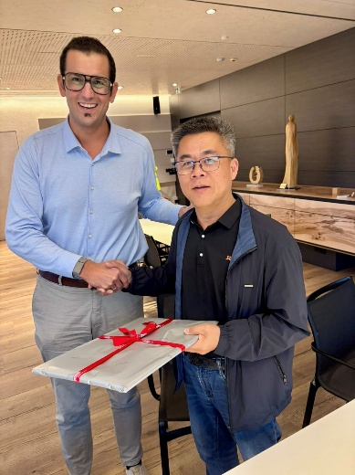 | Michael Egger jun. and Wilson Chu represent the strategic partnership between EGGER and Sinowolf, aimed at further developing the international edging business and creating new opportunities for joint growth.
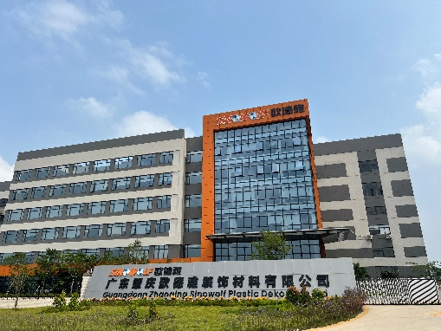 | Sinowolf has established itself as an internationally active specialist in the edge banding market.
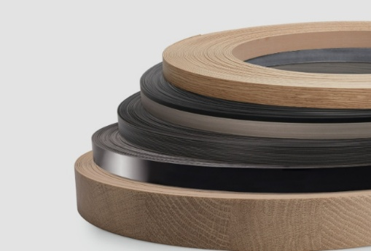 | The partnership with Sinowolf strengthens EGGER’s position in the international edging business and opens up new opportunities for joint growth.

PHOTOS: EGGER, Sinowolf; free of charge for reproduction when the copyright holder is named
REPRODUCTION: All decors mentioned are reproductions.
Image download: https://celum.egger.com/pinaccess/showpin.do?pinCode=nknO0nTvrkB4

For further enquiries:

EGGER Holzwerkstoffe GmbH
Manuela Leitner
Weiberndorf 20
6380 St. Johann in Tirol
Austria
T +43 5 0600-10638
manuela.leitner@egger.com

