EGGER acquires Italian recycling company Lenocart
Successful expansion of the recycling network in Italy
The EGGER Group has acquired 100% of the shares in the Italian recycling company Lenocart S.r.l., based in the Milan metropolitan area. Through this acquisition, the internationally operating wood-based materials manufacturer is further expanding its recycling network in Italy and strengthening access to recycled wood in one of the country's most important economic and metropolitan regions. The acquisition was completed on 28 July 2026. With this step, EGGER underlines its strategic commitment to continuously expanding its international network of recycling collection sites under the EGGER Timberpak brand.
Lenocart has been a trusted business partner of EGGER for many years. With this acquisition, the family company headquartered in St. Johann in Tirol, Austria, is building on this successful collaboration and creating the foundation for the further development of its recycling activities in Italy. In addition to the recycling business, the acquisition also includes Lenocart's transport fleet, supporting efficient collection and logistics processes.
“The acquisition of Lenocart is an important step in strengthening our recycling network in Italy. The Milan region offers significant potential for the collection of recycled wood. Together with the experienced Lenocart team, we aim to further develop the business and contribute to a more circular use of resources,” says Giuseppe Conti, Plant Director of the EGGER plant in Caorso and responsible for wood purchasing.
The operative management of the Lenocart site will remain in the hands of Dario Lenoci, whose family founded the company in the 1950s. “Lenocart has grown over decades as a family business and is deeply rooted in the region. With EGGER, we have found a partner who shares our values and is committed to supporting the long-term development of our site. I look forward to continuing this journey together,” says Dario Lenoci.
Strengthening raw material supply for the Caorso plant
The Lenocart site currently collects 10,000 tonnes of recycled wood per year and will contribute to supplying recycled wood to EGGER's plant in Caorso. There, EGGER manufactures particleboard from 100% recycled wood, consistently focusing on the high-value use of wood from the circular economy.
Part of the international Timberpak network
The acquisition of Lenocart forms part of the continuous expansion of EGGER's recycling activities. Under the Timberpak brand, the EGGER Group operates an international network of recycling collection sites. Recycled wood from the respective region is collected, sorted and pre-shredded at the Timberpak sites before being transported to EGGER plants. Final processing takes place at the plants. With the new location in the Milan region, EGGER strengthens its presence in one of Italy's most important recycling markets.
From a handcart to an established recycling company
Lenocart's history dates back to the 1950s. At that time, company founder Nicola Lenoci began collecting waste paper and textiles on the streets of Milan using a simple handcart. Together with his sons Dario, Elio and Walter, he developed the business over the decades into a recognised specialist in the collection, trading and transport of recyclable and waste materials.
The company's extensive experience and strong regional roots provide an important foundation for the site's future development. With the acquisition, Lenocart becomes part of the international EGGER Group. At the same time, EGGER welcomes all Lenocart employees to the company and looks forward to building on their expertise and market knowledge.

EGGER acquires Italian recycling company Lenocart
- The EGGER Group has acquired 100% of the shares in Lenocart S.r.l., an Italian recycling company based in the Milan metropolitan area.  - EGGER is expanding its recycling activities in one of Italy's most important economic and metropolitan regions. | - The acquisition strengthens EGGER's international network of recycling collection sites.  - EGGER is retaining all Lenocart employees.

About the EGGER Group
EGGER is an internationally leading manufacturer of wood-based materials. The family company, founded in 1961 and headquartered in St. Johann in Tirol (AT), employs around 12,000 people and operates 22 production plants worldwide. EGGER develops and produces wood-based materials for furniture and interior design, timber construction and wood-based flooring. In the 2025/2026 financial year, the EGGER Group generated revenue of around EUR 4.26 billion and produced 10.9 million m³ of wood-based materials and timber.
As a family company, EGGER is committed to long-term development, financial stability and growth based on its own performance. In line with its mission – “More from wood” – EGGER works to use wood responsibly and keep it in the material cycle for as long as possible. In the 2025/2026 financial year, 66% of the wood that the EGGER Group used in its wood-based materials consisted of recycled material and by-products from the sawmill industry. 71% of the energy used Group-wide came from renewable sources. EGGER is pursuing the goal of gradually reducing its greenhouse gas emissions; to this end, it has set interim targets for 2030 and is aiming for Net Zero by 2050 in the long term.

Picture caption
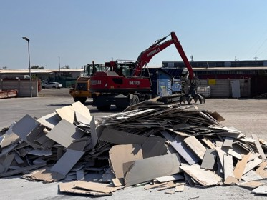 | The EGGER Group has acquired the Italian recycling company Lenocart, based in Milan.
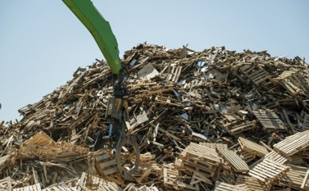 | The EGGER Group is taking measures to further strengthen its own recycling infrastructure.
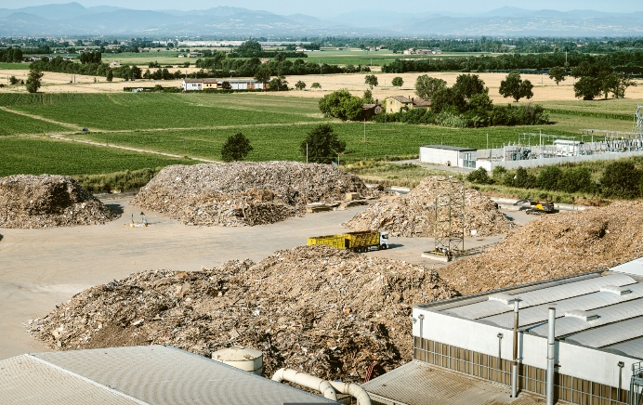 | EGGER's Italian plant in Caorso uses 100% recycled wood in the production of its particleboards.
FOTOS: EGGER Holzwerkstoffe, reproduction with naming of copyright holder free of changes
REPRODUCTION: All our mentioned decors are reproductions.
Download: https://celum.egger.com/pinaccess/showpin.do?pinCode=LnfxQ6VIEja1

For Queries:

EGGER Holzwerkstoffe GmbH
Katharina Wieser
Weiberndorf 20
6380 St. Johann in Tirol
Austria
T +43 5 0600-10128
katharina.wieser@egger.com

