EGGER’s acquisition of Masisa Argentina is concluded
With the closing of the contracts on the 30th of September 2017, the plant in Concordia and the sales structure become part of the EGGER Group
The acquisition of the Masisa plant in Concordia, Argentina, from the Chilean Masisa S.A. is successfully completed upon closing of the contracts. This will be the first time the wood-based material manufacturer EGGER is represented with a production site outside Europe. The Group, with headquarters in St. Johann in Tyrol, takes over the number 2 in Argentina for a purchasing price of USD 155 million debt-free.
The acquisition contracts between EGGER and Masisa were signed on the 17th of July 2017. In addition to the plant in Concordia, which has facilities for producing and coating chipboard and MDF board, EGGER also took over the retail network Masisa Placacentro in Argentina, Uruguay, and Paraguay that is run independently by 43 partners. The plant in Argentina employs 500 people, which the Austrian wood-based material manufacturer is taking over.
“With the acquisition of Masisa Argentina, we are continuing the internationalisation of the Group and continue to grow based on our own performance”, says Thomas Leissing, spokesperson of the EGGER Group Management. “Our goal is to become a key market player in South America.”

About EGGER
The family company founded in 1961 now employs approximately 9,000 people. In 18 plants, they produce an extensive product range of wood-based materials (chipboard, OSB, and MDF board) as well as timber. The company generated a turnover of EUR 2.38 billion in the 2016/2017 financial year, and has worldwide customers in the furniture industry, wood and flooring retailers, as well as DIY markets. EGGER is a full-range supplier for the furniture and interior design industry, for wood construction, as well as wood-based flooring (laminate, cork and design flooring) industries.

Concordia plant, Argentina
- With a 35% market share number 2 in Argentina  - Turnover in Argentina of USD 131 million in 2016. | - The Concordia plant has a capacity of 165,000 m³ chipboard, 280,000 m³ of MDF boards and 274,000 m³ lamination.  All 500 employees are taken over.
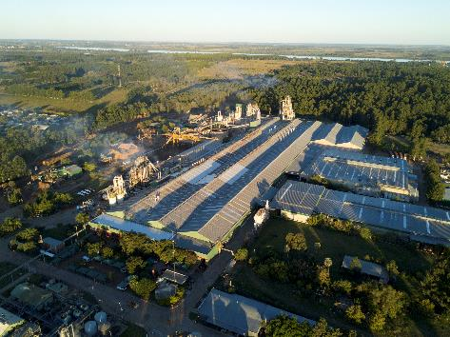 | The 18th EGGER plant Concordia, Argentina  Download picture

For queries:
FRITZ EGGER GmbH & Co OG
Holzwerkstoffe
Manuela Leitner
Weiberndorf 20
6380 St. Johann in Tirol
Austria
T +43 5 0600-10638
F +43 5 0600-90638
manuela.leitner@egger.com

