Announcement: New appointments in the EGGER Group Management as of 1 May 2022
Walter Schiegl, Thomas Leissing and Ulrich Bühler jointly manage the operative business of the EGGER Group since 2009. As of 1 May 2022, there will be changes in the executive committee of the wood-based material manufacturer: After more than 20 years in the Group Management, Walter Schiegl will move to the Supervisory Board. Hannes Mitterweissacher, who has also been with the EGGER Group for more than 25 years, will follow him. In addition, the Group Management will be composed of four persons in the future: Frank Bölling will be responsible for the logistics area. EGGER thus responds to the potentials and developments in the area of internal and external logistics. Together with Thomas Leissing and Ulrich Bühler, Hannes Mitterweissacher and Frank Bölling will thus form the new Group Management team of the EGGER Group.
Transition: Walter Schiegl moves to the Supervisory Board of the EGGER Group
After more than 20 years in the Group Management and more than 40 years of service at EGGER, Walter Schiegl, responsible for technical/production and purchasing, will move from the Group Management to the Supervisory Board of the Group. “Walter Schiegl has been part of our company for more than 40 years and has played a significant role in the development of the EGGER Group. We are therefore very pleased that Walter Schiegl will join us in the Supervisory Board from 1 September 2022”, say the owners Fritz and Michael Egger.
Succession: Hannes Mitterweissacher takes over the management of the technical/production and purchasing area
Hannes Mitterweissacher follows Walter Schiegl: On 1 May 2022, Hannes Mitterweissacher will move from his current position as Division Director Technical/Production EGGER Decorative Products Central to the Group Management, where he will be responsible for the technical/production and purchasing area. He has been with EGGER for more than 25 years. EGGER thus sticks to its usual practice: 77% of management positions within the Group are filled with internal candidates. “If you are willing to learn and experience new things every day, EGGER will open many doors for you “, emphasises Walter Schiegl with regard to the decision for his successor.
Expansion: Frank Bölling will be responsible for the logistics area as additional member of the Group Management
The future position of Frank Bölling as Group Management Logistics will be newly created as of 1 May 2022. Until now, Thomas Leissing was responsible for this area, alongside finance and administration. In the future, he will focus on these two areas and will continue to perform the function of spokesman for the Group Management. Frank Bölling has been with the EGGER Group since 2019 and is currently working as Division Director Logistics EGGER Decorative Products East. Previously, Bölling has worked in various industrial sectors in senior positions in logistics and supply chain management. EGGER is responding to the potentials and developments in the logistics area by creating this separate role in the Group Management. “The transformation processes in internal and external logistics are profound, especially in the areas of digitalisation, automation and process optimisation. We want to use the potential of these developments. That is why we are strengthening the Group Management with Frank Bölling as logistics expert”, says Thomas Leissing.
About EGGER
The family company founded in 1961 employs around 10,400 people. In 20 plants across the world, they produce an extensive product range of wood-based materials (chipboard, OSB, and MDF board) as well as timber. The company generated a turnover of EUR 3.08 billion in the 2020/2021 financial year. EGGER has global customers in the furniture industry, wood construction and flooring retail, as well as DIY markets. EGGER is a full-range supplier for the furniture and interior design industry, for wood construction, as well as wood-based flooring (laminate, cork and design flooring) industries.

New EGGER Group Management as of 1 May 2022
- Walter Schiegl, responsible for the technical/production and purchasing area in the EGGER Group Management, moves to the Supervisory Board.  - Hannes Mitterweissacher follows Walter Schiegl and takes over the function as Group Management Technical/Production and Purchasing.  - Newly created function: Frank Bölling as Group Management Logistics. | - EGGER sticks to its usual practice: 77% of management positions within the Group are filled with internal candidates.  - With the new Group Management function for logistics, EGGER responds to the potentials and developments in the area of internal and external logistics.  - The new EGGER Group Management team from 1 May 2022: Thomas Leissing, Ulrich Bühler, Hannes Mitterweissacher and Frank Bölling.

Captions
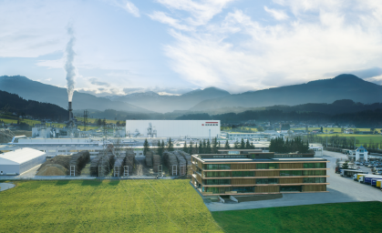 | The EGGER Group's success story started in 1961 with the first plant built in St. Johann in Tirol. The Tyrolean family company with 10,400 employees worldwide is one of the leading wood-based materials manufacturers.
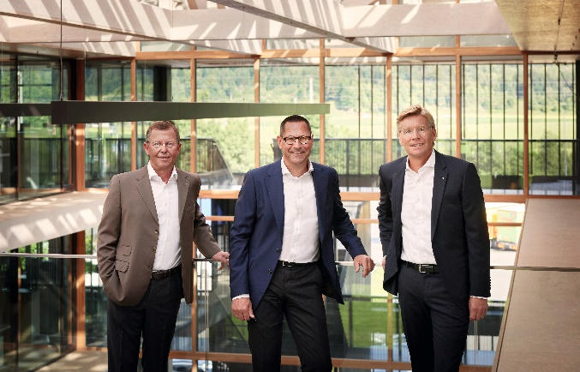 | Walter Schiegl, Thomas Leissing and Ulrich Bühler manage the operative business of the EGGER Group since 2009. From 1 May 2022, the EGGER Group Management will operate in a new composition.
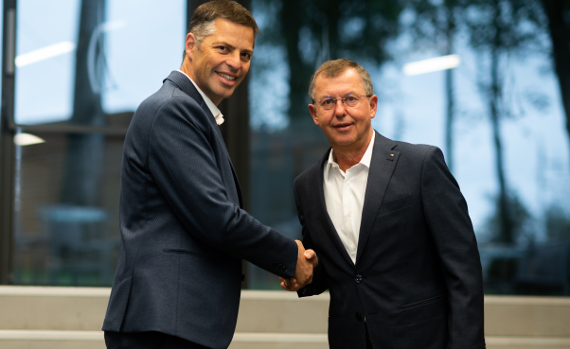 | Handover in the technical/production area: After more than 20 years, Walter Schiegl hands over his function in Group Management to Hannes Mitterweissacher. Walter Schiegl will remain with EGGER and moves to the Supervisory Board.
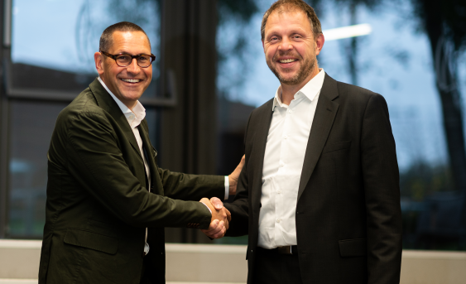 | New in the EGGER Group Management: Frank Bölling is appointed as Group Management Logistics. Until now, Thomas Leissing was responsible for this area. In the future, he will focus on the finance/administration areas and will continue to perform the function of spokesman for the Group Management.
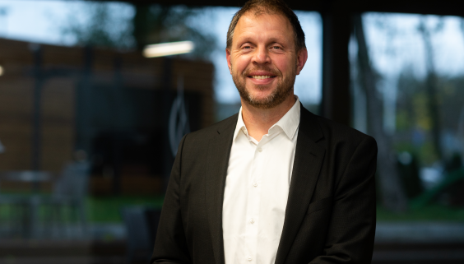 | Frank Bölling has been with the EGGER Group since 2019, currently in the function as Division Director Logistics EGGER Decorative Products East. From 1 May 2022, he will be responsible for the logistics area in the Group Management.
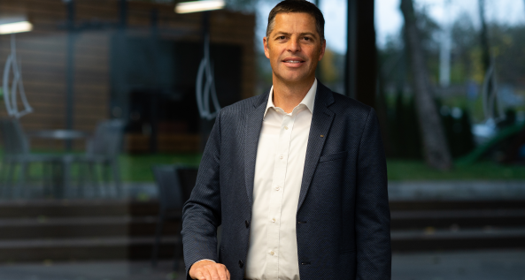 | Hannes Mitterweissacher follows Walter Schiegl: On 1 May 2022, Hannes Mitterweissacher will move from his current position as Division Director Technical/Production EGGER Decorative Products Central to the Group Management, where he will be responsible for the technical/production and purchasing area.
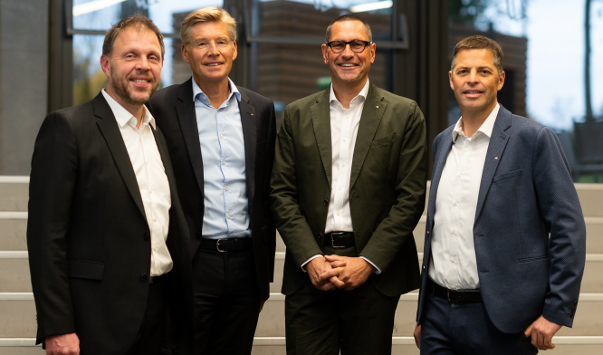 | The future EGGER Group Management from 1 May 2022 (f.l.t.r.): Frank Bölling, Ulrich Bühler, Thomas Leissing, Hannes Mitterweissacher.
PHOTOS: EGGER Holzwerkstoffe, reprints naming the copyright owner are free of charge
Picture download: https://egger.sharefile.eu/d-se6c46e19bcab49b492f635df95b59289

For queries:

FRITZ EGGER GmbH & Co OG
Holzwerkstoffe
Manuela Leitner
Weiberndorf 20
6380 St. Johann in Tirol
Austria
T +43 5 0600-10638
F +43 5 0600-90638
manuela.leitner@egger.com
www.egger.com

