Edging specialist Kromaplast becomes part of the EGGER Group
EGGER strengthens its service level in the European edging business
The EGGER Group has acquired 65% of the shares in the Italian edging specialist Kromaplast S.r.l., based in Cessalto in the Veneto region, in the heart of the Italian furniture industry. The closing took place on 30 September 2026. Kromaplast is a strong partner to the Italian furniture industry and specialises in the further processing, packaging, cutting to size and logistics of edging products. For EGGER, the majority investment represents a major strategic opportunity to further strengthen the service level and logistical availability of EGGER edging from its own plants in Gebze (TR) and Brilon (DE).
“With our specialised edging plant in Gebze (TR) and our site in Brilon (DE), we have two edging-producing plants within the EGGER Group. In Kromaplast, we have found a partner with whom we can make our edging service even more customer-oriented and flexible in one of Europe's most important furniture markets. We are very much looking forward to working with the entire team,” explains Tobias Neumann, Division Director Finance/Administration at EGGER Decorative Products Components, regarding the strategic background. Kromaplast became part of the EGGER Group as a service hub on 30.09.2026. It has been agreed that the purchase price and further details of the transaction will remain confidential.
Operational management of the site will remain with the previous shareholder and Managing Director Francesco Lorenzon. “In EGGER, we have found a partner who shares our values and supports the long-term further development of Kromaplast. For our customers, this step means one thing above all: continuity in day-to-day business combined with additional opportunities for the future. Together, we will further strengthen our market position and be able to offer our customers even more comprehensive solutions,” emphasises Francesco Lorenzon.
EGGER also recently announced its planned minority investment in Chinese edging manufacturer Sinowolf (see the respective press release here). The two investments have different strategic focuses: Sinowolf is a Chinese edging manufacturer with a strong market position in Asia, while Kromaplast provides comprehensive edging-related services for the Italian furniture industry.
High customer benefit
Founded in 1990, Kromaplast has since made a name for itself as a reliable partner to the Italian furniture industry. For this customer group, Kromaplast provides an important service and logistics platform for edging. The demand-driven, customer-specific service portfolio encompasses the further processing, packaging, cutting to size and delivery of edging products. “Kromaplast offers industrial service at a very high level. The customer benefit lies in particular in the high degree of flexibility and responsiveness thanks to on-site storage facilities and individual cut-to-size quantities. This is complemented by short transport routes and thus fast delivery capabilities. In Kromaplast, we have found a partner whose pronounced customer focus ideally complements our edging business. As a result, we will make our edging from Gebze and Brilon available even more quickly in future and further expand our service offering and delivery performance for the furniture industry in Italy,” says Daniel Nehring, EGGER Sales Director Edging.
Consistency and new opportunities
All 21 Kromaplast employees remain part of the team. Continuity and stability are the main focus for Kromaplast's customers. Existing contact persons and established service processes will remain unchanged.
At the same time, customers will benefit in future from the capabilities of the international EGGER Group, expanded development resources and a broader range of products and services. Combining Kromaplast's market and customer expertise with EGGER's industrial strength creates additional potential along the value chain.

Kromaplast becomes part of the EGGER Group
- The EGGER Group has acquired 65% of the shares in the Italian edging specialist Kromaplast S.r.l.  - Kromaplast is a strong partner to the Italian furniture industry with regards to edging. | - EGGER sees a great opportunity to further strengthen the service level and logistical availability of EGGER edging from the Gebze (TR) and Brilon (DE) plants.  - Kromaplast has been part of the EGGER Group as a service hub since 30 September 2026.

About the EGGER Group
EGGER is a leading international manufacturer of wood-based materials. Founded in 1961, the family-owned company with its headquarters in St. Johann in Tirol (AT) employs around 12,000 people and operates 22 production plants worldwide. EGGER develops and produces wood-based materials for furniture and interior design, wood construction and wood-based flooring. In the 2025/2026 financial year, the EGGER Group generated revenues of around EUR 4.26 billion and produced 10.9 million m³ of wood-based materials and timber.
As a family company, EGGER is committed to long-term development, financial stability and organic growth. Based on its mission statement "More from wood", EGGER works to use wood responsibly and keep it in the material cycle for as long as possible. In the 2025/2026 financial year, 66% of the wood that the EGGER Group used in its wood-based materials consisted of recycled material and by-products from the sawmill industry. 71% of the energy consumed Group-wide came from renewable sources. EGGER is pursuing the goal of gradually reducing its greenhouse gas emissions; to this end, it has set interim targets for 2030 and is aiming for Net Zero by 2050 in the long term.

Captions
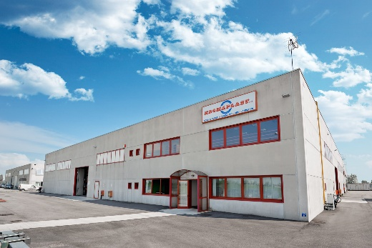 | Kromaplast becomes part of the EGGER Group. A major step for the service level in the edging business.
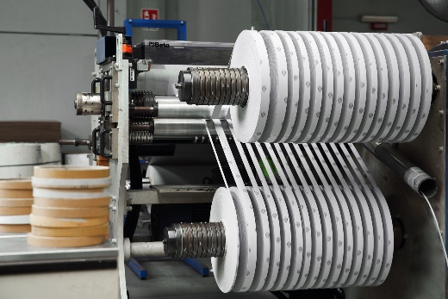 | Kromaplast is an established Italian specialist in the further processing, packaging, cutting to size and logistics of edging products.
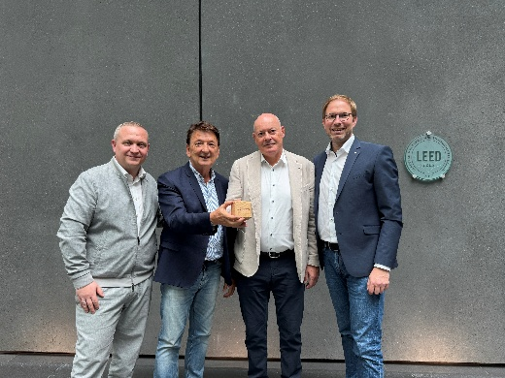 | Delighted about the collaboration, pictured from left: Daniel Nehring (EGGER Sales Director Edging), Paolo Tolotto (Senior Sales Advisor Kromaplast), Francesco Lorenzon (Managing Director Kromaplast) and Tobias Neumann (EGGER Division Director Components).
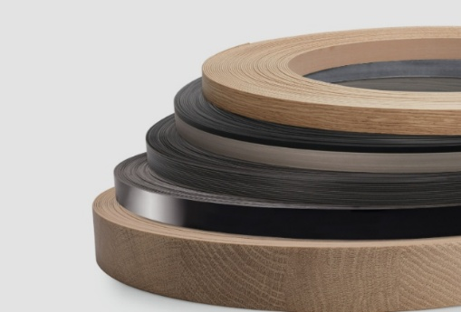 |  | EGGER produces edging at its Gebze (TR) and Brilon (DE) plants. EGGER edging is available in matching decor and texture combinations.

PHOTOS: Kromaplast / EGGER Holzwerkstoffe, free of charge if copyright holder is named
REPRODUCTION: All decors mentioned are reproductions.
Image download: https://celum.egger.com/pinaccess/showpin.do?pinCode=gzqkzlPIi478

For queries:

EGGER Holzwerkstoffe GmbH
Katharina Wieser
Weiberndorf 20
6380 St. Johann in Tirol
Austria
T +43 5 0600-10128
katharina.wieser@egger.com

