Fritz Egger celebrates his 75th birthday
He retires from the Supervisory Board of the wood-based material manufacturer.
Fritz Egger celebrated his 75th birthday on 15th November. He was a key leader of the EGGER Group for many decades. Together with his brothers Michael and Edmund, he was responsible for the strategic direction and successful international expansion of the family business from the 1980s onwards. In 2000, Fritz Egger retired from operational management and from then on was Chairman of the Supervisory Board. Fritz Egger is now stepping down from this role, following in the footsteps of his brother Michael Egger, who retired in 2022. Walter Schiegl, former member of EGGER Group Management and member of the Supervisory Board since 2022, will take over the role of Chairman of the Supervisory Board.
Fritz Egger, together with his brothers Michael and Edmund, took on entrepreneurial responsibility at an early stage in 1982 following the accidental death of their father, company founder Fritz Egger Sr. With vision and innovative strength, together they developed the EGGER Group into one of the world's leading manufacturers of wood-based materials, which today has 22 plants in 11 countries and around 12,000 employees.
Fritz Egger summarises his withdrawal from the Group's Supervisory Board as follows: "With our values of quality, respect and progress, we were able to successfully overcome challenges. As a solid, long-term orientated family business, we are also well positioned for the next generations."
Michael Egger Jr. is now the third generation member of the EGGER Group Management. He summarises the great work of his uncle: "Fritz has significantly shaped the company with his entrepreneurial courage and strategic vision. He was always guided by his understanding of values and the great conviction that our success can only be achieved through the strong commitment of our employees. We want to follow his example and continue to be a company where the handshake counts."
Changes in the Supervisory Board
The Supervisory Board determines the strategic direction of the international Group and advises the EGGER Group Management, which is responsible for the operational business. Fritz Egger handed over the chairmanship of the Supervisory Board to Walter Schiegl on his 75th birthday. The Supervisory Board of the EGGER Group now consists of Walter Schiegl, Robert Briem, Ewald Aschauer, Michael Stiehl and Alfred Wurmbrand.

Fritz Egger celebrates his 75th birthday

- Fritz Egger celebrated his 75th birthday on 15th November 2025 and retired from the Supervisory Board of the EGGER Group. | - Fritz Egger's role as Chairman of the Supervisory Board is taken over by Walter Schiegl.

About the EGGER Group
The family company, founded in 1961, is a leading international manufacturer of wood-based materials with approximately 12,000 employees and 22 production plants worldwide. EGGER is a full-range supplier for furniture and interior design, for wood construction and for wood-based flooring, making it a reliable partner for the furniture industry, wood and flooring retailers and DIY stores. In the 2024/2025 financial year, the EGGER Group generated a turnover of EUR 4.13 billion.
Sustainable business practices are a core focus for EGGER: The family business takes its responsibility for climate protection seriously and is committed to the ambitious Net Zero target by 2050. 66% of the wood used in EGGER wood-based materials already comes from recycling or sawmill by-products. At the end of their long service life, EGGER products are in turn largely recyclable and can be reintroduced into the cycle. EGGER is constantly working towards its goal of "creating more from the valuable resource wood" and thus enabling sustainable living and working.

Captions
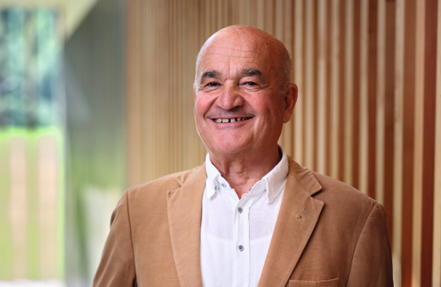 | Fritz Egger celebrated his 75th birthday and looks back on an eventful and successful career that is second to none.
PHOTOS: EGGER Holzwerkstoffe, reprints that quote the name of the copyright owner are free
Image download: https://celum.egger.com/pinaccess/showpin.do?pinCode=28Wxd3ZfvpRy

For queries:
EGGER Holzwerkstoffe GmbH
Katharina Wieser
Weiberndorf 20
6380 St. Johann in Tirol
Austria
T +43 5 0600-10128
katharina.wieser@egger.com

