EGGER turns 60
Since 1961, EGGER has developed from a Tirolean sawmill into one of the world's leading manufacturers of wood-based materials. The pioneering spirit of the founder, Fritz Egger sr., still characterises the company today. His sons Fritz and Michael Egger have positioned the company internationally and as a full-range supplier. On the occasion of its 60th anniversary, the family company presents a new corporate video.
Growth, continuous development of products and services as well as internationalisation and the opening up of new markets have characterised the last six decades. However, despite all these innovations, many things have remained constant over time at EGGER. "The passion for the unique material wood drives us every day anew. At the same time, we are still a family company with clear values: We want to be a partner one can rely on – for our customers, suppliers and employees. On this path, we have been able to develop from our Tirolean beginnings into an international presence," says Michael Egger.
Growth based on our own performance
Fritz Egger sr. set the foundation stone with his motto "Wood is far too valuable to simply throw away". In a trend-setting decision, he closed his sawmill in order to take a new path from then on: He wanted to refine wood scraps into a valuable product. On 18 December 1961, the first EGGER chipboard plant went into operation in St. Johann in Tirol (AT). 60 years later, the EGGER Group has 20 plants in 10 countries, 24 international sales offices and over 10,000 employees. The product range includes a comprehensive product portfolio of wood-based materials in matching decors and materials for furniture and interior design, for structural wood construction as well as for wood-based flooring. To this day, the values and visions of the founder are the basis of the company's business activities. "We make our decisions carefully. We operate sustainably and independently and invest what we have earned. We also believe in a handshake," says Fritz Egger. With this forward-looking and down-to-earth approach, growth is set to continue in the future.
New corporate video tells the EGGER story
On the occasion of the anniversary, the wood-based materials manufacturer presents a new, 13-minute corporate video. It tells the multi-faceted story of the EGGER Group and ventures a look into the past, present and future. The focus is on the perspectives of the employees. In addition to the owners and the Group Management, employees introduce the company and describe what makes EGGER special for them – from the first plant manager of the St. Johann site Manfred Dittrich to mechanical engineering apprentice Alexander Dorfer, from Russian quality manager Anastasiya Cherkasova to sales employee Roman Klejzerowicz from Poland. Employees from different areas and locations have their say. They are all united by the shared values within the Group and the enthusiasm for wood as a material. The video picks up on the themes that have always characterised the EGGER Group. These include: international growth, customer focus of products and services, responsible and transparent management, continuous innovation and further development, diverse development opportunities for employees and the value of good partnerships.
Passion connects
The strong growth of the last decades, with plants in Central, Western and Eastern Europe as well as North and South America, brings with it a high degree of diversity. In the meantime, employees from 77 nations work at the various locations. They are all united by the ambition to provide innovative solutions for customers and to continuously develop them further. With this extraordinary commitment, together with corporate responsibility – oriented towards future generations – the successful path of the EGGER Group is to be continued in the next 60 years.

About EGGER
The family company, founded in 1961, employs approximately 10,400 people. At 20 plants worldwide, they produce an extensive product range of wood-based materials (chipboards, OSB and MDF boards) as well as timber. The company generated a turnover of EUR 3.08 billion in the 2020/2021 business year and has worldwide customers in the furniture industry, wood and flooring retailers, as well as DIY markets. EGGER products are found in countless areas of private and public life, including kitchens, bathrooms, bedrooms, offices, hotels and shops. EGGER is a full-range supplier for the furniture industry, interior design, wood construction and wood-based flooring industries.

60 years EGGER

- The EGGER Group turns 60.  - On 18 December 1961, the first chipboard was produced in St. Johann in Tirol (AT). | - Today, the EGGER Group has 20 plants in 10 countries and over 10,000 employees.  - The new corporate video can be viewed here: www.egger.com/film  or on YouTube: https://youtu.be/ePx2fJQsbY8 (UK English)  https://youtu.be/eIL-32BKnes (US English)

Captions
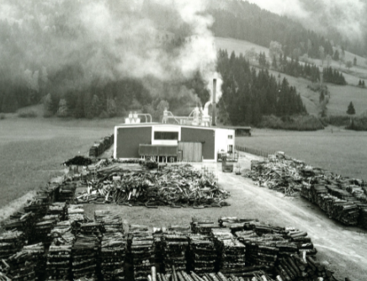 | At home in Austria, at home all over the world: the first chipboard plant in St. Johann in Tirol.
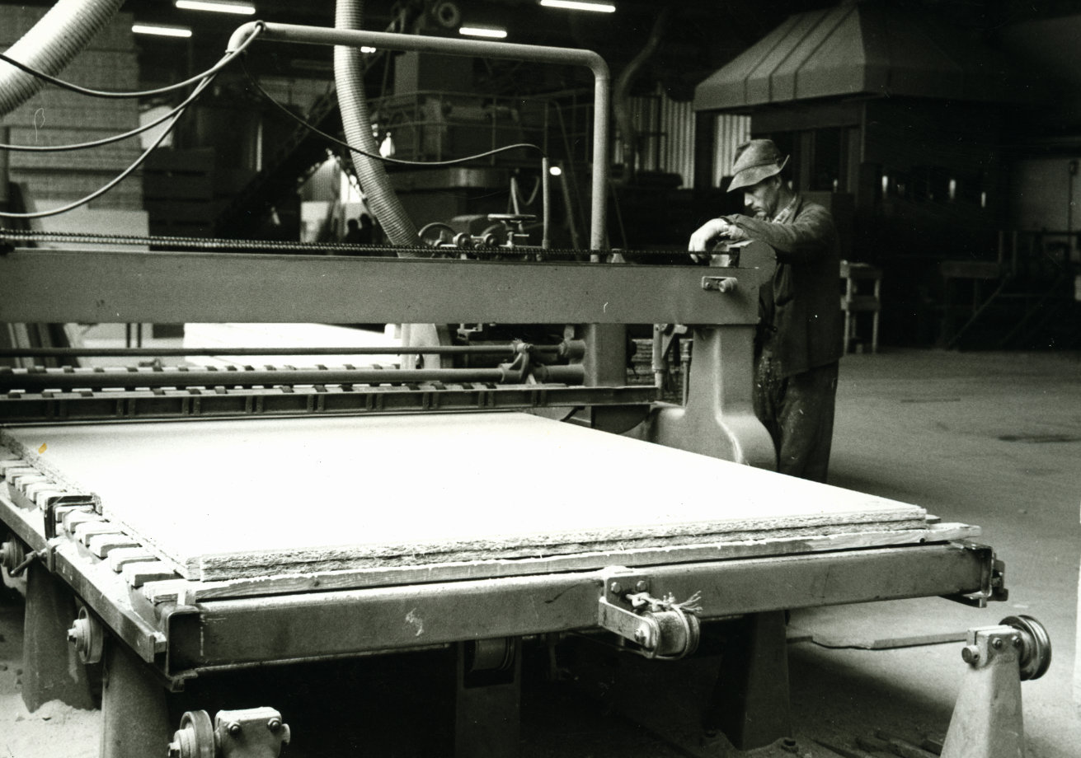 | On 18 December 1961, the first chipboard plant of the EGGER Group went into operation in St. Johann in Tirol.
 | On the occasion of its 60th anniversary, the EGGER Group presents a new corporate video.
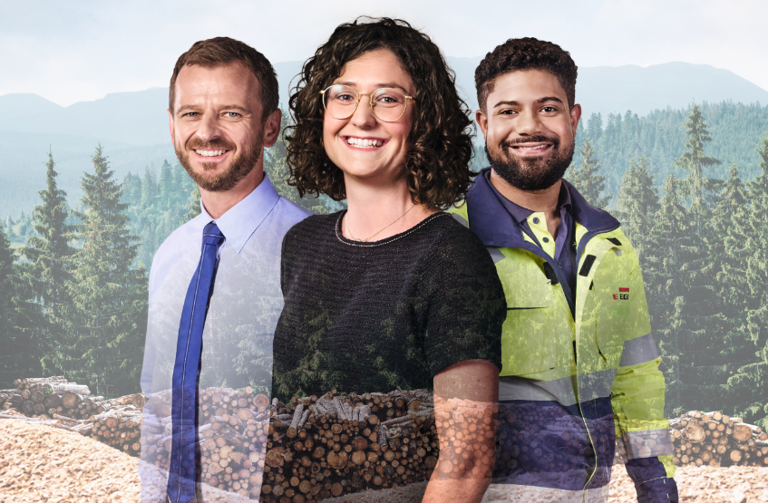 | Passion connects: 20 plants in 10 countries and over 10,000 employees make up the EGGER Group today.

PHOTOS: EGGER Holzwerkstoffe, reprints naming the copyright owner are free of charge
REPRODUCTION: All our mentioned decors are reproductions.
Picture download: https://egger.sharefile.eu/d-sbfdd15ba64c94c12b904021a310a68da

For queries:

FRITZ EGGER GmbH & Co OG
Holzwerkstoffe
Katharina Wieser
Weiberndorf 20
6380 St. Johann in Tirol
Austria
T +43 5 0600-10128
F +43 5 0600-90128
katharina.wieser@egger.com

