SAIB becomes part of the EGGER Group
EGGER acquires 60% of the shares in Italian wood-based materials manufacturer SAIB. Acquisition agreement closed on December 15, 2022.
SAIB, based in Caorso, near Piacenza, has been one of the leading wood-based materials manufacturers in Italy for 60 years, with a strong focus on design and sustainability. For the plant with around 200 employees, the majority shareholding by EGGER opens up further growth and synergies in this globally active group of companies. With this investment, EGGER is confirming its strategy of further growth in its home market of Europe.
Two family businesses, founded almost at the same time, with common values regarding sustainable business and reliable partnerships: EGGER's investment in SAIB is an ideal match and offers great development potential for both companies. The EGGER Group will take over 60% of the shares in SAIB. Additionally, in the long-term EGGER will potentially further increase the participation. The parties have agreed not to disclose the purchase price or further details of the transaction.

Joint growth opportunities
Thomas Leissing, Speaker of the EGGER Group Management, emphasises the synergies of the takeover: "Italy is one of the leading furniture producing countries in Europe, and SAIB is one of the leading suppliers for the Italian furniture industry. With the majority shareholding in SAIB, we are broadening our market access, increasing our capacity and expanding our product portfolio with Italian design expertise."
The members of the SAIB owner family Giuseppe Conti, Clara Conti and Sergio Doriguzzi will continue to manage the plant in Caorso. "The integration of our company into the international EGGER Group gives us a growth perspective for the Caorso production plant and our employees,” Clara Conti explains the company's share sale.
“We will be able to benefit of the experience and the network of a leading Group that has always been focused on production improvement and product quality,” say Sergio Doriguzzi and Giuseppe Conti. “Both companies are founded and developed by families and their common values, like attention to environmental sustainability and trust in their employees and workers. This represents a solid basis for building a common future characterized by continuity and innovation.”
The experienced team of 223 people in Italy will provide significant support for this joint growth course and contribute its experience to the EGGER Group. In particular, the sustainable, circular production processes perfectly contribute to the sustainability goals of the EGGER Group. The plant has been using entirely post-consumer recycled wood in production since 1994.

About SAIB
SAIB is one of the leading manufacturers and distributors of wood-based products in Italy. The third-generation family-run company employs 223 people at its Caorso (IT) site and produces around 600,000 m³ of raw and coated particleboard, supplying mainly the Italian furniture industry with innovative and high-quality design products. SAIB is a leader in the circular economy and has been using 100% recycled wood in its production for almost 30 years.
About EGGER
The family company, founded in 1961, employs approximately 10,800 people. At 20 plants worldwide, they produce an extensive product range of wood-based materials (chipboards, OSB and MDF boards) as well as timber. The company generated a turnover of EUR 4.23 billion in the 2021/2022 business year and has worldwide customers in the furniture industry, wood and flooring retailers, as well as DIY markets. EGGER products are found in countless areas of private and public life, including kitchens, bathrooms, bedrooms, offices, hotels and shops. EGGER is a full-range supplier for the furniture industry, interior design, wood construction and wood-based flooring industries.
_____________________________________________________________________________________________
SAIB becomes part of the EGGER group

- EGGER acquires 60% of the shares in the Italian wood-based materials manufacturer SAIB on December 15, 2022.  - Therefore, the 21st EGGER plant will be in Italy.  - The EGGER Group wins 223 new colleagues. | - SAIB is a leader in the circular economy and has been using 100% recycled wood in production for almost 30 years.  - The members of the SAIB owner family Giuseppe Conti, Clara Conti and Sergio Doriguzzi will continue to manage the Caorso site.
____________________________________________________________________________________________

Images
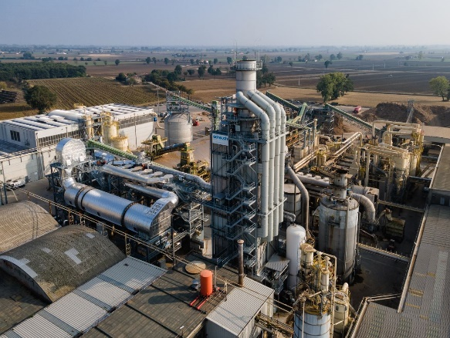 | SAIB, based in Caorso, near Piacenza, is one of the leading suppliers for the Italian furniture industry.
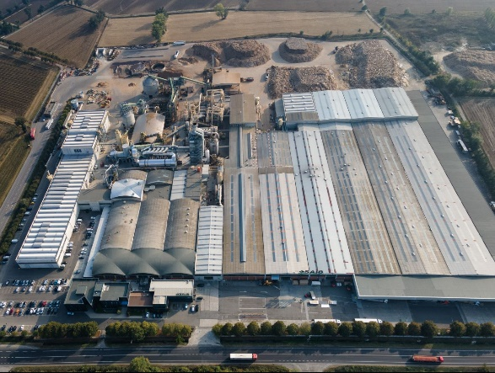 | The family-run company SAIB has existed for 60 years and produces exclusively with post-consumer recycled wood.
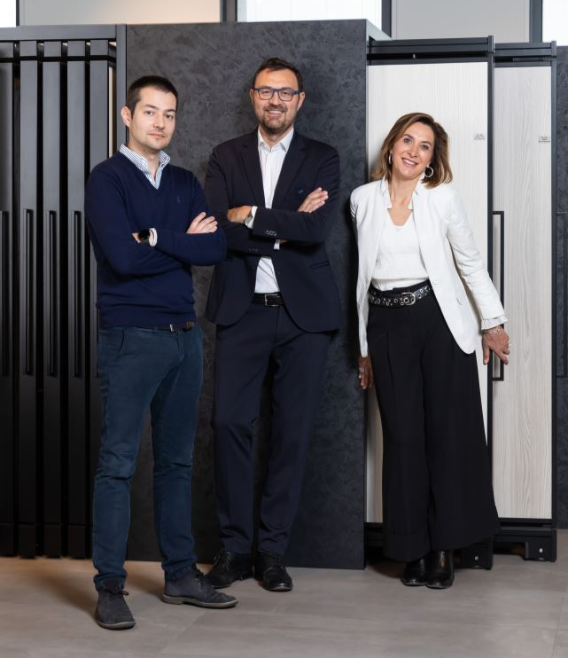 | The members of the SAIB owner family Sergio Doriguzzi, Giuseppe Conti and Clara Conti (from left to right) will continue to manage the plant.
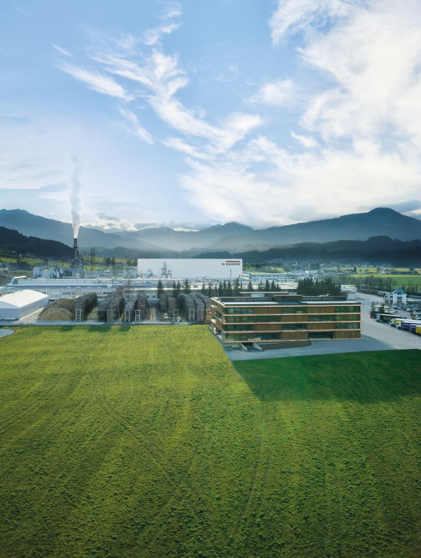 | The EGGER Group has its headquarters in St. Johann in Tirol (AT). The 21st EGGER plant will now be in Italy.

PHOTOS: EGGER Holzwerkstoffe/SAIB
PHOTO-download: https://celum.egger.com/pinaccess/showpin.do?pinCode=EsNT56tevnfN

For queries:
FRITZ EGGER GmbH & Co. OG
Holzwerkstoffe
Manuela Leitner
Weiberndorf 20
6380 St. Johann in Tirol
Austria
T+43 5 0600-10638
F+43 5 0600-90638
manuela.leitner@egger.com

