EGGER Group: Satisfactory company performance at the half-year mark
The EGGER Group, headquartered in St. Johann in Tirol (AT), closed the first half of its 2022/2023 financial year (reporting date 31 October 2022) with consolidated sales of EUR 2.26 billion (+14.0% as compared to the previous year). This increase in sales is primarily due to the sharp rise in costs for raw materials, energy and logistics, which led to higher sales prices. The many uncertainties and crises and their effects on the energy and raw material markets, as well as massive inflation and the resulting loss of purchasing power, have caused a noticeable decline in demand. The outlook for the second half of the year is therefore reserved.
The first half of the 2022/23 financial year was marked by a multitude of crises and uncertainties, both economically and politically. Thomas Leissing, Chief Financial Officer EGGER Group and Speaker of the Group Management: "The very strong results of the previous year are due to the extremely high demand following the cocooning effect that resulted from the Corona crisis, and can therefore be classified as exceptional. This boom in demand has noticeably decreased since spring 2022. In the meantime, we are seeing a decline in demand in almost all markets. At the same time, we continue to face a multitude of uncertainties."
Demand noticeably declined
During the first half-year 2022/23 EGGER was able to generate sales of EUR 2,255.4 million (+14.0% as compared to the first half-year 2021/22) and an EBITDA of EUR 353.7 million
(–26.1% compared to the previous year). The EBITDA margin is 15.7%, the shareholder’s equity ratio is at the high level of 51.2%.
This result reflects the highly volatile conditions and developments of the past months. The decline in earnings is spread across all divisions, taking into account that the same period of the previous year was also characterised by an exceptionally good market environment and margin level in all areas. The decline was most pronounced in the Building Products Division, which had achieved record results in the previous year due to the construction boom. In the Decorative Products Division, volume increases were achieved only in the newest plant, in Lexington, NC (US). The Eastern European plants, where the effects of the Ukraine crisis were felt most directly, posted the largest declines in earnings. Earnings in the Flooring Products Division also declined due to falling demand, especially in the DIY sector.
Continued investment in the plants
It has always been part of the EGGER strategy to continuously develop the Group. Ongoing investments are made in existing plants to keep them at the cutting edge of technology. In the first half of the year, investments amounted to EUR 229.7 million (141.1 million in the same period last year). This capital expenditure went in particular to projects for backward integration, for increasing sustainability performance in production, as well as for optimising the internal flow of materials and increasing efficiency in warehousing.
Challenges concerning raw material and energy markets
The situation on the global raw material and energy markets was and remains extremely challenging. In the first half of 2022/23, prices on all raw material markets relevant to EGGER rose significantly and remain at a very high level. Availabilities were also under pressure. The top priority of EGGER's purchasing strategy was therefore always to secure the supply of the essential raw materials wood, chemicals and paper to all plants and to reliably supply customers. With regard to a potentially threatening energy shortage, EGGER is well secured at all major locations thanks to its own biomass power plants. With this strategy, EGGER is striving to decouple itself from fossil fuels as far as possible, while at the same time avoiding the purely thermal utilisation of raw materials and promoting the cascading use of the valuable raw material wood.
Outlook for second half-year fraught with uncertainties
The overall economic outlook remains fraught with uncertainty for the coming months and will continue to be strongly influenced by the challenges on the energy and raw material markets. This means that earnings expectations for the second half of the 2022/23 financial year are also reserved. In the medium term, EGGER expects price levels to remain high and sales to remain stable, but with moderate demand from the main markets. In the long term, the EGGER Group will continue to exploit the production advantages of its state-of-the-art industrial base. Given its sustainable business model and strong financial base, EGGER will not only weather the current economic slowdown well, but will even emerge stronger.
Growth thanks to acquisition in Italy
Together with its approximately 10,900 employees worldwide, EGGER will continue to grow and make more from wood in the future as well. Another important step on this path has already been taken recently: As communicated last week, EGGER acquired, on 15 December 2022, 60% of the shares in the Italian wood-based material manufacturer SAIB. SAIB, based in Caorso, near Piacenza, has been one of the leading wood-based material manufacturers in Italy for 60 years, with a strong focus on design and sustainability. With this acquisition, EGGER is confirming its strategy of further growth in its home market Europe.
The EGGER half-year financial report for 2022/23 is now available online.

About EGGER
The family company, founded in 1961, employs approximately 10,900 people. In 20 plants across the world, they produce an extensive product range of wood-based materials (chipboard, OSB and MDF board) as well as timber. The company generated sales of EUR 4.23 billion in the 2021/2022 financial year. EGGER has global customers in the furniture industry, wood construction and flooring retail, as well as DIY markets. EGGER products are found in countless areas of private and public life, including kitchens, bathrooms, offices, living rooms and bedrooms. EGGER is a full-range supplier for the furniture and interior design industry, for wood construction and wood-based flooring industries.

Half-year financial statement of the EGGER Group
- Sales for the first half of the financial year 2022/23:  EUR 2.26 billion (+14 % as compared to the previous year)  - EBITDA was EUR 353.7 million  (–26.1% as compared to the previous year) | - Increase in sales primarily due to strong rise in costs for raw materials, energy and logistics  - Decline in earnings in all product areas: most significant decline in the Building Products category  - Outlook for the second half of the year reserved

For queries:

FRITZ EGGER GmbH & Co OG
Holzwerkstoffe
Manuela Leitner
Weiberndorf 20
6380 St. Johann in Tirol
Austria
T +43 5 0600-10638
F +43 5 0600-90638
manuela.leitner@egger.com
Captions
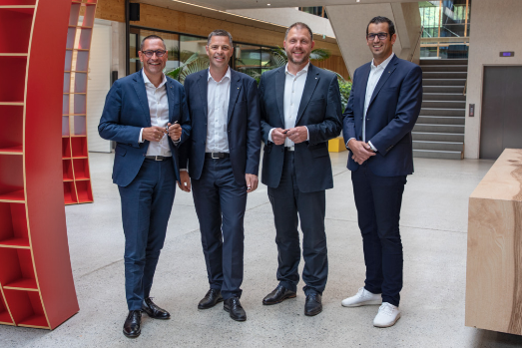 | The EGGER Group Management (from left to right): Thomas Leissing (Chief Financial Officer EGGER Group and Speaker of the Group Management), Hannes Mitterweissacher (Chief Technology Officer EGGER Group), Frank Bölling (Chief Supply Chain Officer EGGER Group) and Michael Egger jun. (Chief Sales Officer EGGER Group).
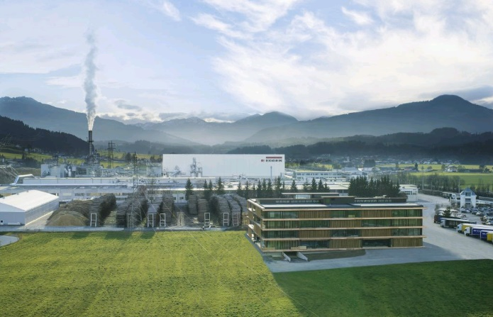 | The EGGER Group, headquartered in St. Johann in Tirol (AT), closes its first half-year of the 2022/23 financial year with sales of EUR 2.26 billion.
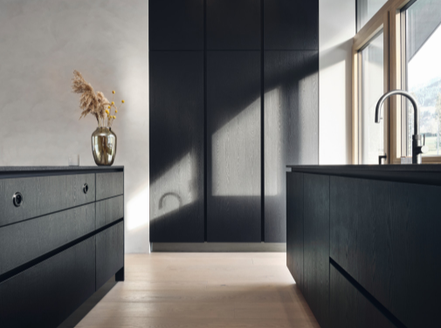 | The highly volatile general conditions are also a challenge for the EGGER Group: it is experiencing a decline in demand.
PHOTOS: EGGER Holzwerkstoffe, reprints naming the copyright owner are free of charge
REPRODUCTION: All our shown and mentioned decors are reproductions.
For download: https://celum.egger.com/pinaccess/showpin.do?pinCode=ciDVM3zKr86T

