Half-year results: EGGER Group holds its own in a difficult environment with stable development
The EGGER Group, headquartered in St. Johann in Tirol (AT), achieved stable business development against the previous year's level in the first half of the 2025/2026 financial year, despite a persistently challenging market environment. The EGGER Group closed the first half of the 2025/2026 financial year (reporting date 31 October 2025) with consolidated revenues of EUR 2.15 billion (+2.6% compared to the same period of the previous year). The ongoing weakness in consumer spending, weak construction activity in the core markets and global uncertainties characterised the general conditions. Thanks to its solid financial basis and consistent implementation of its long-term strategy, the family company was able to secure stability and continue to make far-reaching investments in its own plants.
Thomas Leissing, Speaker of the EGGER Group Management and responsible for Finance/Administration: "Of course we would like to see a more dynamic development. However, given the duration and intensity of the economically challenging phase in which we have found ourselves for some time now, we are satisfied. For us, stability in no way means stagnation; on the contrary, we use it as a basis for targeted investments in the future, sustainability and innovation. We would like to thank our highly committed 12,000 employees worldwide, whose dedication and competence have made a significant contribution to this stable result."
Key financial figures and business development
In the first half of 2025/2026, the EGGER Group generated revenues of EUR 2,148.1 million (+2.6% compared to the first half of 2024/2025) and EBITDA of EUR 293.3 million (-8.4% compared to the same period of the previous year). The EBITDA margin is 13.7% and the equity ratio is at the high level of 41.5%. The markets in Eastern Europe and overseas developed positively, while efficiency and innovative strength were required in Western and Central Europe in order to counter the strong competition within weak markets.
The area of decorative products for furniture and interior design achieved unconsolidated revenues of EUR 1,907.8 million (+2.6% compared to the same period of the previous year). The slight increase in revenues was spread evenly across all regions and resulted primarily from slight volume and price increases. EBITDA in this product segment is below the previous year's figure, which is primarily due to weaker results in Western Europe. The product area for wood construction and flooring generated unconsolidated sales of EUR 365.1 million (+4.0% compared to the same period of the previous year). Although this represents a slight increase in sales, the earnings situation remains extremely tense. Demand in the flooring segment in particular is weak and the lack of new construction activity could only be partially offset by renovations.

Consistent investment activity
Even in the current challenging market environment, EGGER continued to pursue its long-term investment strategy for capacity expansion and sustainability projects at its plants. Investments totalled EUR 248.6 million in the first half of the year (in the same period last year it was EUR 218.4 million). Particularly noteworthy is the major multi-stage project at the Markt Bibart plant (DE) - one of the largest investment projects in the industry: over EUR 200 million will be invested there in sustainability, upgrading and automation by 2026. One milestone is the new processing facility for recycled wood, which has started operation gradually since autumn 2025. In future, it will enable the use of recycled wood in particleboard production - a key step for the circular economy. At the same time, upgrading capacities are gradually being built up at the location. At the beginning of 2026, the production of laminated particleboard with trendy decors will start on a new short-cycle press.
Investments in the sustainable development of the plants, the circular economy and climate protection were also driven forward at other locations. New Timberpak recycling collection sites were opened and the processing capacities for recycled wood were expanded at several plants. At the headquarters in St. Johann in Tirol (AT), the construction of the second power plant, which will supply even more renewable energy from biogenic fuels, is making great progress.
Setting new impulses
EGGER's innovative and premium product portfolio creates real added value for customers. This ambition is seamlessly continued with the new EGGER Decorative Collection 26+, which will be launched in February 2026. With more than 360 decor and texture combinations as well as decor, product and surface innovations and digital services, this update of the successful retail collection responds flexibly to current market trends and customer needs, while also offering planning security and providing a globally standardised decor and product portfolio.
Reserved outlook for the 2nd half of the year
The overall economic outlook remains challenging, even though the low point of the downturn appears to have passed. The ongoing price pressure due to weak demand is nevertheless expected to continue in the current financial year. This also results in reserved revenue and earnings expectations for the EGGER Group in the second half of the 2025/2026 financial year.
With its solid financial basis, future-oriented energy supply from its own biomass power plants, long-term, successful relationships with customers and suppliers, productivity advantages built up over many years in its plants and, above all, the reliable commitment of over 12,000 qualified and motivated employees, EGGER considers its competitive position to be secure. The family company is convinced that it is in an ideal starting position for a future economic upturn.

Half-year financial statement of the EGGER Group
- Revenues in the first half of the 2025/2026 financial year:  EUR 2.15 billion (+2.6% compared to the same period of the previous year)  - EBITDA totalled EUR 293.3 million  (-8.4% compared to the same period of the previous year)  - Stable development despite challenging environment | - Outlook for the second half of the year reserved  - Strategic investments in the plants continued consistently  - The EGGER half-year financial report 2025/2026 is now available online.

About the EGGER Group
The family company, founded in 1961, is a leading international manufacturer of wood-based materials with approximately 12,000 employees and 22 production plants worldwide. EGGER is a full-range supplier for furniture and interior design, for wood construction and for wood-based flooring, making it a reliable partner for the furniture industry, wood and flooring retailers and DIY stores. In the 2024/2025 financial year, the EGGER Group generated a turnover of EUR 4.13 billion.
Sustainable business practices are a core focus for EGGER: The family business takes its responsibility for climate protection seriously and is committed to the ambitious Net Zero target by 2050. 66% of the wood used in EGGER wood-based materials already comes from recycling or sawmill by-products. At the end of their long service life, EGGER products are in turn largely recyclable and can be reintroduced into the cycle. EGGER is constantly working towards its goal of "creating more from the valuable resource wood" and thus enabling sustainable living and working.

For queries:
EGGER Holzwerkstoffe GmbH
Katharina Wieser
Weiberndorf 20
6380 St. Johann in Tirol
Austria
T +43 5 0600-10128
katharina.wieser@egger.com

Captions
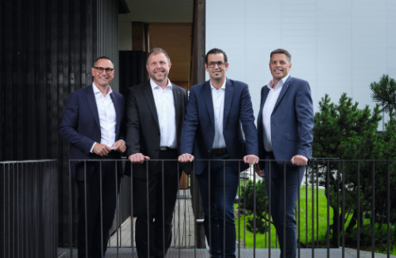 | The EGGER Group Management (from left): Thomas Leissing (Chief Financial Officer and Speaker of the Group Management), Frank Bölling (Chief Supply Chain Officer); Michael Egger Jr. (Chief Sales Officer) and Hannes Mitterweissacher (Chief Technology Officer)
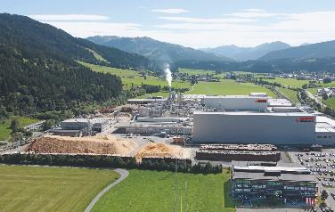 | The EGGER Group, headquartered in St. Johann in Tirol (AT), closed the first half of the 2025/2026 financial year with revenues of EUR 2.15 billion.
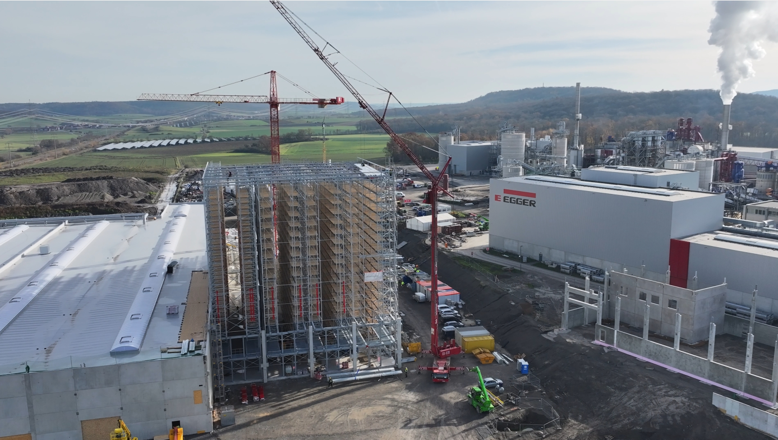 | Rapid construction progress in one of the largest investment projects in the industry. The EUR 200 million investment in the expansion of the Markt Bibart (DE) plant is progressing fast.
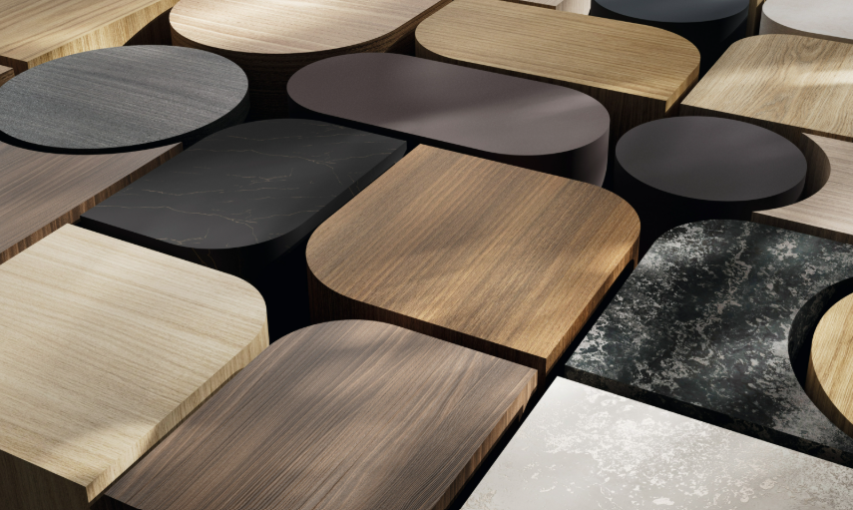 | The new EGGER Decorative Collection 26+ will be launched in February 2026 with 360 decor/texture combinations under the motto "Space for solutions". EGGER is a reliable partner for its customers in times of constant change.
PHOTOS: EGGER Holzwerkstoffe, reprints that quote the name of the copyright owner are free
Image download: https://celum.egger.com/pinaccess/showpin.do?pincode=ln1lrp0pdpgk

