EGGER Group: Sales and earnings growth at half-year
The EGGER Group, headquartered in St. Johann in Tirol (AT), closed the first half of its 2021/2022 financial year (reporting date 31st October 2021) with consolidated sales of EUR 1.98 billion (+36.5% as compared to the previous year). The special economic situation in the construction and furniture sector as well as the capacity increases of new plants contributed significantly to the result. The situation on the raw material markets was challenging. The outlook for the second half of the year is optimistic despite existing uncertainties.
The corona pandemic and its effects on the economy and society were also decisive factors for the EGGER Group in the first half of the 2021/2022 financial year. The special situation in which the industry has found itself since summer 2020 remained in place. The strong increase in demand at an exceptionally high level continued. Thomas Leissing, EGGER Group Management Finance/Administration/Logistics: "The so-called cocooning effect, i.e., the increased consumer investment in one's own home, as well as the uninterrupted new construction activities in almost all regions of the world are the main drivers behind the high demand for our products. We are pleased that we have been able to make good use of the opportunities offered by this market setting. At the same time, the pandemic also presents us with significant challenges, especially in the area of raw material supply."
Demand at an extremely high level
During the first half-year 2021/2022, the EGGER Group was able to generate sales of EUR 1,978.1 million (+36.5% compared to the first half-year 2020/2021) and an EBITDA of EUR 478.6 million (+62.9% compared to the previous year). The EBITDA margin is 24.2%, the shareholder’s equity ratio is at the high level of 47.1%.

This result reflects the high level of demand. In order to meet this demand, production capacities were utilised to the maximum in all plants. The new EGGER plants in Biskupiec (PL), where volumes were significantly increased, and in Lexington, NC (US), contributed significantly to the increase in sales and results. The start-up losses could be reduced in the US. In addition, the product mix was optimised in all plants. In particular, the building products product area recorded disproportionately high growth, triggered by exceptional demand in the US. The increases can also be partly explained by the weaker sales in the previous year's months of May and June 2020, which were still characterised by lockdown-related sales weaknesses at the beginning of the pandemic.
Significant growth in the building products area
The Decorative Products area for furniture and interior design, with its four regional divisions West, Central, East and Americas, generated sales of EUR 1,596.6 million (+34.4% compared to the previous year). In the Flooring Products Division, sales growth was +23.8% in the first half of 2021/2022. A total of EUR 242.2 million was generated from flooring. The Building Products Division increased sales by +75.7% to EUR 273.4 million. The sawmill in Brilon (DE) had a large share in the sales growth in this division. The global market setting for timber was very positive, especially due to exceptional demand in the US.

Growth based on our own performance
It has always been part of the EGGER strategy to continuously develop the Group. Ongoing investments are made in existing plants to keep them at the cutting edge of technology. In the first half of the year, investments amounted to EUR 141.1 million. These investments were primarily aimed at optimising the internal material flow and increasing the efficiency of warehousing. In addition, the EGGER Group is focusing on resource-saving technologies with systems for the processing of recycling material.

Massive challenges on raw material markets
Since the beginning of the year, the supply situation on the global raw materials markets has become increasingly tense - a dynamic that has intensified considerably in recent months. This applies in particular to the chemical raw materials needed for wood-based materials, edging and surface production. The situation is aggravated by the sharp rise in energy as well as transport costs and the greatly reduced transport capacities and internationally shifted trade flows. Since raw material and energy costs account for a significant share of total costs, there have been considerable cost increases.

Stable expectations for the second half-year
Despite continued uncertainties due to the corona pandemic, the overall outlook for the second half of the 2021/2022 financial year is positive. Challenges include volatility in raw material costs, reduced logistics capacity and inflation risks that could lead to reduced consumption. Traditionally, construction activity is limited in the winter and therefore the second half of the financial year is weaker. EGGER Group Management expects a stable development of the main markets and emphasises that the company, with its modern industrial base, its broad product range, its solid financial basis and, last but not least, its approximately 10,600 motivated and loyal employees, is very well positioned to face any new challenges.
The EGGER half-year financial report for 2021/2022 is now available at www.egger.com/credit-relations.

About EGGER
The family company, founded in 1961, employs approximately 10,600 people. At 20 plants worldwide, they produce an extensive product range of wood-based materials (chipboards, OSB and MDF boards) as well as timber. The company generated a turnover of EUR 3.08 billion in the 2020/2021 business year and has worldwide customers in the furniture industry, wood and flooring retailers, as well as DIY markets. EGGER products are found in countless areas of private and public life, including kitchens, bathrooms, bedrooms, offices, hotels and shops. EGGER is a full-range supplier for the furniture industry, interior design, wood construction and wood-based flooring industries.

Half-year financial statement of the EGGER Group

- Sales for the first half of the financial year 2021/2022:  EUR 1.98 billion (+36.5% as compared to the previous year)  - EBITDA was EUR 478.6 million  (+62.9% as compared to the previous year) | - All product areas contributed to the positive development: disproportionate growth in the building products area  - Outlook for the second half of the year stable despite uncertainties

For queries:

FRITZ EGGER GmbH & Co. OG
Holzwerkstoffe
Katharina Wieser
Weiberndorf 20
6380 St. Johann in Tirol
Austria
T +43 5 0600-10128
F +43 5 0600-90128
katharina.wieser@egger.com

Captions
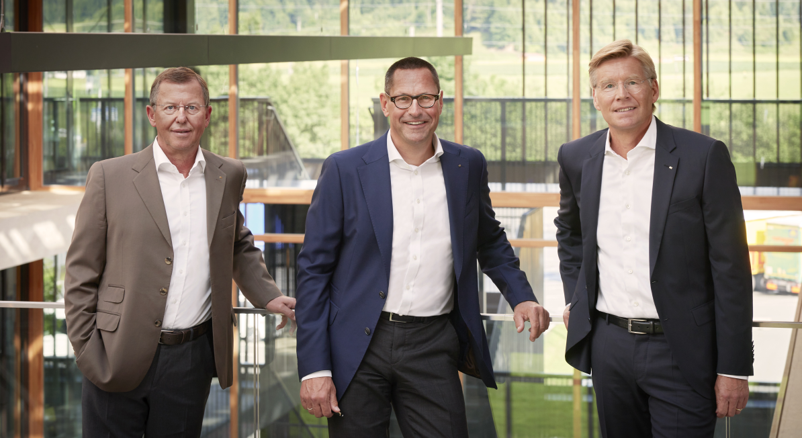 | The EGGER Group Management from left to right: Walter Schiegl (Group Management Technical/Production/Purchasing), Thomas Leissing (Group Management Finance/Administration/Logistics), Ulrich Bühler (Group Management Sales/Marketing)
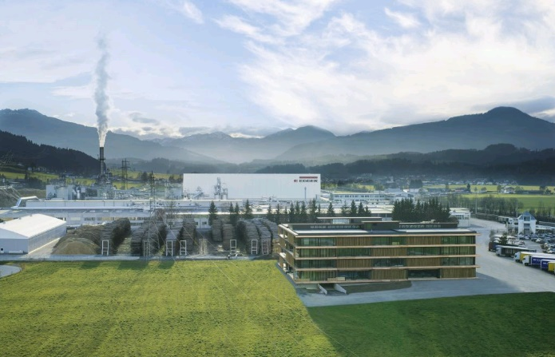 | The EGGER plant at the St. Johann in Tirol (AT) headquarters.
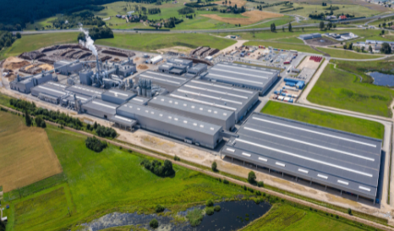 | The capacity increases of new plants contributed to the positive development. The EGGER plant in Biskupiec (PL) was opened in 2019.

PHOTOS: EGGER Holzwerkstoffe, reprints naming the copyright owner are free of charge
REPRODUCTION: All our mentioned decors are reproductions.
For download: https://celum.egger.com/pinaccess/showpin.do?pinCode=feLuAPg3WjPI

