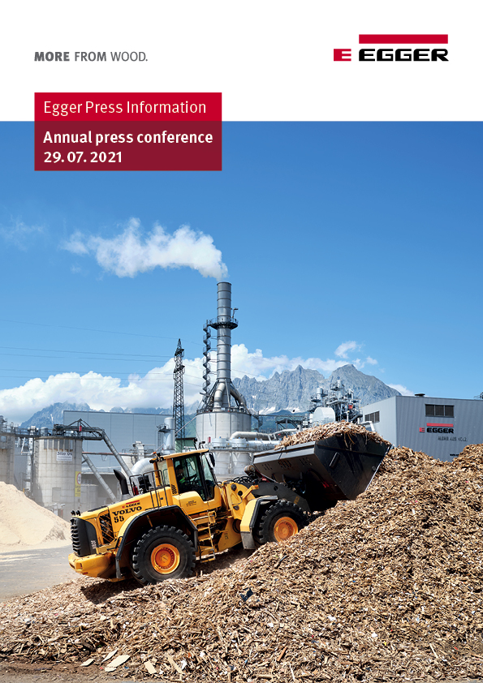

Your contacts

 |  | 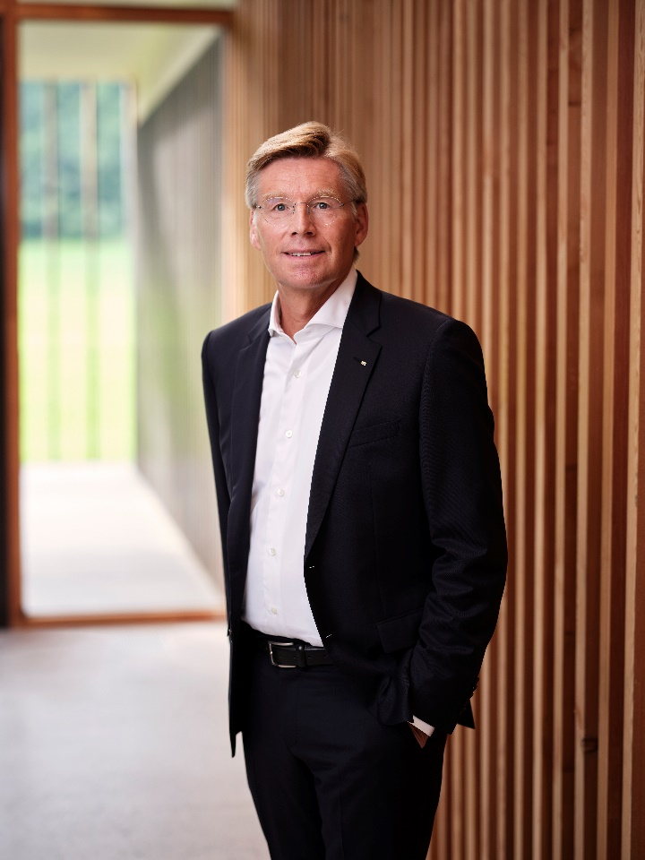
Thomas Leissing  Head of Finance /  Administration / Logistics  EGGER Group;  Spokesman for Group Management | Walter Schiegl  Head of Production / Technology  EGGER Group | Ulrich Bühler  Head of Sales / Marketing  EGGER Group

For queries:

FRITZ EGGER GmbH & Co.
Holzwerkstoffe
Katharina Wieser
Weiberndorf 20
6380 St. Johann in Tirol
Austria
T +43 5 0600-10128
katharina.wieser@egger.com
Crisis-proof: EGGER Group closes 2020/2021 business year with EUR 3.08 billion turnover
Global sales growth thanks to new production capacities and special situation in the construction and furniture sector - challenges in raw material procurement
With the close of the EGGER Group's business year on 30.04.2021, the company looks back on a special situation for the past twelve months. After Corona-related effects at the beginning of the business year, EGGER experienced a strong increase in demand in almost all markets from the summer of 2020 onwards, which has remained at an exceptionally high level to this day. In order to be able to meet this demand, production capacities are being utilised to the maximum at all EGGER plants and record quantities are being produced. The recent capacity increases at the new EGGER plants in Biskupiec (PL) and Lexington, NC (USA) also contributed to the positive development.
"We are of course pleased with the positive annual result. It is due on the one hand to the special economic situation, but also to our rapid and comprehensive emergency measures at the beginning of the pandemic," explains Thomas Leissing, spokesman for the Group Management and responsible for finances, administration and logistics. Overall, EGGER can report a stable development of its key figures for the business year 2020 / 2021: The Group generated revenue of EUR 3,082.8 million (+8.9 % compared to the previous year) and EBITDA of EUR 622.3 million (+46.6% compared to the previous year). The EBITDA margin is 20.2% (previous year 15.0%), the equity ratio is 42.0% (previous year 37.9%). “This clear development shows that at EGGER, on the one hand, we have coped well with the challenges of the pandemic, and at the same time, we have also made very good use of the opportunities that have arisen in our industry.
In addition, the new plant in Biskupiec (PL) in particular made a significant contribution to the increase in earnings."

EGGER keeps growing
The wood-based materials manufacturer attributes the continued high demand to the cocooning effect associated with the pandemic protective measures and lockdowns, i.e. the massively increased consumer investment in one's own home. “The boom in furniture, flooring and building products is very gratifying for our industry, but it also presents us with great challenges. We would therefore like to expressly thank our approximately 10,400 employees, who have contributed to these results and to a new peak production quantity of 9.6 million m³ of wood-based materials and timber in this challenging business year," says Walter Schiegl, EGGER Group Management Production & Technology.
A milestone in the past business year was the commissioning of the 20th production site in Lexington, NC, USA - the first EGGER plant in North America. Despite the difficult conditions and the ongoing special situation, the plant was able to go into operation on schedule in September 2020.
Very high demand worldwide
After pandemic-related effects at the beginning of the business year, EGGER experienced a strong increase in demand in almost all markets from the summer of 2020 onwards, which has remained at an exceptionally high level to this day. “The high demand, especially from the trade, craft and furniture industry sectors, is still a reality, despite lockdowns in almost all of Europe. In addition, there was already a significant backlog of construction projects in many parts of Europe before the pandemic," Ulrich Bühler, EGGER Group Management Sales & Marketing, describes the situation. “Our top priority was and is the reliable supply of our customers. To this end, we make the best possible use of our capacities and try to serve customer needs via various supply plants."
Overall, EGGER was able to record a strong increase in demand in almost all markets worldwide in this environment and increase sales compared to the previous year, in some cases significantly:
The Decorative Products Central Division generated in the last business year a turnover of EUR 930.4 million (+4.9 % compared to the previous year). At EUR 690.9 million, sales in the Decorative Products West Division were +4.2% higher than in the previous year. This division, with plants in Great Britain and France, was particularly affected by the economic downturn caused by the Corona pandemic; lower sales were recorded there in May and June 2020. However, these were made up for in the following months.
The turnover in the Decorative Products East Division rose by +10.8 % to EUR 981.8 million. The new plant in Biskupiec (PL) developed particularly positively in this division. The latest Decorative Products Americas Division increased turnover by +32.0 % to EUR 181.2 million. In addition to the Argentinean site in Concordia, this already includes turnover in North America through the newest plant in Lexington, NC (USA).
The Flooring Products Division, with turnover of EUR 552.5 million, is +25.3 % above the previous year. The Other segment has a turnover of EUR 201.5 million (+16.0 % compared to the previous year) and includes the sawmill in Brilon (DE), smaller independent divisions and Group functions.
The development of earnings in the divisions varied. In May 2020, lower results were recorded across the board due to the Corona pandemic. The Decorative Products West Division was particularly affected. Overall, all divisions were even able to exceed the previous year's results, with the exception of the Decorative Products Americas Division due to high start-up costs for the Lexington, NC (US) site.
All detailed information on the 2020/2021 business year can be found in the annual financial report at www.egger.com/credit-relations.
Challenges in the supply of raw materials
At the beginning of the 2020/2021 business year, the raw material prices that are essential for EGGER initially developed in a decreasing trend, but due to the globally disrupted flows of goods, they have been rising sharply in some cases since January 2021. As raw material and energy costs account for a significant proportion of total costs, securing and constantly improving availability and monitoring price trends is a top priority for EGGER. The wood-based materials manufacturer has therefore always relied on long-standing and reliable partners for the supply of raw materials.
Optimistic outlook for 2021/2022
The Group Management is certain that EGGER will be able to continue to get through the Corona crisis in good shape with this forward-looking, sustainable approach to business. “We are well positioned as a solid family business. The EGGER Group has a modern industrial base and a solid financial structure. Our strategy of backward integration and sustainable investments, our focus on regionality, our partnership-based supplier and customer relationships and the great loyalty of our staff are proving their worth," emphasises Thomas Leissing.
Projections are currently difficult due to the lack of reliable forecasts on the development of the pandemic and possible further lockdown measures. Despite these uncertainties, EGGER anticipates a positive development in the 2021/2022 business year. “We expect demand from the market to remain high and will serve our customers to the fullest extent possible while fully utilising our capacities," says the EGGER Group Management.
Although some of the production and sales markets are currently still in crisis, there are signs of increasing demand in almost all markets and with all product areas. Greater uncertainties may arise from the further development of the effects of the Corona pandemic, which are now expected to vary locally, from the effects of Brexit, the political situation in the Middle East and Turkey, the currency and inflation and economic development in Argentina and the trade dispute between the USA and China and its effects on the global economy.
The development of the raw materials markets, and especially the current shortage of chemical products, also continue to pose a risk. EGGER counteracts this by commissioning additional refinement capacities and investments to improve the raw material and energy situation, as well as with the continuous optimisation of material use and costs structure.
Sustainable. Innovative. Reliable.
Further information on raw material procurement as well as on all other material sustainability topics can also be found in the EGGER Group's Sustainability Report (non-financial statement) at www.egger.com/sustainability, which is published at the same time as the annual financial report. It contains the Group's strategy, objectives and performance with regard to economic, ecological and social sustainability. With the report, EGGER transparently discloses its strategic sustainability goals and again underlines its clear commitment to sustainable, generation-oriented business. The current report contains the EGGER Group's commitment to the United Nations Sustainable Development Goals (SDGs). The wood-based materials manufacturer shows how it works towards the goals and sub-goals of the Agenda 2030 in its business activities in order to make the greatest possible contribution to achieving them. This once again confirms the family company's pioneering role as a responsible player.

EGGER Group closes 2020/2021 business year with positive business development despite pandemic
- Sales: EUR 3.08 billion (+8.9 %)  - EBITDA: EUR 622.3 million (+46.6%)  - New production peak:  9.6 million m³ rawboards incl. timber (+8.0 %)  - Reduced investment activity:  EUR 193.0 million for growth and maintenance investments | - Successful commissioning of the 20th plant in Lexington, NC (US) in September 2020  - Strong increase in demand despite pandemic (cocooning effect)  - Increasingly challenging raw material supply since the beginning of 2021  - Outlook 2021/2022: positive sales and earnings development

Captions
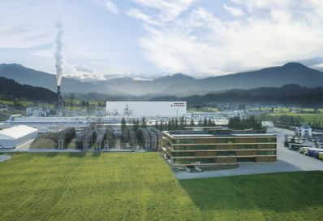 | The EGGER Group with headquarters in St. Johann in Tirol generated a turnover of EUR 3.08 billion in the 2020/2021 business year.
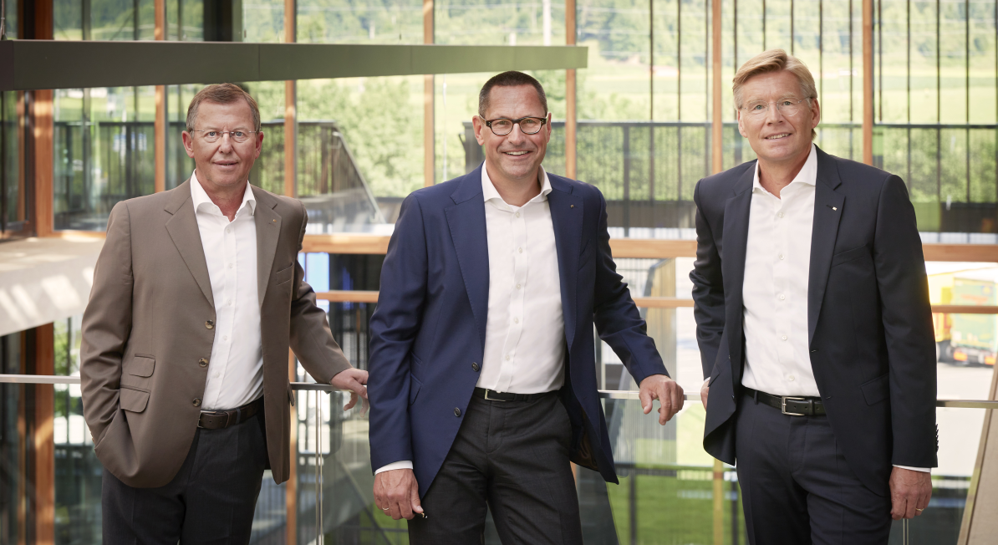 | The EGGER Group Management with Walter Schiegl, Thomas Leissing and Ulrich Bühler (from left) reports a strong increase in demand and a continuing special situation.
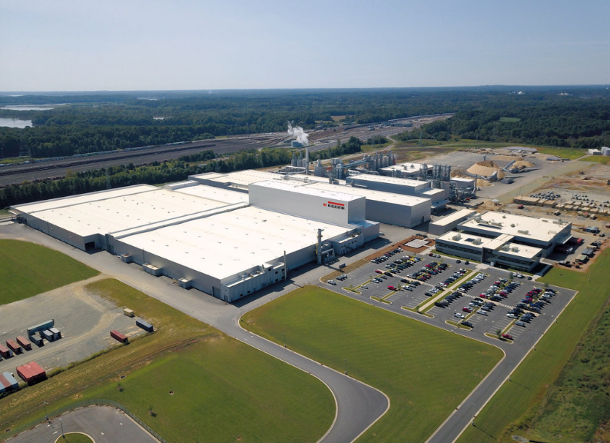 | A milestone for EGGER:  On 19.09.2020, the 20th plant in Lexington, North Carolina, USA, starts production.
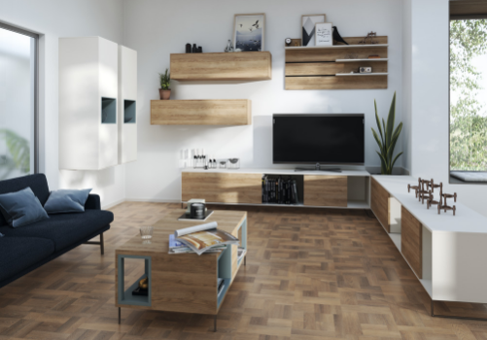 | The special situation that has persisted until now has led to the cocooning effect: Massively increased consumer investment in one's own home leads to a strong increase in demand in almost all markets.

PHOTOS: EGGER Holzwerkstoffe, reprints naming the copyright owner are free of charge
IMAGE DOWNLOAD: https://celum.egger.com/pinaccess/showpin.do?pinCode=lFLMmRACZb7u

