EGGER UK announces 2021 apprentice intake.

International wood-based material manufacturer, EGGER UK, has recruited 16 local apprentices to join its 800 strong and growing team.

Mechanical, Electrical, Production, Marketing, Business Administration and IT apprentices have joined departments across the Hexham, Barony and Timberpak sites.

To mark the start of the 2021 apprenticeship programme, EGGER UK hosted an induction week packed full of activities, tours and talks. The new recruits saw the production of chipboard at EGGER Barony, took part in an activity day on the Isle of Arran, went on a tour of EGGER Hexham to see the production of melamine faced chipboard, visited a Timberpak recycling site, and spent an afternoon with EGGER Forestry.

Hannah Pigg, Marketing Apprentice for EGGER UK, said, “We all had a really good time on the apprentice induction week. It was great to meet, and get to know, apprentices from other parts of the business and find out about the departments they are working in”.

Keith Robson, Apprentice Training Manager, EGGER UK, added, “We are delighted to welcome our new apprentices to the team. The induction week is a fantastic opportunity for our apprentices to get to know each other and build a support network as they start their career with us.”

Yasemin Bozbey, Learning & Development Senior Specialist, EGGER UK, said, ““At EGGER our motto for apprenticeships is ‘More Stability, More Future, My Prospects’. During the induction week we explored personal growth and development opportunities within EGGER with our new apprentices.”

EGGER Hexham has recruited Nathan Carr, Thea Willis, Emma Boaden, Luke Elliott, Nathaniel Grieves, Hannah Pigg, Anna Bailey and Ben Smith.

EGGER Barony has recruited Aiden Burinski, Ryan Devlin, Declan Hay, Daniel Merrilees, Lewis Symonds and Ben Wheeler.

Timberpak Ltd has recruited Jordan Graham and Ryan McKenna.

Over 14% of EGGER UK’s current workforce joined as an apprentice, which illustrates its ongoing commitment towards the development of its employees. Its apprentice programme has been running for 19 years, with a strong focus on the development and training of people from areas local to its sites.

Recruitment for the 2022 EGGER apprenticeship programme will start at the end of September 2021.

-ends-

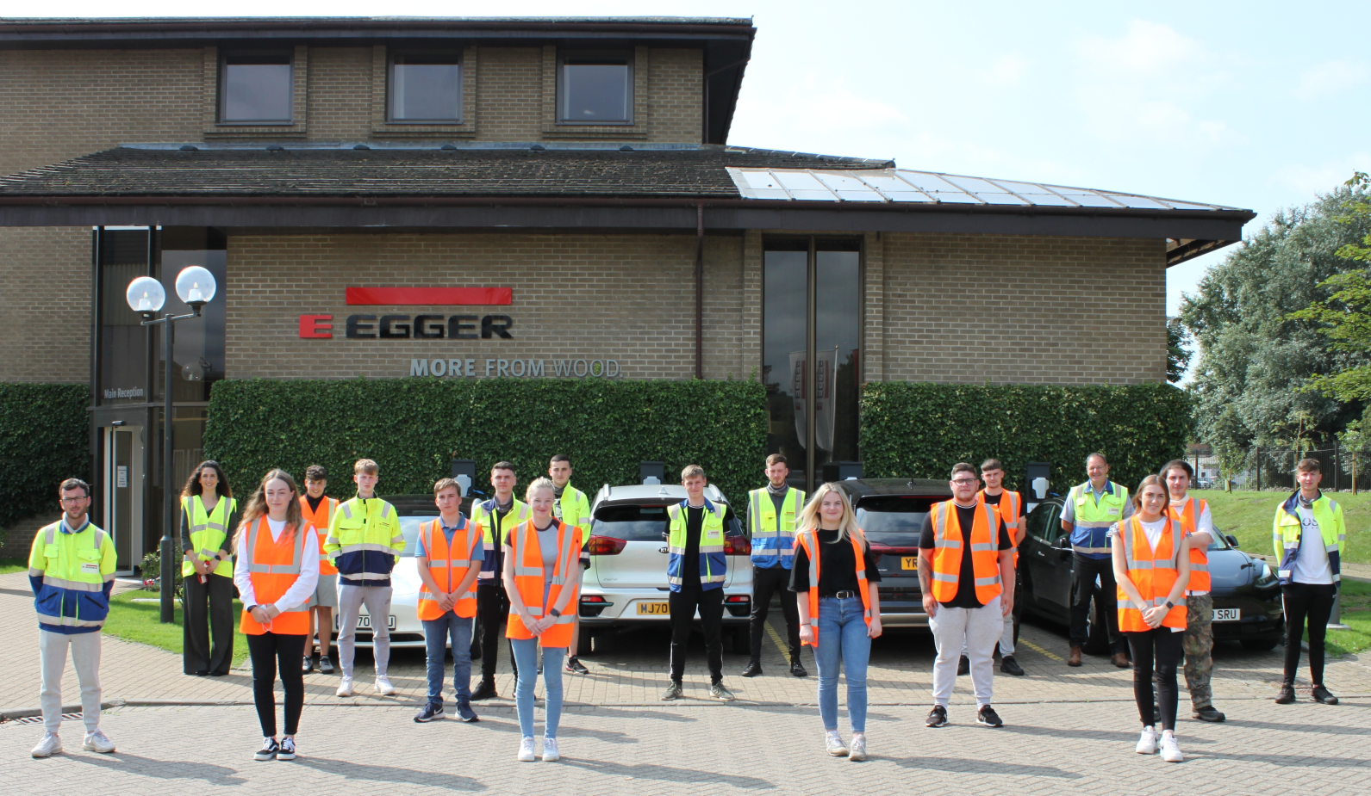
To download this image, please click here.

