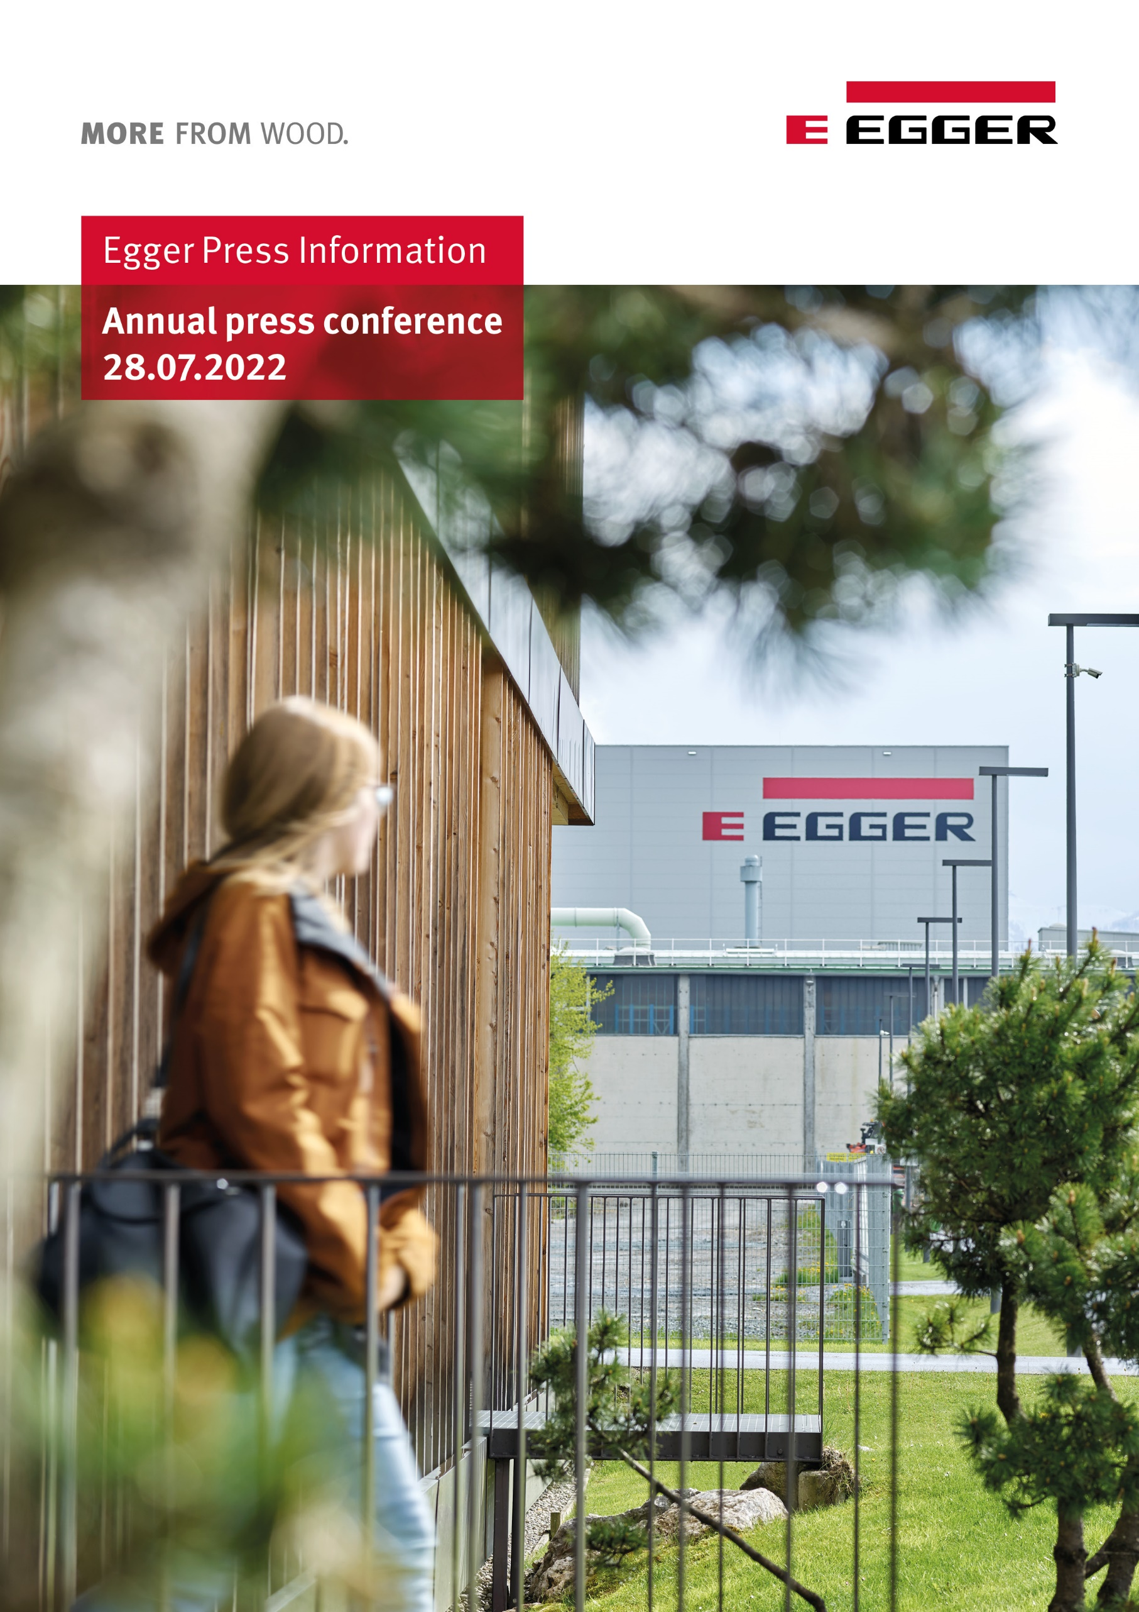
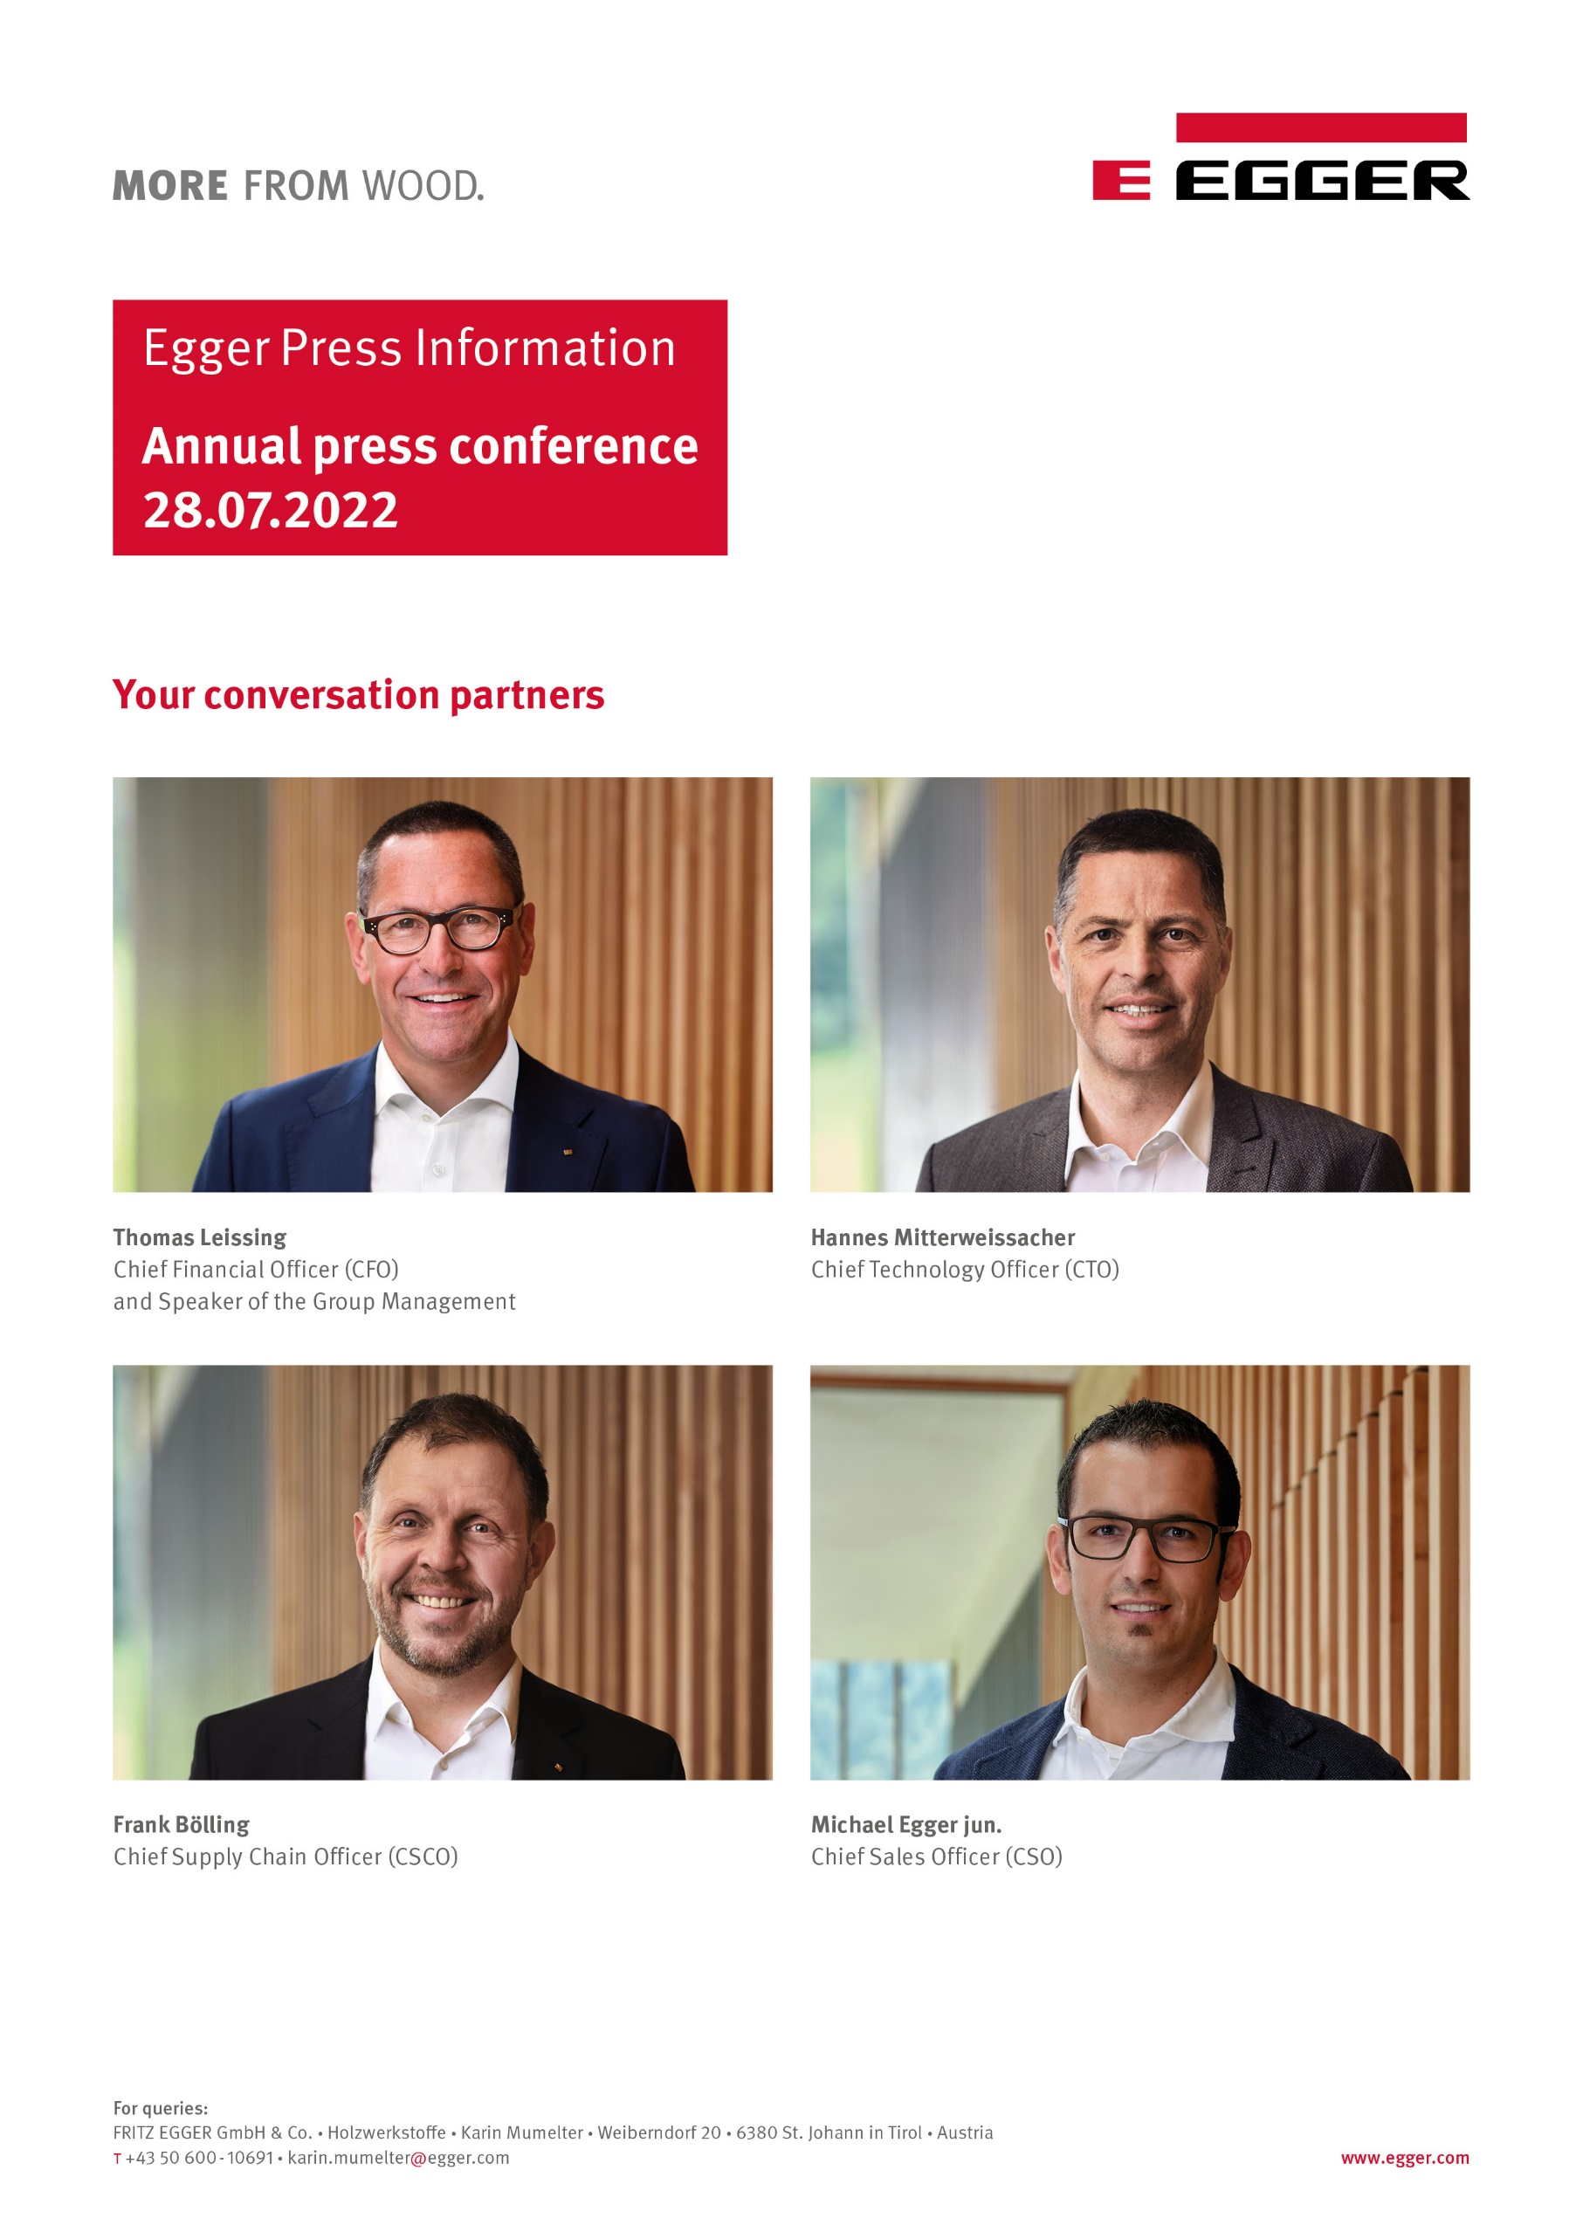
EGGER Group Closes Financial Year with 4.23 Billion Euros in Sales in a Challenging Environment
The strong demand for products, record quantities produced, but also price increases necessitated by cost pressures bring the wood-based materials specialist a significant increase in turnover in the 2021/2022 financial year.
The EGGER Group is closing its 2021/2022 financial year in exceptionally challenging times. The ongoing COVID-19 pandemic and the dramatic developments in Ukraine are having an impact on the global energy and raw materials markets. Product demand was high and is reflected in the financial figures: EGGER generated group-wide sales of EUR 4.23 billion.
"We are pleased with this significant increase in turnover, given the fact that we are experiencing difficult times. Demand for our products has been at a high level during the past business year. However, the geopolitical situation is challenging and we are monitoring the developments in the global energy and commodity markets, as well as those of the conflict in Ukraine," says Thomas Leissing, Chief Financial Officer and Speaker of the Group Management, at the annual press conference at the headquarters in St. Johann in Tirol (AT).
EGGER reports a positive development of the key figures for the financial year 2021/2022: Group-wide sales of EUR 4,234.3 million (+37.4% compared to the previous year) and EBITDA of EUR 877.5 million (+41.0% compared to the previous year) were generated. The EBITDA margin is stable at 20.7% (previous year: 20.2%), and the shareholder’s equity ratio of 50.9% is above the previous year's figure of 42.0%. "This increase in results shows that we have managed the challenges of the ongoing pandemic well, and at the same time made very good use of the opportunities that have arisen in our industry". This increase in earnings with a stable EBITDA margin is mainly due to the positive market environment for sawn and building products, the reduction of start-up losses at the plant in Lexington, NC (US), and optimised product and customer mix.
EGGER has produced record quantities in recent months, serving strong customer demand. With 10.5 million m³ of wood-based materials and timber, the group achieved a production record. Based on the 2020/21 fiscal year, this is an increase of 9.4% or 900,000 m³.
Positive Developments in all Product Areas
"The tailwind of the cocooning effect that arose during the COVID-19 pandemic brought high demand from the furniture industry and the wood-based materials trade in the past business year," says Michael Egger Jr, Chief Sales Officer. The EGGER Group recorded sales growth in all product areas. These result from three main factors: The positive market environment for sawn and building products, especially in the North American market, volume increases, especially due to the newest plants in Biskupiec (PL) and Lexington, NC (US), and the price increases necessitated by cost pressure.
Decorative Products (products for furniture and interior design) achieved the largest share of turnover with 76.9% and, at EUR 3,473.4 million, is +36.6% above the previous year. All regions, West, Central, East and Americas, recorded increased sales.
At EUR 506.9 million, the Flooring Products Division was up +13.4% on the previous year. The increase in turnover is largely due to cost-related price increases.
The Building Products Division closes the 2021/2022 business year with EUR 534.7 million (+62.7%). EGGER's own sawmill in Brilon (DE) played a major role in the growth in sales, as the prices for timber, including in the American region, developed significantly.
Full details of the 2021/2022 financial year can be found in the annual financial report at www.egger.com/credit-relations.
Massive Cost Developments: Energy, Raw Materials, Supply Chain
The situation in the global raw materials markets is extremely challenging. "Since the beginning of 2021, we have been confronted with an unpredictable supply situation. The events in Ukraine and their impact on global trade have had repercussions on the availability and price of raw materials," says Hannes Mitterweissacher, Chief Technology Officer, describing the current situation.
EGGER is experiencing an increase in energy costs as well as the considerable rise in the price of chemical raw materials. The increasing demand for wood, the most important raw material for the wood-based materials producer, is leading to additional cost pressure.
In addition to significantly increased energy and raw material prices, EGGER is also confronted with the enormous rise in transport costs. "Conditions never expected, such as strikes and congestion, are affecting logistics chains worldwide. This has a massive impact on delivery processes. We are talking about freight costs for land transport increasing by almost a quarter. Sea freight has become at least 69% more expensive," says Frank Bölling, Chief Supply Chain Officer.
Geopolitical Developments: Responsibility For employees
At the end of the financial year, the dramatic development in Ukraine became apparent. "We are following the situation with great concern, are deeply saddened by the dramatic events and hope for peace soon," said the EGGER Group management in unison. EGGER is represented by two plants in Russia. For the family business, trust and respectful interaction with each other characterise its daily activities. The resulting responsibility also applies to the more than 1,000 employees in the two Russian plants and their families. Both plants continue to produce in compliance with all EU sanctions for economic relations between the EU countries relevant for EGGER and Russia. For this purpose, a strict compliance structure and a programme for compliance with EU sanctions has been established. The wood-based materials produced in Russia are mainly sold locally as well as in the neighbouring Stan states.
Investments in Supply Chain, Refinement and Sustainability
In total, the group invested EUR 293.6 million in its production plants in the last business year. A large share of the growth investments (EUR 194.5 million) went to the expansion of the headquarters in St. Johann in Tyrol (AT). An additional high-bay warehouse for laminated boards, a recycling tower and a second biomass boiler are currently being built. Significant investments were made in the refinement and infrastructure sectors at the German plants in Brilon, Wismar and Gifhorn, as well as in the French plant in Rambervillers. In Hexham (UK), investments were made in the expansion of recycling capacities. The majority of the investments support the objective of reducing CO₂ emissions through recycling, process optimisation and innovations.
Counteracting the Shortage of Skilled Workers
“We owe the positive development in this challenging environment to our approximately 10,800 employees," said the Group Management in unison. EGGER is also confronted with the labour shortage. The group is countering this with comprehensive employee recruitment, retention and development programmes. 80% of management positions are filled by internal employees. "Our objective is to train specialists and line supervisors from within our own company. We have set up training programmes at 16 of our 20 locations. Recruiting apprentices and thus ensuring the next generation of skilled workers was and remains one of our focus topics," says Thomas Leissing. EGGER offers a wide range of career opportunities in all areas of the company. A detailed overview can be found at www.egger.com/jobs.
New Appointment to the EGGER Group Management
In the current financial year, the top management body of the wood-based materials manufacturer is reshaping itself: Walter Schiegl stepped down from the Group Management after more than 20 years and will take over the Supervisory Board mandate from Michael Egger starting in autumn, thus helping to shape the strategic orientation of the EGGER Group in the future as well. Michael Egger celebrates his 75th birthday at the end of August and will then retire from the strategic board. The position of Walter Schiegl as responsible Chief Technology Officer is taken over by Hannes Mitterweissacher. Frank Bölling complements the Group Management and is responsible for the supply chain management. EGGER is thus responding to the potential and developments in the area of internal and external supply chain. Likewise, after many years, a representative of the Egger family will once again be active in the operational management of the EGGER Group: Michael Egger Jr. will take over the marketing/sales agenda from Ulrich Bühler, who will accompany Michael Egger Jr. with his many years of experience and expertise.
Together with Thomas Leissing and Michael Egger Jr., Hannes Mitterweissacher and Frank Bölling thus form the new management team of the EGGER Group.

Subdued Expectations for the 2022/2023 Financial Year
The crisis in Ukraine, volatile commodity markets, uncertain energy supplies, the ongoing COVID-19 pandemic and rising inflation are factors that dampen the EGGER Group's earnings expectations for the coming financial year. "In addition, uncertainties arise for us from the currency development in Russia, Argentina and Turkey. This mixture of factors makes it difficult to forecast the next few months," says Thomas Leissing.
For the EGGER Group as a whole, the outlook for sales development is subdued. The persistently high raw material and energy costs will lead to increased product prices. "Earnings expectations for all divisions will depend on the further development of overall economic demand. The impact of rising inflation and the associated higher energy and living costs on consumer willingness to spend and thus on the demand for our products tends to be a burden," says Thomas Leissing, painting a subdued picture for the results of the coming business year. Even though the outlook is currently gloomy, EGGER is sticking to its company strategy, and continuing its stable growth under its own steam. "We continue to focus on a diverse product portfolio and innovations for our customers, make investments in additional finishing capacities, as well as in improving the raw material and energy situation, and maintain our long-term supplier relationships with customers and suppliers," says Thomas Leissing.
Transparent Communication of the Sustainability Goals
At the same time as the Annual Financial Report, the EGGER Group publishes the current Sustainability Report (non-financial statement) at www.egger.com/sustainability. It contains the Group's strategy, objectives and performance with regard to economic, ecological and social sustainability. With this report, EGGER discloses its strategic sustainability goals and underlines its clear commitment to sustainable, generation-oriented management and to transparent communication throughout.

EGGER Group Closes Financial Year with 4.23 Billion Euros in Sales in a Challenging Environment

- Sales: EUR 4.23 billion (+37.4%)  - EBITDA: EUR 877.5 million (+41.0%).  - New production record: 10.5 million m³ rawboards incl. timber, increase of 9.4% compared to previous year  - EUR 293.6 million for growth and maintenance investments  - Volume increases especially in our newest plants Biskupiec (PL) and Lexington, NC (US) | - Challenging situation with energy, raw material and supply chain costs  - Forecast 2022/2023: Subdued general outlook and sales development for the EGGER Group  - Publication of the new sustainability report at www.egger.com/sustainability

Captions
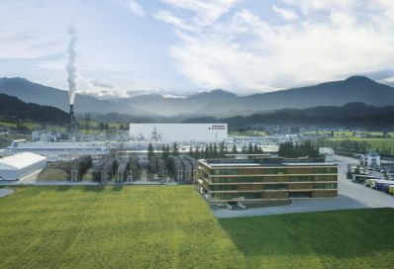 | The EGGER Group, headquartered in St. Johann in Tyrol (AT), closes its 2021/2022 financial year with sales of 4.23 billion euros.
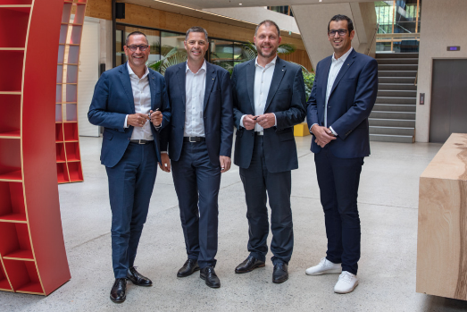 | The management team of the EGGER Group reports on the results for the year and challenging situations (from left): Thomas Leissing (Chief Financial Officer and Speaker of the Group Management), Hannes Mitterweissacher (Chief Technology Officer), Frank Bölling (Chief Supply Chain Officer) and Michael Egger Jr (Chief Sales Officer).
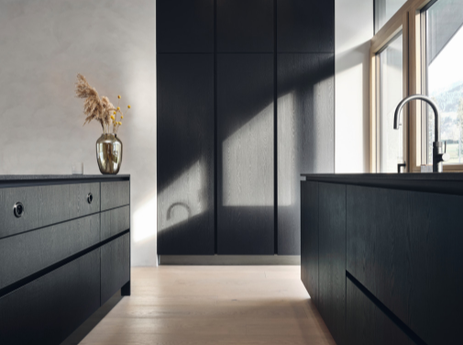 | The cocooning effect continued in the second year of the pandemic too: strong consumer investment in people's own homes again led to high demand.
PHOTOS: EGGER Holzwerkstoffe, reprints naming the copyright owner are free of charge
REPRODUCTION: All our shown and mentioned decors are reproductions.
Image download: https://celum.egger.com/pinaccess/showpin.do?pinCode=PIsDAsHougz3

