EGGER employees take on iconic Three Peaks Challenge, raising over £4,000 for North East charity Daft as a Brush
Five employees from EGGER took on the demanding UK Three Peaks Challenge on Saturday 23 May, raising over £4,000 in support of cancer patient care charity Daft as a Brush.
Will Pearson, Shaun Ridley, James Armstrong, Michael Robson and Scott Dowden set out to climb the UK’s three highest mountains within 24 hours: Ben Nevis (1,345m), Scafell Pike (978m) and Snowdon (1,085m). Patrick Havery supported the team as the driver, covering more than 460 miles between peaks.
Having set out with the goal of simply finishing the challenge within the 24-hour limit, the team exceeded expectations and finished in only 22 hours and 23 minutes.
The challenge formed part of a wider EGGER fundraising campaign aiming to raise £48,000 towards a new electric ambulance for Daft as a Brush cancer patient care. The Three Peaks Challenge brings EGGER close to completing its goal, with just over £40,000 raised so far.
Thanks to this campaign, Daft as a Brush can further broaden the scope of its work in transporting cancer patients to and from life-saving treatment appointments.
Previous fundraising efforts have included the Inflatable Run in summer 2025, with EGGER employees running anywhere from 5 to 15 kilometres and raising a total of £3,362. Fundraising initiatives are led by volunteer employees from EGGER Hexham’s Charity Committee.
Despite not being regular hikers, the Three Peaks team embraced the challenge as an opportunity to push themselves physically while supporting a cause close to their hearts. "We aren't seasoned hikers, so we knew from the start that this would push us to our absolute limits," said Will Pearson. "But the Three Peaks gave us the ultimate goal to focus on. We wanted to challenge ourselves, stir up some motivation, and most importantly inspire people to get behind a truly vital charity."
The Three Peaks Challenge is widely regarded as one of the UK’s toughest endurance tests. It involves around 23 miles of walking, more than 3,000 metres of ascent, and strict time pressures to reach all three summits within 24 hours. Only around 40% of participants successfully complete the challenge within the allocated time.
Andy Sanderson, Chair of EGGER Hexham’s Charity Committee, said:
“We are incredibly proud of Will, Shaun, James, Michael, Scott and Patrick for taking on such a demanding challenge in support of a fantastic cause. Their commitment, alongside the generosity of everyone who has donated, will make a real difference to people undergoing cancer treatment.”
Picture caption
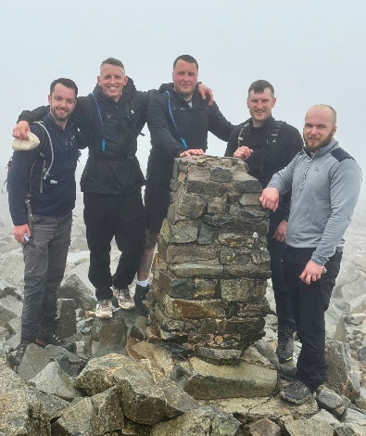 | L-R: Scott Dowden, Will Pearson, Michael Robson, James Armstrong, and Shaun Ridley at Scafell Pike Summit, Cumbria
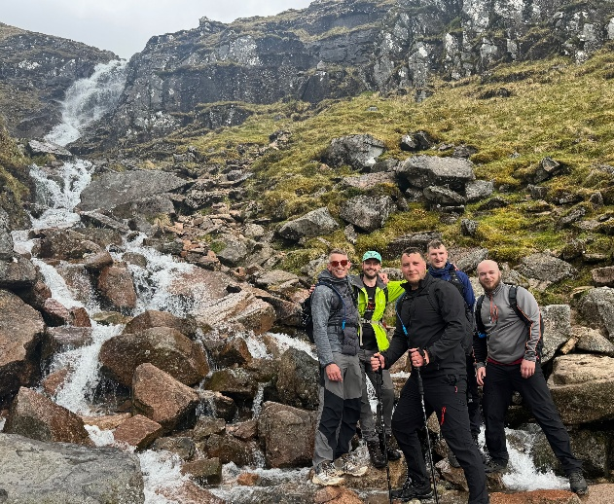 | L-R: Will Pearson, Scott Dowden, Michael Robson, James Armstrong, and Shaun Ridley ascending Ben Nevis, Scotland
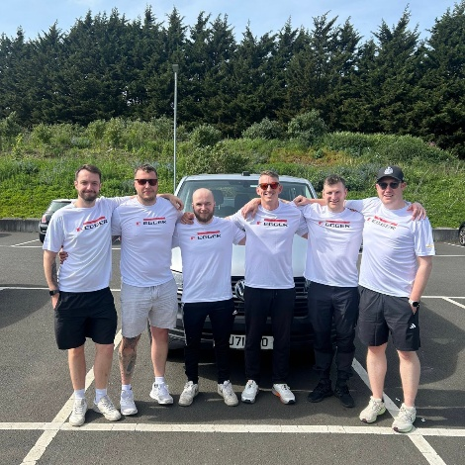 | L-R: Scott Dowden, Michael Robson, Shaun Ridley, Will Pearson, James Armstrong, and Patrick Harvery setting off for their challenge from the EGGER UK parking lot in Hexham, Northumberland
PHOTOS: EGGER UK Ltd, reproduction with naming of copyright holder free of changes
REPRODUCTION: All our mentioned decors are reproductions.
Download: ShareFile Link
Notes to editors:
- The Three Peaks Challenge involves climbing Ben Nevis, Scafell Pike and Snowdon within 24 hours.
- Total distance: approximately 23 miles walking, 3,000 metres of ascent and 462 miles driving.
- Funds raised contribute towards EGGER’s £48,000 fundraising target for Daft as a Brush.
- Daft as a Brush Cancer Patient Care provides free transport for people undergoing cancer treatment.

About EGGER UK:
In the UK since the 1984 opening of its Hexham, Northumberland plant, EGGER UK is a leading manufacturer of wood-based materials. The company employs over 900 people in the UK. In 1998, the company expanded with a second manufacturing plant in Barony, East Ayrshire in Scotland. EGGER UK produces wood-based panels and structural flooring products for the furniture and construction industries. Through its parent company EGGER Group it also supplies wood-based flooring and further construction and decorative products, making it a full-range and reliable partner. EGGER Group generated a turnover of EUR 4.13 billion in the 2024/2025 financial year.
EGGER UK operates within a closed production cycle. It sources wood from responsibly managed forests, and 75% of the wood used in production comes from sawmill by-products or recycling. At the end of their life cycle, EGGER UK manufactured products can be fully recycled. Through its wood recycling subsidiary Timberpak Ltd, EGGER UK works with its customers to ensure its products have another life. EGGER UK is constantly working towards its goal of creating more from the valuable resource of wood.

EGGER UK Ltd.
Annette Lordereau
Anick Grange Road
Hexham NE46 4JS
United Kingdom
T +44 1434 613364
M +44 7890 660780
annette.lordereau@egger.com
For Queries:

