EGGER at Sicam 2025: Innovative New Introductions in Focus
Under the motto "Inspire. Grow. Create.", the wood-based material specialist presents its new products, decors and surfaces.
From 14 -17 October 2025, the wood-based material manufacturer will be presenting product solutions and services that merge to create a unique experience, and open up new possibilities for furniture and interior design.
"Inspire. Grow. Create.” Under this vision, EGGER welcomes visitors from all over the world to its exhibition stand at Sicam 2025 in Hall 5, Stand A21/B20. Here, the wood-based material manufacturer demonstrates what lies behind these words: inspiration as a basis for creative solutions, growth through sustainable developments and the creation of new perspectives. "We have used the last few years to further develop our plants and production capacities, and to strategically prepare our company for the future. Our focus is on providing an inspiration for sustainable growth and innovation through direct exchanges with our customers. "I am looking forward to having exciting conversations with our visitors together with our exhibition team and opening up new perspectives," explains Roland Auer, Chief Marketing Officer of the EGGER Group.
Red Dot and interzum awards for EGGER product and service innovations
In the continuous further development, EGGER is guided by changing customer needs as well as the development of new trends. New technologies and constant dialogue with customers and partners in the supply industry are firmly at the heart of this. This ambition has now been recognised internationally on multiple occasions.
The new ST35 Feelwood Canyon texture and the repeatless half format combine aesthetics with sophisticated functionality and were honoured with the Red Dot Award 2025 for "High Design Quality" and the interzum Award 2025 for "High Product Quality". The digital consulting tool EGGER TrendCast also impressed with its design quality and innovative strength and was honoured with the renowned Red Dot Award 2025 for "Design Concept" and the interzum Award 2025 for "High Product Quality". "We are proud of these awards as they confirm our desire to always be thinking ahead, in terms of design quality and technical innovation. For us, it is confirmation of the creative potential that arises when design, technology and market understanding go hand in hand," emphasises Auer.
PerfectSense ® Ambiance: exclusive elegance with partial gloss effects
With PerfectSense Ambiance, the wood-based material manufacturer is setting a special accent at this year's Sicam: After the first decors were presented at interzum 2025, EGGER is already showing the further development of the product line with exciting new variants. An exclusive decor in an expressive red marble look, F198 Red Ambiance Marble, is clearly in the spotlight. EGGER also presents an innovative solution for direct coating, featuring an exclusive Colour Match developed specifically for this application, enabling high-end stone reproductions with exceptional precision.
PerfectSense Ambiance is our answer to the desire for elegant, expressive stone effects that are both robust and easy to clean. Thanks to the anti-fingerprint characteristic and synchronised look and feel, the surfaces are not only aesthetically appealing but also ideal for high-quality kitchens, living room furniture, as well as shopfitting and trade fair construction," explains Klaus Monhoff, Head of Design and Decor Management at the EGGER Group. The expansion of the PerfectSense product range to include fascinating stone effects combines matt and glossy areas in a unique way. The perfect coordination of the partial gloss effects with the underlying decor image of the stone reproductions creates a synchronised effect that is both visually and haptically impressive
Further development of the uni colours: PerfectSense® Matt lacquered chipboard
EGGER is also consistently developing its PerfectSense® Matt lacquered boards on chipboard core and significantly enhances the uni colours with the new TM surface. The new surface is based on an improved lacquer formulation that delivers even higher lacquer quality on chipboard core. With the new TM surfaces, the wood-based material manufacturer offers a noticeably better feel and creates real added value for its customers. "With the refined feel of the new TM surfaces, we create a stronger fusion of aesthetics, functionality, and cost-effectiveness, tailored to the needs of our customers," explains Hubert Höglauer, Head of Marketing and Product Management for furniture and interior design at the EGGER Group. The velvety warm surface on a recyclable chipboard core perfectly combines design and function. It also offers a high-quality matt look and the proven anti-fingerprint characteristics of the wood-based material manufacturer.
EGGER TrendCast: The next level of decor consultation
With EGGER TrendCast, visitors to Sicam 2025 can experience first-hand how EGGER is taking the interplay between design, technology and consulting to a new level. The innovative decor consultation makes it possible to visualise trends and design concepts in virtual rooms. While conventional customer presentations often only show small hand samples, TrendCast enables an unprecedented decor consultation in which customers can immerse themselves in the fine details of the various decors and textures.
Following the launch of TrendCast at interzum in Cologne (DE), EGGER will be showcasing a further development of the tool at Sicam. This will make the consulting experience even more intuitive, interactive and practical. "We see TrendCast as an important and very useful service for our customers. We are therefore all the more pleased to be able to present a further development at Sicam. We want to emphasise how innovative services and digital technologies not only go hand in hand, but also comprehensively expand the creative potential of our industry," explains Monhoff enthusiastically.
Focus on product transparency
From working in closed cycles and the responsible, resource-conserving use of wood as a valuable resource to the gradual reduction of fossil resources: Sicam 2025 will also focus on transparent communication about the wood-based material manufacturer's products. "It is important to us to strengthen trust in ourselves and our products and to promote responsible, informed decisions. This only works if we communicate transparently and based on facts," emphasises Auer. With its new exhibition stand concept, EGGER is sending out a strong signal in favour of innovation and creativity. The exhibition stand had an open, inviting concept with a studio character and represented an architectural highlight. With a construction made from finger-jointed studwork timber, the wood-based material specialist sets a clear example for sustainable trade fair construction. For the wood-based materials manufacturer, 'More from wood' is more than just words, it’s reflected in every detail.

EGGER at SICAM 2025

- EGGER exhibition stand in Hall 5, Stand A21 / B20 at Sicam in Pordenone (IT) from 14 - 17 October 2025.  - With the new exhibition stand concept, EGGER is sending a strong signal for innovation and creativity. A construction made from finger-jointed solid wood sets a clear example for sustainable trade fair construction. | - Under the motto “Inspire. Grow. Create.” EGGER presents innovative product solutions, helpful services and sustainable concepts.  - Thanks to the new ST35 Feelwood® Canyon texture, the repeatless half format and the innovative EGGER TrendCast decor consultation, the wood-based materials specialist has impressed across the board and has won multiple international awards.

Captions
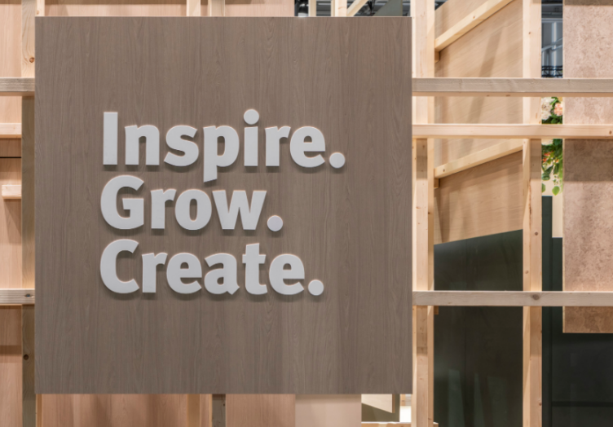 | Under the motto "Inspire. Grow. Create." EGGER will be presenting innovative product solutions and services at Sicam 2025 that combine to create a unique experience and open up new possibilities for furniture and interior design.
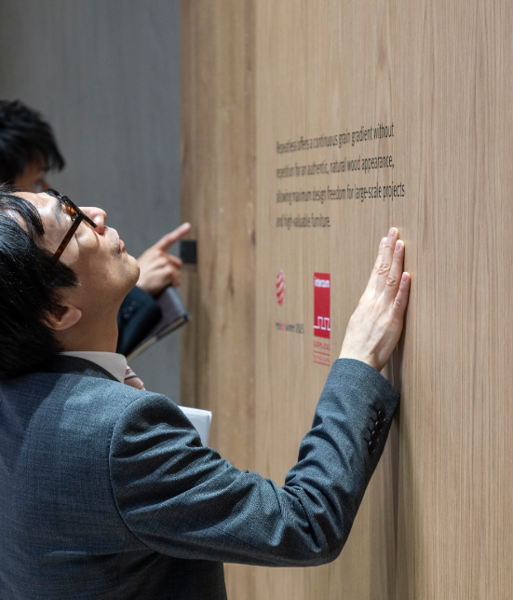 | The EGGER repeatless half format offers a continuous grain pattern without repetitions for an authentic, natural wood effect and allows maximum design flexibility for large-scale projects.  Pictured: H1316 ST17 Bookmatch Oak
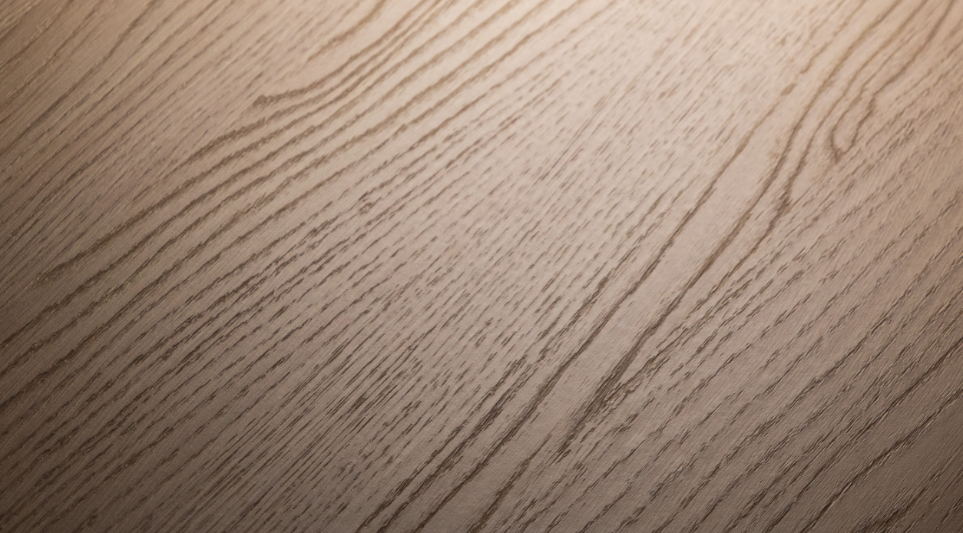 | Due to a special technique, the synchronised pore surface of ST35 Feelwood® Canyon appears more matt and even more striking. A deeper embossing enhances the texture experience.  Pictured: H3377 ST35 Natural Rocher Oak
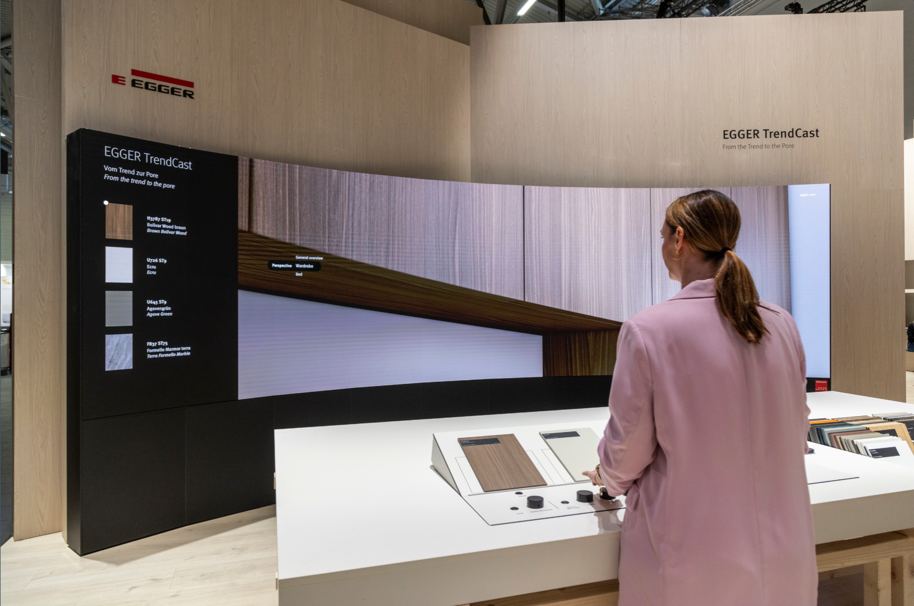 | EGGER TrendCast goes beyond traditional presentation methods: virtual rooms, real samples and immersive design worlds create a unique decor consulting experience.
 | ST35 Feelwood® Canyon and the EGGER repeatless half format received the interzum Award 2025 for "High Product Quality" and the Red Dot Award 2025 for "High Design Quality".  EGGER TrendCast received the Red Dot Award 2025 "Design Concept" and the interzum Award 2025 for "High Product Quality".
PHOTOS: EGGER Holzwerkstoffe, reprints that quote the name of the copyright owner are free
REPRODUCTION: All our mentioned decors are reproductions.
Image download: https://celum.egger.com/pinaccess/showpin.do?pinCode=ZJZGmdgFrWoU

About EGGER
Established in 1961, the family company is a leading international wood-based material manufacturer with around 12,000 employees and 22 production plants worldwide. EGGER is a full-range supplier for furniture and interior design, wood construction, and wood-based flooring, making it a reliable partner for the furniture industry, wood and flooring distributors, DIY stores and DIY markets. In the 2024/2025 financial year, the EGGER Group generated a turnover of EUR 4.13 billion.
Sustainable business management is the focus for EGGER. The family company takes its responsibility for climate protection seriously and is committed to the ambitious Net Zero target by 2050. 66% of the wood used in EGGER wood-based materials already comes from recycling or sawmill by-products. At the end of their long service life, EGGER products are in turn largely recyclable and can be reintroduced into the cycle. EGGER is also constantly working towards its objective to create “more from the valuable resource wood” and thus enable sustainable living and working.

If you have any queries, feel free to contact:

FRITZ EGGER GmbH & Co OG
Holzwerkstoffe
Verena Feiersinger
Weiberndorf 8
6380 St. Johann in Tirol
Austria
T +43 5 0600-11135
verena.feiersinger@egger.com

