Timberpak Ltd purchases new site in Leeds
Waste wood recycling and reprocessing company, Timberpak Ltd, has announced a significant investment into a site in Leeds.

The six-acre site, on Cross Green Industrial Estate, will increase Timberpak’s waste wood capacity in order to meet the growing demand for recycled material from EGGER (UK) Ltd. This material is used to produce carbon negative chipboard at plants in Hexham and Barony, destined for the interior design and housebuilding industries.

Previously owned by Hesco Bastian Ltd, the new site is perfectly located to service Timberpak customers in Yorkshire and the surrounding areas. The investment reinforces the recycling company’s commitment to make More from Wood by storing carbon in waste wood that would otherwise be burnt or sent to landfill.

Over the next nine months, the site will undergo an extensive fit out, with the installation of state-of-the-art picking and processing technology, to ensure the maximum amount of waste wood material can be processed. This substantial investment will bring additional revenue to the area.

The new site is strategically located to benefit the large furniture groups, civic amenity sites and industrial users, which are regular suppliers of waste wood to Timberpak. The purchase signals a commitment by the company to continually invest in the business and ensure a secure and sustainable long-term supply of recycled material.

Mark Hayton, Director of EGGER Timberpak Ltd, said, “Our new site will ensure we can maximise our output and protect one of our most valuable natural resources, wood. It is a fantastic opportunity for us to fully support our customers with disposing of waste material responsibly and continue to grow our business”.

“The recycled wood we supply to EGGER UK makes up 40% of a chipboard panel, which is 100% recyclable following use. Our new site will offer additional processing and storage capacity to meet the demand from EGGER’s production sites”

Paul Mack from commercial property consultant, Gent Visick, supported Timberpak Ltd with the purchase of the site.

In addition to the new site, Timberpak has invested over £1.9 million across its four existing sites. This includes the acquisition of three Liebherr loading shovels, one Scania tractor unit, three Legras walking floor trailers, two Sennabogon Electric 360 material handlers and 50 yard bins.

-Ends-

For more information, please contact kate.wallace@egger.com/01434 613395

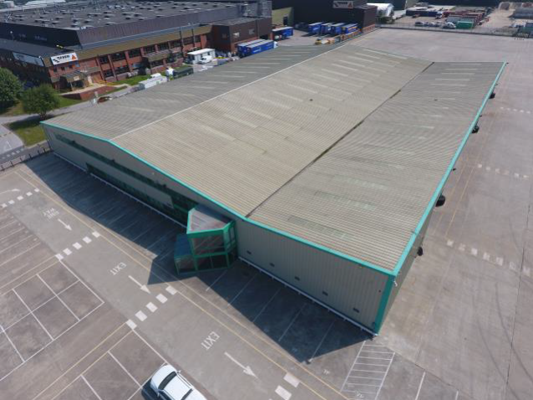 | New Timberpak Ltd site Cross Green Industrial Estate, Leeds

