Create. Collaborate. Specify.
Introducing EGGER LONDON at One Dallington Street.
EGGER has launched an immersive design space in the heart of Clerkenwell, in partnership with CLEAF and BLUM.

EGGER LONDON brings together three family owned companies - EGGER, CLEAF and BLUM - at One Dallington Street in Clerkenwell, London’s globally leading design community. Opening its showroom doors for the first time at the internationally renowned Clerkenwell Design Week in May, EGGER London welcomed over 1200 visits to experience its remarkable interior design transformation, network with peers and meet the three brands behind the concept. Since, it continues to welcome designer guests from around the world to create, collaborate and specify in the open space.

EGGER LONDON offers an eclectic experience for its designer guests. Its light, bright and flowing interior comprises of design space for guests to work and collaborate on projects, digital space to access supporting tools and brand information, private space for meetings and workshops, and welcoming hospitality space for relaxed networking. Every part of its interior its created with the designer in mind, with real life product application merging form with function throughout. It is packed with large format samples, supporting resources, and on-hand expertise from its team.

The highly anticipated showroom is a stand-out space. Set inside the iconic One Dallington Street, a striking example of late 20th Century open and fluid architecture, it is flooded with natural light through its double height, glass-blocked façade. Inside, visitors are greeted by its spacious open atrium, centred by a statement, bespoke feature pendant that tells the story of EGGER’s history of celebrating wood. Moving inside, the space is a designers’ playground packed with creative stimulation - from textures and colours to conversations and curated events.

The showroom is founded by EGGER, a leading, global manufacturer of wood-based materials for interior design and construction. With its unique sole supplier offer for designers, specifiers, architects and fabricators, EGGER supplies a range of decorative materials for interior furniture, surfaces and wall panelling, decorative interior flooring and structural flooring, suitable for commercial and domestic projects. Priding itself on its strong environmental ethos and sustainable product portfolio, EGGER operates environmentally conscious manufacturing processes at 22 facilities worldwide.

At EGGER LONDON, EGGER showcases over 300 finishes for furniture and flooring in a life-size sample library, and some of its most innovative materials in real applications across fitted furniture, working tables, networking spaces and design installations.

Adding to the breadth of inspiring surface finishes, designers are invited to explore CLEAF, an Italian company producing innovative surfaces for furniture and interiors. Renowned for striking texture development and exceptionally tactile finishes, CLEAF exclusively manufactures a considered selection of surfacing solutions at production sites in Brianza, and sees its material installed worldwide by interior architects and furniture designers, building inspiring spaces for living and working. Visitors can explore over 150 CLEAF finishes in the space.

BLUM brings movement and fluidity to the space. A global-leading manufacturer of innovative lift, hinge, pull out and pocket systems for furniture and interiors, the brand specialises in motion technologies while advocating responsible growth and preservation for future generations. BLUM is a pioneering business, focussed on solution-led product development, and renowned for its catalogue of innovative fittings and mechanisms designed to make furniture move, rather than be moved, for a better quality of living and working.

Under one roof the three partners provide an integrated interior design solution covering a wide range of decors, fittings and flooring, alongside heavy-weight product expertise, giving its designer guests the tools they need to specify bravely, with confidence, and without compromise.

Following its successful launch, EGGER LONDON is open for business. To arrange your visit, contact londonshowroom@egger.com or drop into 1 Dallington Street, London, EC1V OBH.

Image options, files here.
Promotional asset options, files here
Thumb nails and captions below.

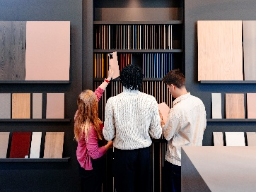

EGGER LONDON offers collaborative, creative space to work on designs


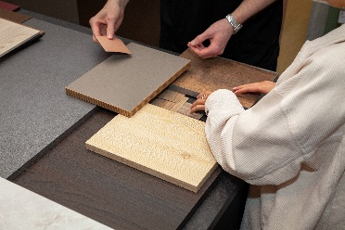
EGGER LONDON is packed with over 450 decorative surface finishes for endless design
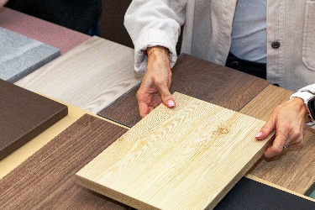


An immersive digital experience and space for workshops and networking on offer at EGGER LONDON
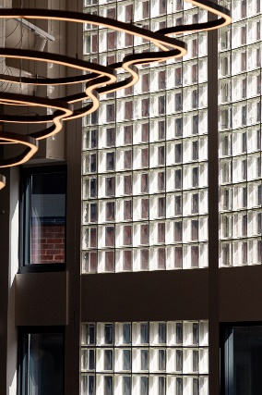

EGGER LONDON is an iconic space enjoying ample natural light thanks to its striking facade
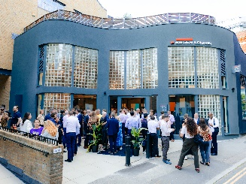

EGGER LONDON officially opened at this year’s Clerkenwell Design Week

FOTOS: EGGER Wood Based Materials, reproduction with naming of copyright holder free of changes
REPRODUCTION: All our mentioned decors are reproductions.
Download:

