Worktops for distinctive, design led spaces.
EGGER’s best ever range of worktops: sophisticated, simple and sustainable.
Traditionally worktops were only found in the kitchen, but due to innovation, design developments and budget friendly solutions, they can now be found across multiple applications. EGGER’s new collection of worktops brings new opportunities, with a fantastic range of durable, hygienic and stylish laminate surfaces.
34 carefully chosen decors, three thickness and two profiles make up this sophisticated collection of worktops. Realistic reproductions in 16 mm, 25 mm and 38 mm include oak, marble, stone and granite, offering a low maintenance, cost effective alternative to solid surfaces.
A highlight of the EGGER Worktop Collection 2020 is the elegant range of six striking 16 mm square edge material surfaces. Double-sided, the worktops are perfect for the creation of waterfall islands, shelving and side panels. Matching decors are also available as a 38 mm postformed worktop, so an on-trend, thick and thin finish can be achieved.
Four Halifax Oak decors, from EGGER’s popular Feelwood range, are available as 38 mm square edged worktops. Realistic to the touch, the design and texture perfectly align to produce a surface almost indistinguishable from real oak.
EGGER’s standard worktop length is 4100 mm, but the 38 mm postformed worktops are also available as 3050 mm. Offered in 24 on-trend woodgrain and material decors, this size is optimised for easy transportation and fitting.
Suitable for kitchens, bathroom, offices and retail spaces, there is a finish to suit every interior. As a stylish alternative to tiling, matching upstands and splashbacks are available for all decors. They create a coordinated finish, whilst being simple to look after and maintain.

Matching edging is available for all decors, so a 38 mm postformed worktop can easily be adapted to create a square edge finish. If a coordinated look is required 17 worktops have matching melamine faced chipboard (MFC) available from UK stock which can be used for door frontals and carcasses. Matching laminate is also available for all decors.

As part of EGGER’s commitment to the environment, all worktops are PEFC certified and made using renewable material (88%). The 25 mm square edge and 38 mm postformed worktops can also be recycled following use. The range has undergone rigorous testing, and has been awarded the prestigious FIRA Gold Award.
Elliott Fairlie, Head of Decor Management, UK & Ireland, said, “Our worktops can be used across a number of different applications. Whilst they are still a popular choice for residential kitchen projects, we’re now seeing them used regularly in commercial spaces. Student accommodation and office projects are specifying worktops for desks, retail spaces are using them for counters and the hospitality sector is using them for tables.”
Fairlie continues, “Our carefully considered trend driven range, is the next generation of laminate worktops, offering a cost-effective, low maintenance alternative to solid surfaces”.
A range of installation accessories has been developed alongside this new collection to provide easy access to essential items. This includes two installation kits, and EGGERSeal waterproof sealant and adhesive. If used in conjunction with the EGGER Worktop Fitting Guide, the worktop is guaranteed for 10 years.
For more information, please visit www.egger.com/worktops
-ends-

For more information, please contact Kate.Wallace@egger.com/01434 613395

16mm square edge worktop
F120 ST76 Light Grey Metal Rock
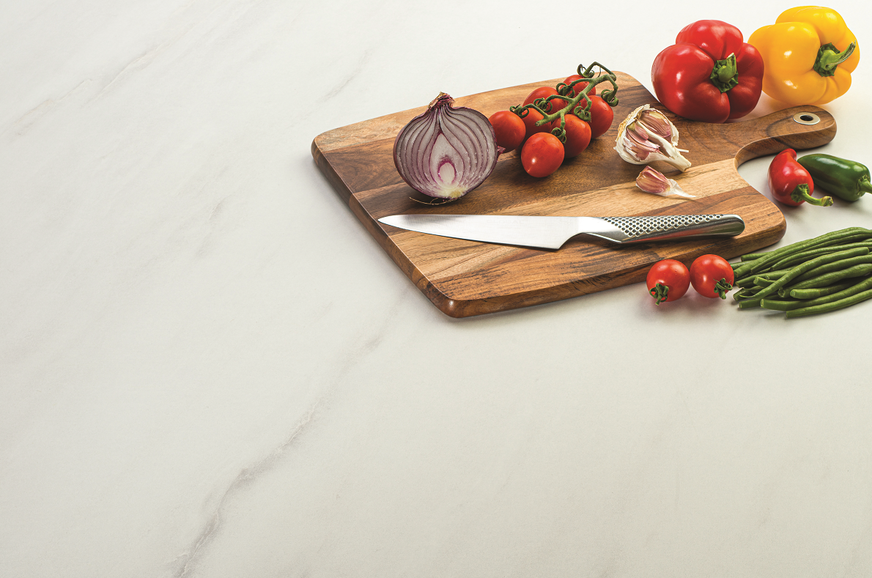 | 25mm square edge worktop  F812 ST9 White Levanto Marble
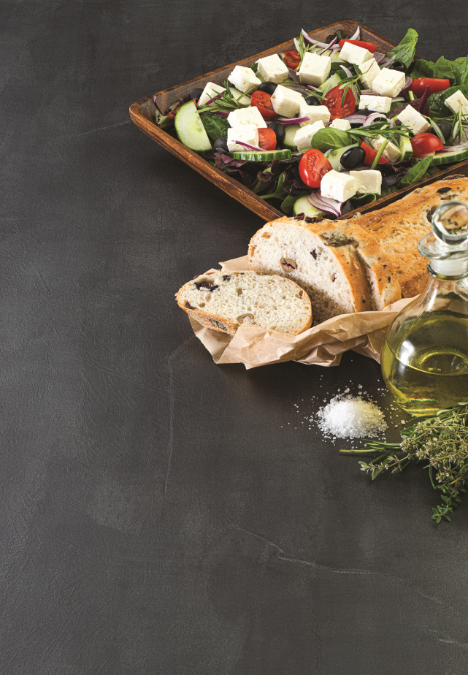 | 38mm postformed worktop  F628 ST16 Silver Grey Metal Slate
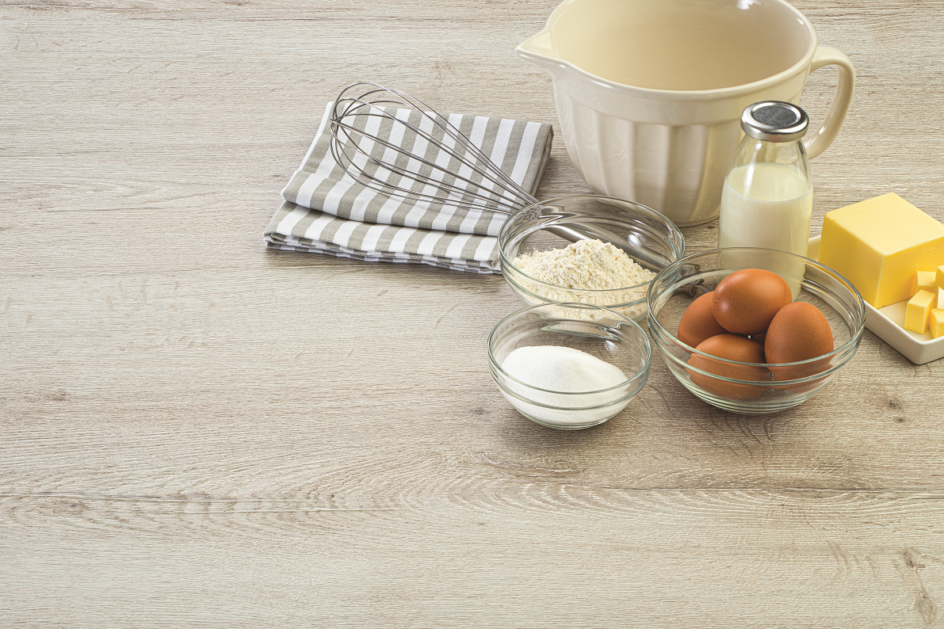 | 38mm square edge worktop  H1336 ST37 Sand Grey Glazed Halifax Oak

