Warm, neutral tones gain prominence in personalised living spaces.
EGGER’s Decor Management team for UK & Ireland share the development of warm, neutral decors in interior design.
“Over the last 18 months our homes have become a place of security and comfort. The shift in how we live, work and socialise has had a huge impact on design, colour and style preferences. People now aspire to living in multi-functional spaces that cater for all elements of their lives.

The design decision process has changed too. People are no longer looking at the latest trends for inspiration, but creating a personal collage of style preferences that fit with their new lifestyle. This has been prominent for a couple of years, but the recent pandemic has elevated it even further.

As a result, we are seeing a higher demand for more neutral decors, that offer warmth and comfort. Consumers are moving away from industrial materials and looking for neutral tones and natural, realistic textures.

Whilst cool greys continue to remain prominent in many areas of interior design, and dark greys to a lesser extent, it is the warmer grey tones, such as taupe, pebble and stone grey that have particularly grown in popularity. These modern shades still relate to the longstanding grey trend, but add warmth to contemporary, comfortable spaces.

Taupe grey also provides a softer decor combination for the ever increasing black trend, which adds a bold contrast to interior design. Traditionally combined with cool greys or sharp whites, this new combination enhances the warmth of these taupe, grey hues and provides a striking, modern alternative.

With beige back in fashion in many product sectors, including clothing, we see these traditional tones interpreted into warm taupe shades in the interior design industry.

Surface textures are extremely important in the choices designers and consumers are now making. An example of this can be seen in the furniture industry, where linen and textile finishes add value and depth to solid uni colours, particularly in cabinetry. By adding texture, whether woodgrain, metallic, stone or textile, a luxurious interior can be achieved for less.

Looking forward, I expect the desire for warm and comfortable interiors to stay at the top priority list. Cooler greys will still be a popular choice, but consumer interest in the warmer tones will continue to rise, bringing a welcome and refreshing alternative to interior design.”

-ends-
For more information, please contact Kate.Wallace@egger.com/01434 613395
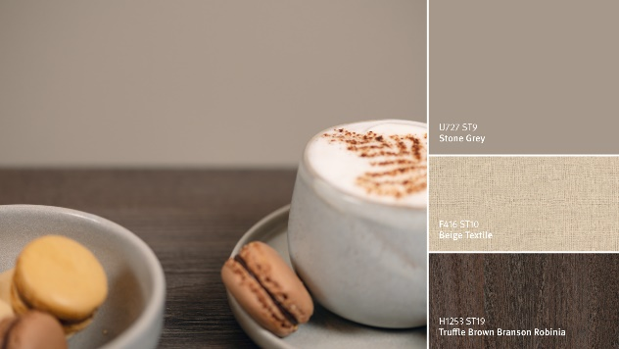 | 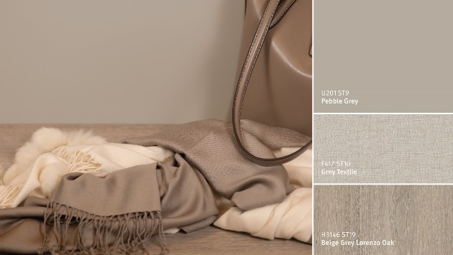
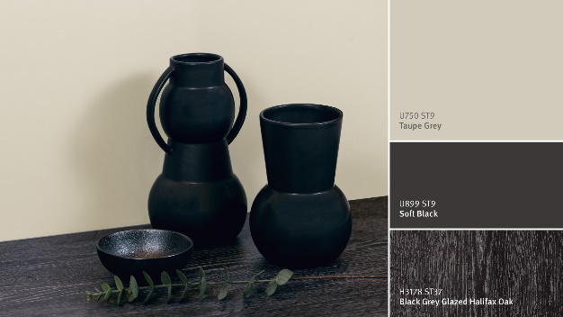 | 