EGGER Group brings the 2018/2019 financial year to a close with stable results and very high investments
The wood-based materials manufacturer recorded sales of EUR 2.84 billion and adjusted EBITDA of EUR 425.0 million.
The EGGER Group reports on a successful, albeit challenging, 2018/2019 financial year (4/30/2019) during its annual press conference on 25 July 2019 at its headquarters in St. Johann in Tirol. The key performance indicators showed a stable development: Group turnover increased by +5.6%, while adjusted EBITDA declined slightly by -4.7%. The record total investment of EUR 489.1 million had a strong impact on this result. One of the flagship projects was recently completed: The 19th EGGER plant in Biskupiec, Poland, started operations at the end of June.
EGGER Group Management is satisfied with the sales of EUR 2,841.5 million achieved in the 2018/2019 financial year (+5.6% compared to the previous year) and the adjusted operating result (EBITDA) of EUR 425.0 million (-4.7% compared to the previous year). The adjusted EBITDA margin amounts to 15.0% and is thus in line with the long-term average. The equity ratio remains at the high level of 36.8% (previous year: 40.8%). The quantity of rawboards (including timber) increased to 8.8 million m³ (+3.5%), which means the full utilisation of all primary production capacities. Across the Group, EGGER employed an average of 9481 employees last year.
In the second half of 2018, global economic growth slowed, particularly in the eurozone. The construction industry is growing slower than forecast. For EGGER, environments in the key markets in Europe and Russia were satisfactory in the past financial year and enabled stable development. The most important geographical market for the company is Western Europe, and above all Germany with the furniture industry strongly represented there. The Western European market with a turnover of EUR 1,672 million (+4.7%) also grew in the 2018/2019 financial year and thus generated 58.9% of the sales revenues. The Central & Eastern European and Russian markets also achieved a stable sales share of 29.5%, with declining sales of flooring products in Turkey and falling demand for OSB having a negative impact. However, this was offset by an increase in sales of flooring and interior design products in Russia and sales growth in other sales territories of the region.
Non-European countries are playing an important role for EGGER. In 2018/2019 they accounted for EUR 330 million (+10% compared to the previous year) or 11.6% of total sales. Sales at the new plant in Argentina fell short of expectations: "The Argentine market, which is new to us, was very challenging, as it was characterized by very high inflation and the currency decline of the Argentine peso and the associated economic recession," explains Ulrich Bühler, EGGER Group Management Sales/Marketing.
Record amount invested
In the 2018/2019 financial year, EGGER invested EUR 489.1 million in property, plant equipment and intangible assets (previous year: EUR 483.8 million). Of this amount, EUR 78.1 million was attributable to maintenance investments and EUR 411.0 million to growth investments. The two greenfield projects in Biskupiec (PL) and in Lexington, NC (USA), accounted for the largest investments.
Continued focus on sustainability
EGGER is once again publishing its annual sustainability report (non-financial statement) at the same time as the annual financial report. This is available at www.egger.com/nachhaltigkeit and contains all approaches, objectives and performance with regard to economic, ecological and social sustainability. The EGGER Sustainability Report 2018/2019 contains many best practice examples of the company's sustainable actions.
Positive outlook for 2019/2020
In the current financial year, EGGER aims to exploit the earnings potential of the investments made. Thomas Leissing is confident about this: "Although weaker economic development has been noticeable in some of our markets in recent months, our outlook for the 2019/2020 financial year is positive. With our competitive industrial base, we will be able to build on our current results. In addition, we will launch our new EGGER Decorative Collection 2020–22 in the market at the turn of the year, continuing the great success of the first edition of this collection". EGGER also anticipates a positive development in demand for the OSB and timber product areas. Laminate flooring will continue to be under market pressure in Western Europe. Due to the stable development in the core area of furniture and interior design, growth in Russia and the shift of volumes from weaker regions to alternative markets, EGGER anticipates sustained sales growth and stable earnings for the Group as a whole in the 2019/2020 financial year.

EGGER Group brings the 2018/2019 financial year to a close with sales and investment highs
- Turnover: EUR 2.84 billion (+5.6%)  - Sales growth in all divisions  - EBITDA: EUR 425.0 million (-4.7%)  - Investments: EUR 489.1 million  - Biggest projects: Biskupiec (PL) was put into operation on 6/28/2019; construction work started in Lexington, NC (US) in November 2018 | - EGGER employs around 9600 people across 19 locations worldwide  - Outlook 2019/2020: sustained sales growth and stable earnings  - Future focus on sustainability and digitization solutions

For queries:

FRITZ EGGER GmbH & Co.
Holzwerkstoffe
Johanna Simonini
Weiberndorf 20
6380 St. Johann in Tirol
Austria
T +43 5 0600-10808
F +43 5 0600-90638
johanna.simonini@egger.com

Captions
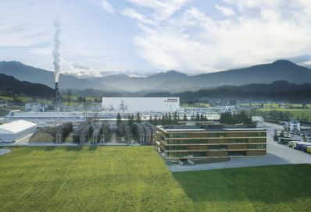 | The EGGER Group, headquartered in St. Johann in Tyrol, increased its sales by 5.6% to EUR 2.84 billion in the 2018/2019 financial year.
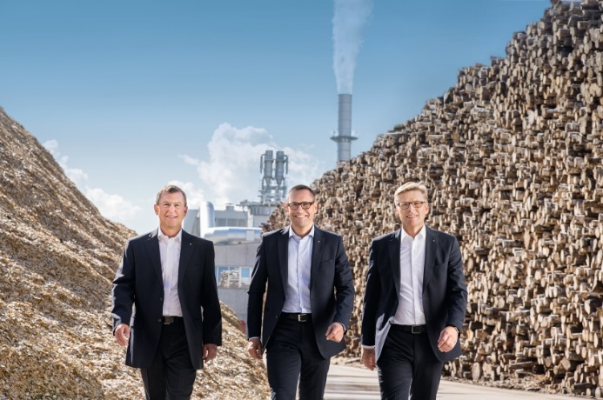 | The EGGER Group Management with Walter Schiegl, Thomas Leissing, and Ulrich Bühler (left to right) reported a stable financial year and major plans for the future.
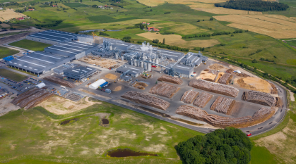 | On 28 June 2019 the time had come: production started at the new EGGER plant in Biskupiec, Poland. The plant is equipped with state-of-the-art equipment, a raw chip capacity of 650,000 m³ and coating facilities.

PHOTOS: EGGER Holzwerkstoffe, reprints quoting the name of the copyright owner are free
IMAGE DOWNLOAD: https://celum.egger.com/webgate/pin.html?lang=en&pin=81HH1RKXOJIX

