Materials that make PerfectSense
EGGER introduces new material decors into its award winning range of matt and ultra-gloss surfaces.
Marble and industrial materials continue to be in high demand by consumers across the furniture industry. Often out of reach, due to high price tags, EGGER’s new PerfectSense decors offer cost effective alternatives that are easy to process, on-trend and durable.
Combining marble decors with a matt or ultra-gloss finish transforms a previously traditional surface into an on-trend element. The delicate grain found on F812 White Levanto Marble is modernised, and the bold elements of F206 Black Pietra Grigia are enhanced when united with a PerfectSense finish.
In addition to the marble decors, F627 Dark Steel and F120 Light Grey Metal Rock provide a more industrial look. Both available in a matt finish, the surface replicates the smooth, cool surface of the material to provide a realistic look and feel.
Matt surfaces are more practical than ever before, with anti-fingerprint technology maintaining the high-end look and feel of a smooth, velvet surface. Available as PerfectSense Matt UV Lacquered MDF board for vertical applications or PerfectSense Topmatt Laminate when a more hardwearing, micro-scratch resistant, horizontal surface is required.
The high reflectivity of an ultra-gloss surface helps to make rooms appear lighter and larger. The luxurious, glass-like finish provides a contemporary look that is otherwise difficult to achieve. Available as PerfectSense Gloss UV Lacquered MDF boards, the range is suitable for vertical applications.
Elliott Fairlie, Head of Decor Management, UK & Ireland commented, “Over the last three years, the demand for matt and ultra-gloss surface has soared. The new material decors in our PerfectSense range are a welcome addition to the EGGER Decorative Collection 2020-22. They are extremely versatile, on-trend and provide plenty of new opportunities when developing new design concepts”
The whole PerfectSense range comprises 14 material and uni colour decors, 10 of these are available in both matt and ultra-gloss finishes. All decors have matching (ABS) and two tone Doppia (PMMA) edging to provide a high-end finish.
For more information, please visit egger.com/insights.
-ends-
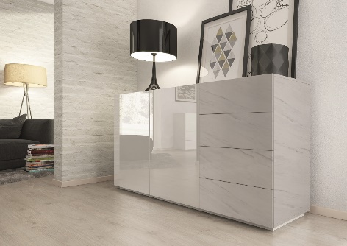 | F812 PM White Levanto Marble and W1100 PG Alpine White
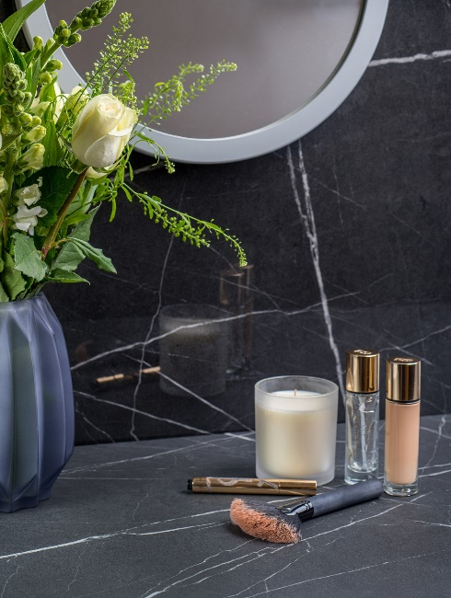 | F206 PG and PM Black Pietra Grigia
 | F627 PT Dark Steel
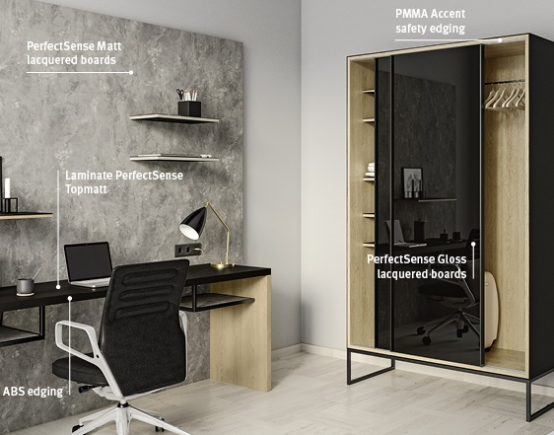 | F120 PM Light Grey Metal Rock and U999 Black PM and PT

For more information, please contact Kate.Wallace@egger.com/01434 613395

